Kossi AMAH
GCH-360-002 (Fall 2016)

Term Topic: “Outlook of Zika and Population in Brazil”
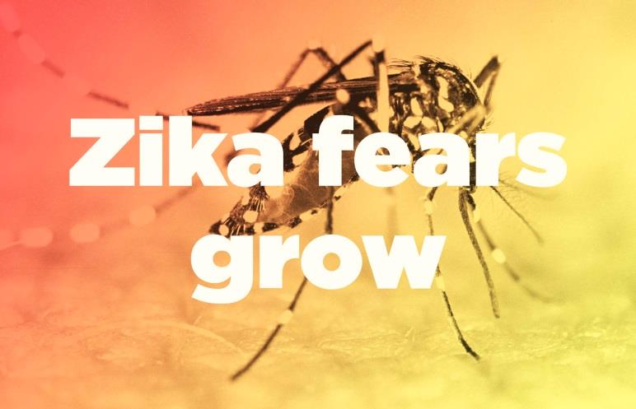 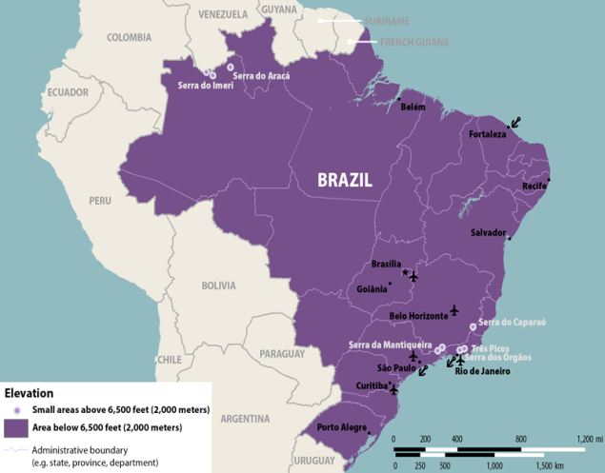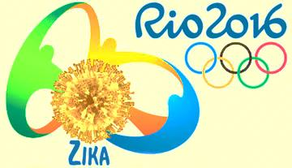Figure 1……… This figure show how the Zika virus increase or spread mostly in Brazil toward other countries.
Figure 2……… Shading indicates countries and territories where mosquito-borne transmission of Zika virus has been reported. It does not necessarily indicate that mosquito-borne transmission is occurring throughout the entire country or territory.
Figure 3…………. Brazil is the epicenter of the Zika outbreak, which has reportedly infected at least 1.5 million people there. Brazil also was the first to report a surge in newborns with microcephaly that parallels the outbreak. At least 4,100 infants reportedly have been born with that condition, compared with fewer than 150 in 2014. ( In the picture : Dr. Valeria Barros treats a 6-week old baby born with microcephaly at the Lessa de Andrade polyclinic during a physical therapy session.)
Figure 4………. Brazil has recorded nearly 4,000 cases of microcephaly, a serious and normally rare birth defect that may be linked to Zika, since the start of 2015. Around a third of these have been in the state of Pernambuco.( 23 countries in the Latin Americas have active Zika virus transmission).
Figure 5………As shown on the graph, in 2015, there were 3,000 cases reported about the occurrence of microcephaly in Brazil.
Figure 6………. (A) Yellow fever vaccination coverage in individuals aged 15-49 in Brazil; (B) reported cases of microcephaly between October 2015 and March 2016; (C) confirmed cases of microcephaly between October 2015 and March 2016; (D) clusters of confirmed cases of microcephaly associated with ZIKV; arrows indicate location of clusters. Observation units are the 5,570 municipalities of Brazil.
Figure 7…….. The figure shows where Zika virus started and how it grows to other various countries:
1947: Scientists conducting routine surveillance for yellow fever in the Zika forest of Uganda isolate the Zika virus in samples taken from a captive, sentinel rhesus monkey.
1948: The virus is recovered from the mosquito Aedes africanus, caught on a tree platform in the Zika forest.
1952: The first human cases are detected in Uganda and the United Republic of Tanzania in a study demonstrating the presence of neutralizing antibodies to Zika virus in sera.
1969–1983: The known geographical distribution of Zika expands to equatorial Asia, including India, Indonesia, Malaysia and Pakistan, where the virus is detected in mosquitos. As in Africa, sporadic human cases occur but no outbreaks are detected and the disease in humans continues to be regarded as rare, with mild symptoms.
2007: Zika spreads from Africa and Asia to cause the first large outbreak in humans on the Pacific island of Yap, in the Federated States of Micronesia. Prior to this event, no outbreaks and only 14 cases of human Zika virus disease had been documented worldwide.
2013–2014: The virus causes outbreaks in four other groups of Pacific islands: French Polynesia, Easter Island, the Cook Islands, and New Caledonia.26,27 The outbreak in French Polynesia, generating thousands of suspected infections, is intensively investigated. The results of retrospective investigations are reported to WHO on 24 November 2015 and 27 January 2016.
2 March 2015: Brazil notifies WHO of reports of an illness characterized by skin rash in northeastern states. From February 2015 to 29 April 2015, nearly 7000 cases of illness with skin rash are reported in these states. All cases are mild, with no reported deaths. Zika was not suspected at this stage, and no tests for Zika were carried out.
1 February 2016: WHO declares that the recent association of Zika infection with clusters of microcephaly and other neurological disorders constitutes a Public Health Emergency of International Concern.
Figure 8………… The figure on the left- Is the distribution of reported cases of ZIKV infection in Brazil by state, from the beginning of the outbreak in December 2014 untild the end of January 2016. The figure on the right- Is the distribution of reported cases of microcephaly in Brazil from July 2015 to February 2016.
Figure 9………Phylogenetic analysis based on partial E gene nucleic acid sequences (327bp). Closed circles represent 4 strains of Zika virus from Rio de Janeiro, Brazil 2015. The remaining 6 strains were identical to these 4 and are not shown here. The tree was inferred using the maximum likelihood algorithm based on the Tamura 3-parameter model as implemented in MEGA 6. The numbers shown to the left of the nodes represent bootstrap support values > 70 (1,000 replicates). The tree was rooted with West Nile virus.
Introduction:
Scientists, throughout the world are subject to critiques about how information and their findings are arranged and decided upon so people will actually benefit from them. It is very clear that it takes time to gather information needed to be able to help the communities and society; this is the case of the Zika virus which actually have grown slowly and have an outbreak in specific countries; But scientists began sounding the alarm after multiple outbreaks were discovered in the Pacific islands and south-east Asia through their advance technologies. Since then, Zika has spread to Brazil. The Centers for Disease Control and Prevention (CDC), reported that scientists estimate as many as 1.5 million people could be infected in Brazil. To understand how information is gathered in the health profession, we have to examine the technology and computer programs that scientist used to investigate. In our society, technology, including computers has become the engine for how information is processed. Scientists and other professional use this computer technology because it`s faster and easier to look at everything that is related to a patient’s health or the population health crisis of a country suck as the Zika virus. Moreover, scientists are warning people living in tropical climates, and especially pregnant women, about a new and alarming virus that once only affected subtropical forests in Africa. Called Zika, and the public health officials in the US believe it could be an emerging health threat. This paper will analyze how the Zika virus will have an impact throughout the life of a person in Brazil and the potentially devastating effect of this virus on health, socioeconomic status, gender, race, class, culture, values and beliefs. Because of this, health departments have informed communities about the Zika virus and how it has expanded through the world and how people will be aware of it and the precautions they should take.
Background:
The rise in the spread of Zika virus has been accompanied by a rise in cases of microcephaly and Guillain-Barré syndrome. First identified in Uganda in 1947 in monkeys, Zika was later identified in humans in 1952. The first large outbreak of disease caused by Zika infection was reported from the Island of Yap in 2007. There are currently several countries experiencing Zika virus outbreaks. The Outbreaks of Zika have occurred in Africa, Southeast Asia, and the Pacific Islands. Because the Aedes species mosquitoes that spread Zika virus are found throughout the world, it is likely that outbreaks will spread to new countries. “ZIKV is a positive-sense, single-stranded (nonsegmented) RNA arbovirus of the flaviviridae family which is transmitted to humans by a bite from mosquitos of the genus Aedes . The virus is related to other flaviviruses such as yellow fever virus (YFV), dengue virus (DENV), and Japanese encephalitis virus, but is mostly similar to the Spondweni virus. ZIKV is composed of ~10,000 nucleotides which encode a polypeptide protein of ~3,500 aa” (Jorg Heukelbach., 2016, p.116). In 2015, Brazil was faced with the cocirculation of three arboviruses of major public health importance. The emergence of Zika virus (ZIKV) presents new challenges to both clinicians and public health authorities. The rise of the Zika Virus has emerged especially in South America or Latin America and therefore is rapidly becoming a public health crisis. Throughout the population of in Latin America, women are being advised not to become pregnant for at least a year or more. There will obviously be a birthrate gap, if women heed the warning. Zika can also be passed through sex from a person who has Zika to his or her sex partners and it can be spread from a pregnant woman to her fetus. People can protect themselves from mosquito bites and getting Zika through sex. The Zika virus is a mosquito-borne infection which is caused by a virus transmitted primarily by Aedes mosquitoes. Zika virus was first revealed by scientists in 1947 in the Zika forest in Uganda. It was not considered as a great threat to anyone. After it was detected in Brazil last May; this mosquito-born virus has been spreading fast among in North America. Before then, these mosquitos do not just bite at night, and can become infected when biting a person who is infected with the virus, then spreading the disease to more people (Centers for Disease Control and Prevention). Public health officials suspects that there’s a link between Zika and a birth defect called microcephaly which mean, babies, born with significantly small heads and a neurological disorder. In some countries, officials suggest that women put off plans for pregnancy. Luciano Pamplona de Góes Cavalcanti et al. (2016), reported that, by March 2016, a total of 6,381 suspected microcephaly cases were reported, and 854 confirmed; many of them occurred in infants born to women living in areas of ZIKA transmission. Transmission of ZIKA virus was confirmed in 22 of Brazil’s 26 states including the Federal District (Page.563). “During the first 6 months of 2016, large outbreaks of Zika virus disease caused by local mosquito-borne transmission and other U.S. territories, but local mosquito-borne transmission was not identified in the continental United States (1,2). In May of 2015, the Pan American Health Organization (PAHO) confirmed the first Zika case in Brazil, issuing an alert concerning the virus in order to keep the public and healthcare personnel informed (CDC).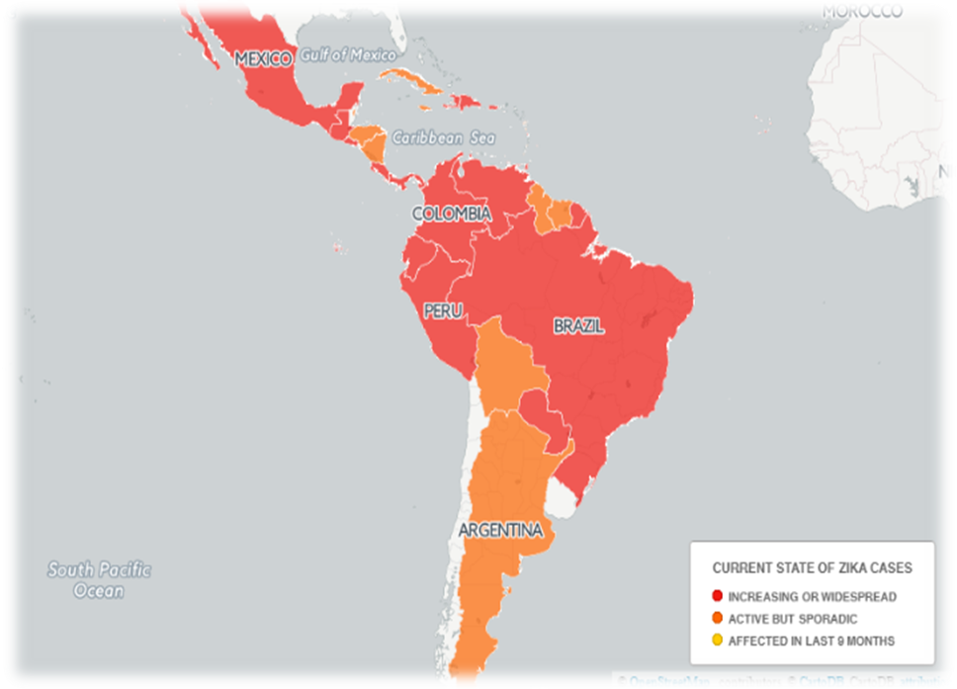Figure 1

Health Implication:
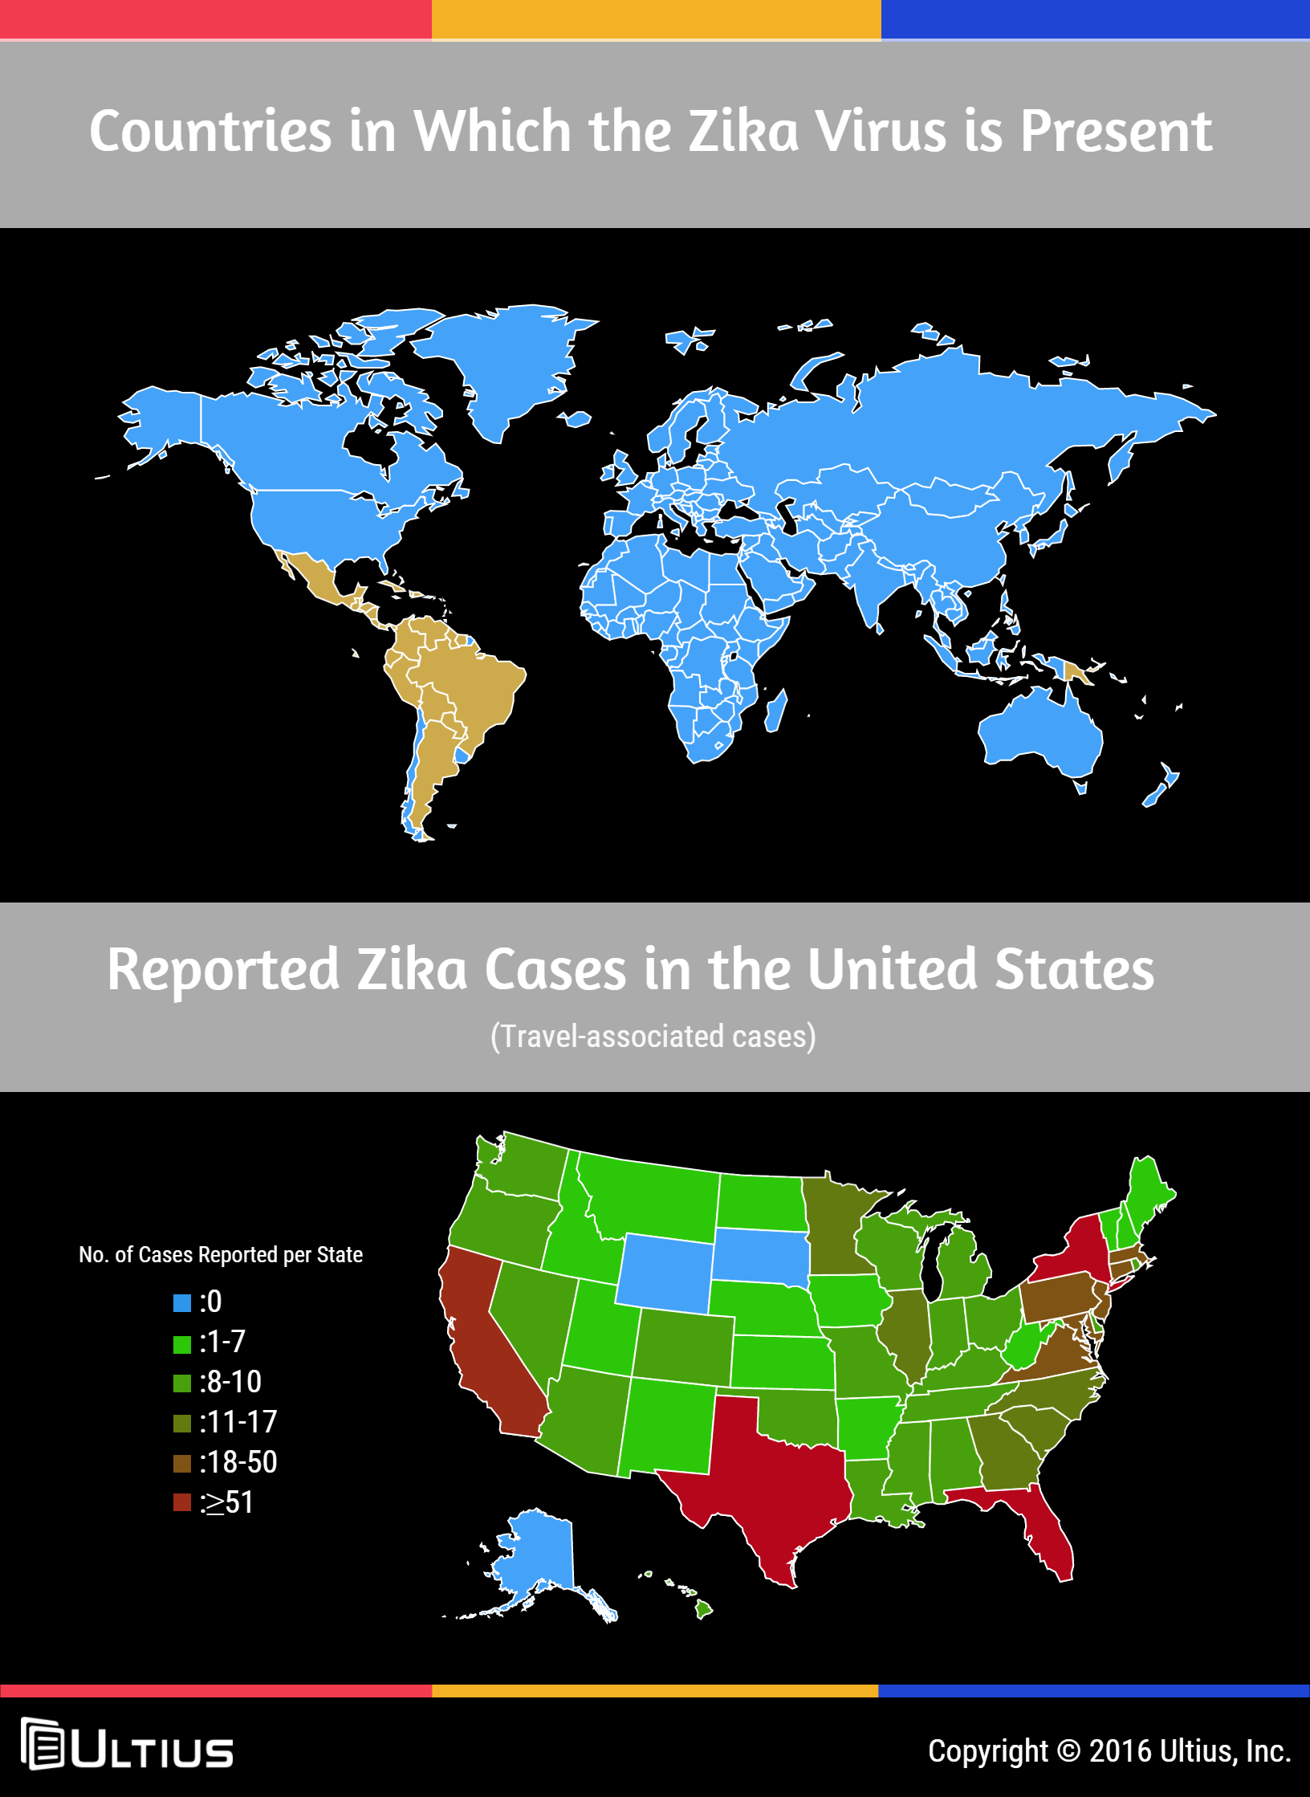
Figure 2
Zika virus can have a health implication in some areas of your body if being infected like: in the back of the eyes, joints, or muscles and Whole body such as fatigue, fever, chills, loss of appetite, or sweating. Also common: eye redness, headache, skin rash, or vomiting. The virus’ symptoms include fever, conjunctivitis, joint pain, rash, sometimes muscle pain and headache. At the same time there are many patients with the virus that have no symptoms at all. The incubation period is unknown, but is likely to be from a few days to a week. “Zika virus and yellow fever virus, in its urban transmission cycle, both share the same mosquito vector, Aedes mosquitoes.
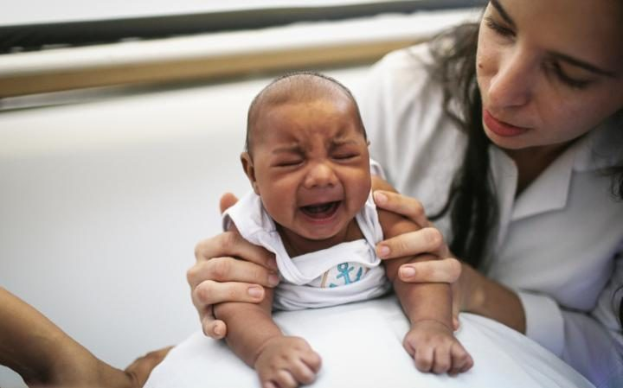 Figure 3: Dr. Valeria Barros treats a 6-week old baby born with microcephaly at the Lessa de Andrade polyclinic during a physical therapy session

Microcephaly: is a serious and uncommon birth defect that doctors believe is caused by below-normal brain development in utero. Microcephaly causes lifelong physical and developmental problems for babies born with it. Problems can be wide-ranging, from seizures, to difficulty walking and learning, to hearing loss and vision difficulties.
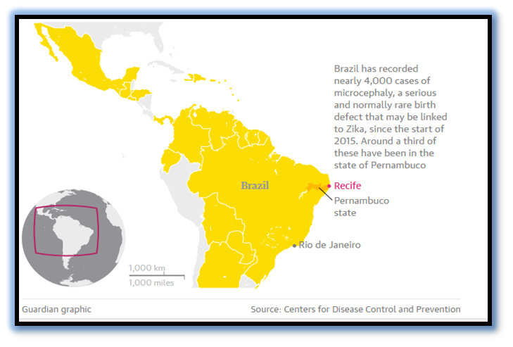Figure 4
In the South American country of Brazil, a significant number of people have contracted and continue to contract the Zika virus, and the effect on the fetuses of pregnant women has become a great concern to health officials and healthcare providers in the region (CDC). There has been an increase in the amount of infants born with congenital microcephaly, which produces a much smaller head size than is expected for the age and sex of the infant (CDC). Due to the small head size, brain damage may be present in these infants, and may affect them for the rest of their lives, or even cut their lives short. The scientists consider that the Zika outbreak may cause an increase in a number of babies with microcephaly. In the end of November the disease rate in Brazil was about 100 cases for every 100,000 births (usually five to six cases for every 100,000 births).

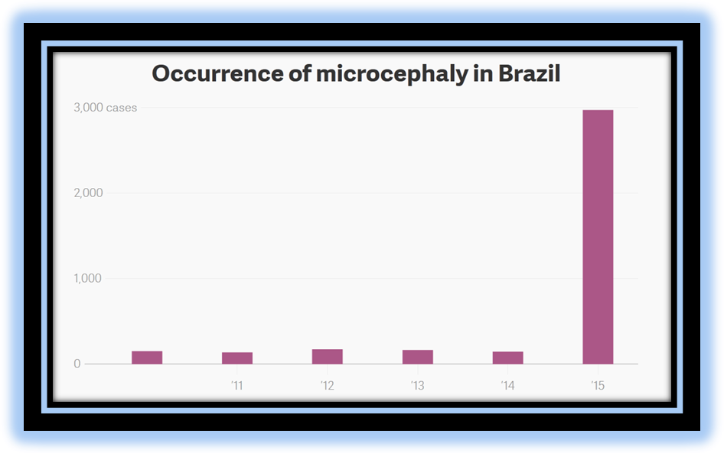Figure 5
Methodology
Brazil is a country of continental dimensions, with a population of approximately 205 million inhabitants and 5,570 municipalities, with major parts of its territory considered as risk areas for yellow fever transmission. Three different descriptive spatial analyses were performed, using the Brazilian municipalities as units of analysis: 1. yellow fever vaccination coverage in Brazilian municipalities in individuals aged 15-49 years; 2. reported cases of microcephaly by municipality; and 3. confirmed cases of microcephaly related to ZIKV, by municipality. Influence the spread of Zika virus in yellow fever endemic areas). Therefore, no causal relationship can be established, and we emphasize an urgent need for systematic studies to confirm the possible link between low yellow fever vaccine coverage and microcephaly.
Our data also suggest that a vaccine based on the existing yellow fever vaccine should be considered. Additional systematic studies are needed, such as a cohort study investigating yellow fever antibody titres in populations at risk. Adequately designed laboratory based investigations and studies on animals need to be performed to investigate the possible protective effect of yellow fever vaccination against subsequent infection with Zika virus, and thus microcephaly. Yellow fever is an acute vector-borne short term viral disease. Despite the availability of an effective vaccine, there is still active transmission in many countries. In Brazil, autochthonous cases of sylvatic yellow fever regularly occur in small clusters, transmitted by other mosquito species. In 2015, 7 autochthonous cases of yellow fever were reported” (Luciano Pamplona de Góes Cavalcanti et al., 2016, p.563).
To analyze the possible association of yellow fever vaccine with a protective effect against ZIKV-related microcephaly, the following spatial analyses were performed, using Brazilian municipalities as units as yellow fever vaccination coverage in Brazilian municipalities in individuals aged 15-49; then reported cases of microcephaly by municipality; after then confirmed cases of microcephaly related to ZIKV, by municipality. SaTScan software was used to identify clusters of municipalities for high risk of microcephaly.
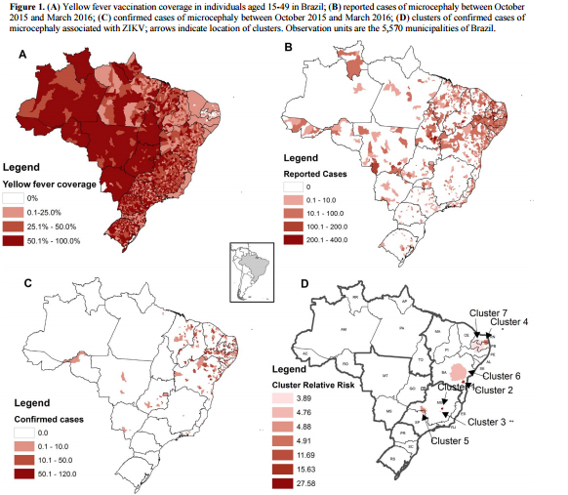
Figure 6
“The outpatient service for acute febrile illnesses in Fiocruz initiated a syndromic clinical Observational study in 2007 to capture unusual presentations of DENV infections. In January 2015, an increase of cases with exanthematic disease was observed. Trained physicians evaluated the patients using a detailed case report form that included clinical assessment and laboratory investigations. The laboratory diagnostic algorithm included assays for detection of ZIKV, CHIKV and DENV. 364 suspected cases of Zika virus disease were identified based on clinical criteria between January and July 2015. Of these, 262 (71.9%) were tested and 119 (45.4%) were confirmed by the detection of ZIKV RNA. All of the samples with sequence information available clustered within the Asian genotype” (Patrícia Brasil et al.22016,p.1).
First supporting case/example
The risk of transmission of diseases by the Aedes aegypti mosquito in Brazil during the period of the Olympic and Paralympic Games will be minimal. This is what the data presented by the Minister of Health, Ricardo Barros, on Friday (10), in Rio de Janeiro, during a press conference with foreign correspondents, indicates. The indices of cases of the Zika virus are declining in the country and have already fallen 87% in the comparison between February and May this year.Reports of the disease peaked in the third week of February, with 16,059 cases. In the first week of May, reports plunged to 2,053. The figures demonstrate, once again, the effectiveness of the actions taken against the Aedes aegypti mosquito, apart from indicating a different behavior than usual this year. In 2016, the cases started declining earlier than expected, since until then the diseases transmitted by the Aedes aegypti peaked in April.
"According to a study released by the University of Cambridge, it is expected there will be less than one case of infection among the 500,000 tourists planning to come to the Olympics. The risk of Zika will be minimal, primarily due to the climatic conditions of the season and the mobilization against the mosquito here in Rio de Janeiro," stressed Minister Ricardo Barros. He also said that Rio de Janeiro will receive a reinforcement of 2,500 health professionals and that repellent, specific clothing and the necessary materials will be available for all athletes under the responsibility of the Olympic Committee. "As with the FIFA World Cup and World Youth Day, we have no doubt that the Olympic Games will be bolstered by the hospitality of the Brazilian people and the quality in carrying out mega events," In the cities where there will be Olympic and Paralympic games, the figures indicate similar behavior as the national ones, with the disease peaking around February and then significantly receding in the following months. The city of Rio de Janeiro, for example, had the highest number of reported cases in the third week of February, with 2,116. In the following weeks, the numbers decreased, dropping to 208 cases in May, representing a reduction of 90%. Contrary to the northern hemisphere, it is winter in Brazil, when historically and epidemiologically the rates of diseases transmitted by the mosquito are declining and reach their lowest rate. This period is precisely in August and September, when the Olympic and Paralympic Games will be held in Brazil.
The Minister of Health, Ricardo Barros, recalls that in the 2014 FIFA World Cup people were also nervous about coming to the country and catching diseases transmitted by Aedes aegypti mosquito. "During the World Cup, there were only three recorded cases among tourists. Statistics show that the period of the games is not endemic. This is mainly because there is less rain in the winter, which hinders the proliferation of mosquitoes,"

Second supporting case/example
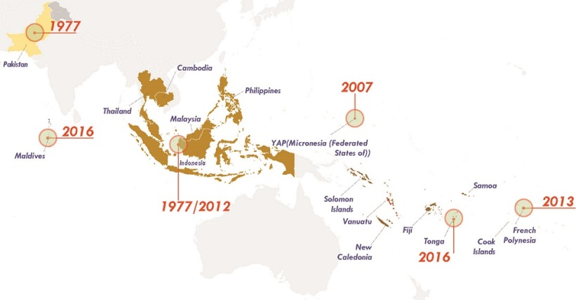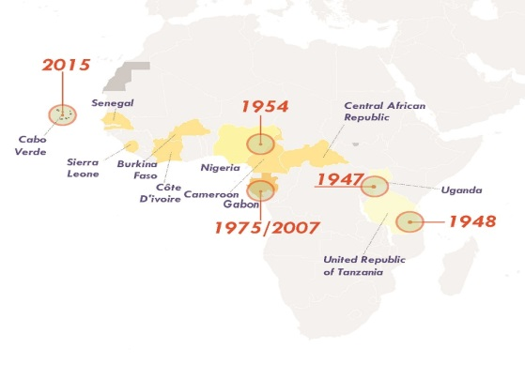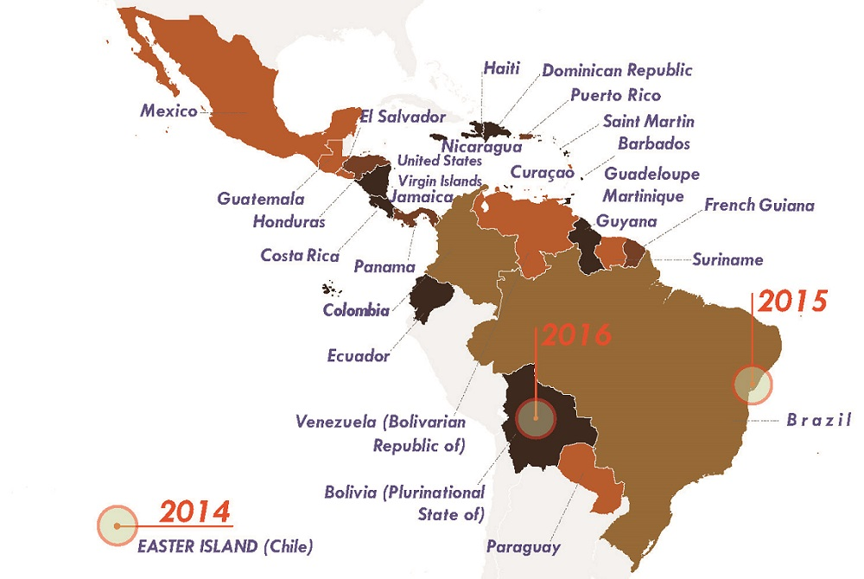
Figure 7

The Puerto Rico Department of Health reported today the first locally acquired case of Zika virus infection in Puerto Rico. Zika was confirmed in a resident of Puerto Rico with no known travel history. CDC is working closely with the Puerto Rico Department of Health to investigate how the patient may have contracted the virus. Health officials in Puerto Rico are monitoring for other cases of Zika virus infection.
By the end of 2014, a few months after the Football World Cup in Brazil, reports of an acute exanthematic disease in various urban centers of Northeastern Brazil began to emerge. From February 2015 onwards, other municipalities began notifying the Brazilian Ministry of Health of similar cases in their area. At the end of February 2015, the Ministry of Health (Secretary of Surveillance – SVS/MS) started monitoring the increasing number of an exanthematic disease in the Northeast Region of Brazil. All cases were reported to be self-limited, without any clinical interventions needed. The patients presented with maculopapular exanthema, pruritus, low fever (or no fever), and in some cases headache, hyperemia of the conjunctiva, joint pain, and edema. The most commonly affected age group was 20-40 years, with a range from 4 months to 98 years of age. (Jorg Heukelbach et al., 2016, p.117)
In March 2015, the Ministry of Health began to investigate the source of the outbreak and if the reported symptoms were caused by dengue fever, rubella, or Chikungunya fever. The preliminary results excluded infection by these pathogens. Later that month, ZIKV was isolated in Natal, capital of Rio Grande do Norte State , where 7 of 8 confirmed Zika cases were females (mean age 39 years), with similar signs and symptoms and fever presenting between 2 to 15 days . In two of these cases, the strain of ZIKV was determined to be from the Asian lineage. During a similar time frame, ZIKV was isolated from samples collected from 7 patients with negative serology for DENV and CHIKV in the city of Camaçari in Bahia State. By the end of September 2015, reports surfaced of an increasing number of infants born with small head circumference or microcephaly from various healthcare facilities in Pernambuco State in the Northeast region (2 to 3 standard deviations below average for age and gender) [25]. By October, the State Health Secretariat of Pernambuco State (SES/PE) notified 29 cases of microcephaly in infants born since August. Taken together, these findings represent an extreme increase in microcephaly as compared to previous years. On the 23rd October 2015, the Brazilian Ministry of Health notified the World Health Organization about the occurrence of the increased number of infant microcephaly. On 12th November, the Ministry of Health of Brazil published an order declaring a Public Health Emergency of National Importance (Emergência de Saúde Pública de importância Nacional - ESPIN), and on 17th November, a technical note was also published. On 24th November, ZIKV was identified in blood and tissue samples of a newborn from Ceará State that had died in the postpartum period (Pamplona, personal communication 2016). After this incident, ZIKV was also isolated from the umbilical cord of a newborn and the Ministry of Health declared a possible association between ZIKV infection and the increasing number of microcephaly cases.( (Jorg Heukelbach et al., 2016, p.118).

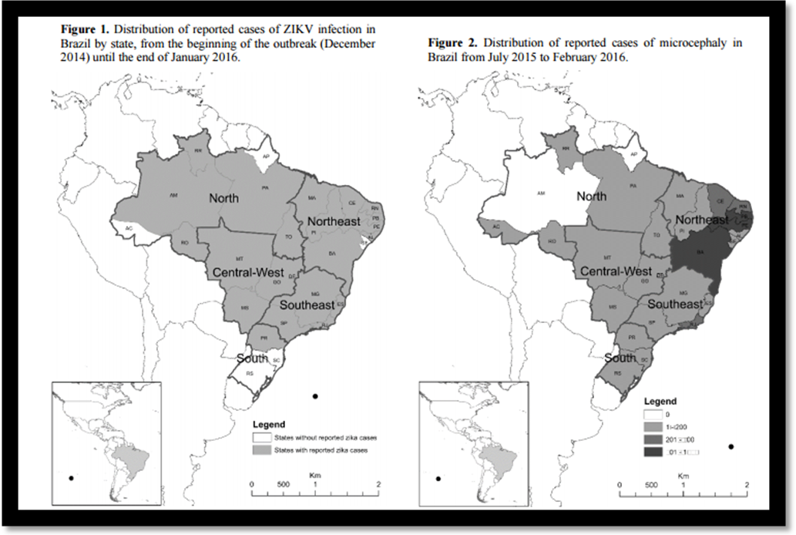
Figure 8
Third supporting case/example
A new study, led by researchers from the University of Utah, has examined the Utah episode, and concludes that Zika virus is at least a very peculiar case which appears to have been spread through physical contact alone. Not only that, but the virus could be deadlier than we first thought, because while the patient in this scenario was elderly, he was otherwise healthy when he contracted the virus, but died soon after in hospital. The first such case that’s been documented. The circumstances of the case began when the elderly patient, a 73-year-old Salt Lake City resident, visited Mexico in May last year. During his trip, he was bitten by mosquitoes, which is the most likely explanation for how he contracted Zika. This rare case is helping us to understand the full spectrum of the disease, and the precautions we may need to take to avoid passing the virus from one person to another in specific situations. For example, upon returning from his trip, he went to hospital experiencing inflammation, watery eyes, and a rapid heart rate. With his condition deteriorating, the man's 38-year-old son visited him in the hospital, and comforted his father, helping to reposition him in bed and wiping away his tears. The father later died in hospital and tests after his death confirmed he had Zika. But only a week after the father passed away, Swaminathan happened to notice that the son also had watery eyes, a common Zika symptom and tests confirmed he too had contracted the virus. In these circumstances, the researchers conclude "infectious levels of virus may have been present in the father's sweat or tears, both of which the son contacted without gloves." This case expands shown how Zika virus can potentially spread from an infected patient to a non-infected patient without sexual contact or a mosquito vector, this and any future cases will force the medical community to critically re-evaluate established triage processes for determining which patients receive Zika testing and which do not.

Solution:
Recently, all the country are fighting against this incurable disease; however the situation in Brazil even in the rest of the countries, Zika has been affected leaves scientists, health care workers, and political leaders with addressing urgent action to take to be able to reduce this type of virus .In order to protect others, avoid mosquito bites or sexual activity to occur (CDC). If the symptoms of the disease occur two weeks or more after travel, the disease may not be Zika (CDC). The Centers for Disease Control and Prevention stated that, it is likely that a person cannot be re-infected if that person has already had Zika once. The best protection from Zika is avoidance of areas where there are or have been recent outbreaks; these precautions are most important for pregnant women and they are advised not to travel to any country in Latin America, where the virus is spreading. Furthermore, there is no treatment or vaccine against the Zika virus today. “To decrease the expansion of ZIKA Virus and its associated infection rate, the extremely rapid spread of the outbreak to other regions must be controlled.” (Jorg Heukelbach et al., 2016, p.119).The best prevention measure is to avoid mosquito bites. Instead the focus is on relieving symptoms and includes rest, rehydration, take medicine such as acetaminophen to reduce fever and pain. If you are taking medicine for another medical condition, talk to your healthcare provider before taking additional medication. Aspirin and non-steroidal anti-inflammatory drugs (NSAIDs) like ibuprofen should be avoided. All travelers should follow general precautions against mosquitoes such as screens, pants, long sleeves and insect repellent. Luciano Pamplona de Góes Cavalcanti et al. (2016) mentioned that, adequately designed laboratory based investigations and studies on animals need to be performed to investigate the possible protective effect of yellow fever vaccination against subsequent infection with Zika virus, and thus microcephaly.(P.565). There were seven significant high risk clusters of confirmed microcephaly cases, with four of them located in the Northeast where yellow fever vaccination rates were lower. The clusters harbored only 2.9% of the total population of Brazil, but 15.2% of confirmed cases of microcephaly.
Analysis
A new analysis based on data from seven countries hit hard by the Zika virus found a strong link between Zika infection and Guillain-Barre syndrome (GBS), a complication marked by numbness, weakness, and sometimes paralysis of the limbs. The Brazilian sequences were found to be closely related to a sequence from French Polynesia. This lends support to the hypothesis that the virus might have been introduced to Brazil during the Va'a World Sprint Canoeing Championship in Rio de Janeiro in 2014, which included a team from French Polynesia, rather than the World Cup in which no teams from Pacific countries participated. Among the factors that influence Zika infection, 'antigenic variability' (the way the virus alters its surface proteins to evade the host's immune response) and pre-existing immunity caused by cross-reactions with other viruses might play an important role. Such cross-reactions also make a diagnosis of Zika infection unreliable, and could thus facilitate the spread of the virus. This virus is believed to have arrived during the 2014 World Cup, carried by wealthy Polynesian tourists, but has nested and found purchase in Brazil because of the climate, a poor public-health system crippled by the recession, and a substandard system of sanitation. It is very clear that they were a very small concern about the rise of the Zika virus during the 2014 World Cup; back then the Zika virus was not well known and it was not a big impact in the country and the people. Recently, it has been a very huge concern because this Zika virus has spread widely throughout Brazil and it causing and prevent tourist from other countries to come in. Because most people clear the Zika virus from their blood in less than 10 days, many travelers who become infected in Brazil are likely to be free of the virus before or shortly after returning home.
Laboratory Analysis and Confirmation
“Acute phase serum samples were tested by qRT-PCR for ZIKV [23] and RT-PCR for DENV
RNA [24]. CHIKV qRT-PCR testing was performed for a random sample of 25% of patients as
no patient tested positive and there was no on-going transmission of CHIKV in Rio at the time
of this study. Cases were classified as ZIKV infection if ZIKV RNA was detected in the serum” ( Patrícia Brasil et al.,2016, p.4-5).
Phylogenetic Analysis
“Phylogenetic analysis of nucleic acid sequences derived from 10 random ZIKV positive samples (out of 119) was performed using 327 base pairs of the envelope protein (GeneBank accession number KT381874). The tree was inferred using the maximum likelihood algorithm based "on the Tamura 3-parameter model as implemented in MEGA 6. The numbers shown to the left of the nodes represent bootstrap support values > 70 (1,000 replicates). The tree was rooted with Spondoweni virus” ( Patrícia Brasil et al.,2016, p.4-5).fF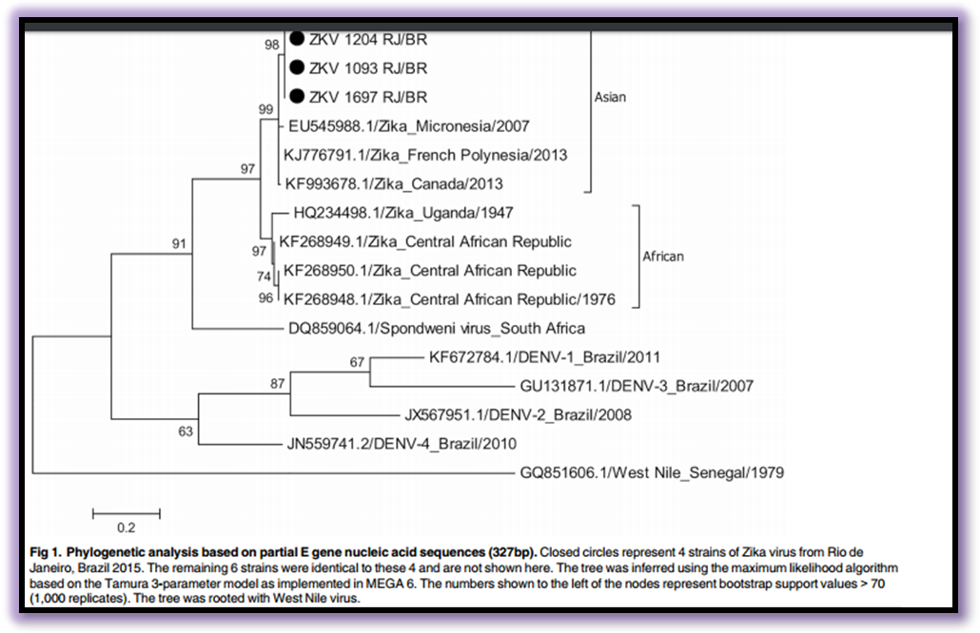Figure 9

Conclusion:
Zika is a virus that people deal with their daily life and must be carefully considered and weighed against the harm that it can cause for everyone involved in the act. Zika outbreaks are currently happening in many countries and territories. The mosquitoes that can become infected with and spread Zika live in many parts of the world, including parts of the United States and it is a pandemic, virus but researchers in America and other countries have begun work on a vaccine, experts predict that this process could take years. Furthermore, providing information, educating and counseling people about the Zika virus is very important because doing so will actually alert them about the risks will keep them safer. There is an urgent need for systematic studies to confirm the possible link between low yellow fever vaccination coverage, Zika virus infection and microcephaly.

References:
Brasil, P., Calvet, G. A., Siqueira, A. M., Wakimoto, M., de Sequeira, P. C., Nobre, A., & ... Jaenisch, T. (2016). Zika Virus Outbreak in Rio de Janeiro, Brazil: Clinical Characterization, Epidemiological and Virological Aspects. Plos Neglected Tropical Diseases, 10(4), 1-13. doi:10.1371/journal.pntd.0004636
Cao-Lormeau VM, Roche C, Teissier A, Robin E, Berry AL, Mallet HP, et al. Zika virus, French Polynesia, South Pacific, 2013. Emerg Infect Dis., 2014.
Centers for Disease Control and Prevention (CDC). “Zika Virus.” Zika Virus Home. Centers for Disease Control and Prevention, 2016. Web. 17 Feb. 2016.
De Góes Cavalcanti, L. P., Tauil, P. L., Alencar, C. H., Oliveira, W., Teixeira, M. M., & Heukelbach, J. (2016). Zika virus infection, associated microcephaly, and low yellow fever vaccination coverage in Brazil: is there any causal link?. Journal Of Infection In Developing Countries, 10(6), 563-566. doi:10.3855/jidc.8575
Heukelbach, J., Alencar, C. H., Kelvin, A. A., de Oliveira, W. K., & de Góes Cavalcanti, L. P. (2016). Zika virus outbreak in Brazil. Journal Of Infection In Developing Countries, 10(2), 116-120. doi:10.3855/jidc.8217

