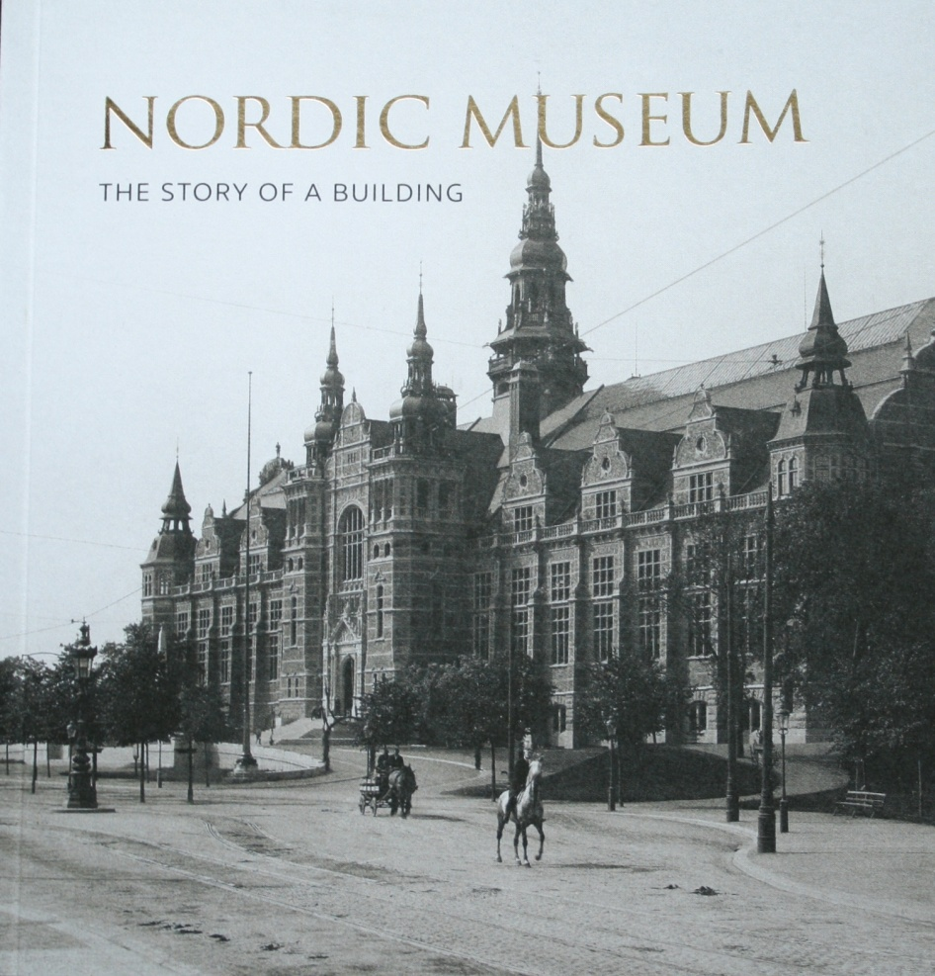
The Building of a Museum/ The Story of a Building
Elisabet Stavenow-Hidemark

The main building of the Nordic Museum on Djurgården in Stockholm was inaugurated with pomp and circumstance on 8 June 1907. King Oscar the II had been following the development of the museum with great interest but was weakened by illness and could not take part. Crownprince Gustaf took his place.
Nineteen years had elapsed since the first sod had been cut and sixteen since the mighty granite foundation was laid. Considering the solid architectural work, the unparalleled precision of the craftmanship and the meticulously chosen building materials, the long construction time is not surprising. Neither had it been easy to make financial ends meet - but it had finally been successful. When the building was finished it had cost slightly more than 3,4 million crowns in the monetary value of the time.
How it began
The history of the Nordic Museum is older than the present building. In the summer of 1872 its founder Artur Hazelius undertook a journey in Dalarna together with his wife Sophie and could then see a society and a culture that was changing rapidly. Industrialism.....

