Bowenwork® Intake Form

Name __________________________________________________ DOB________________ M / F _________
Address ____________________________________________________________________________________
E-mail (Bowenwork use only)___________________________________________________________________
Phones (h)________________________ (w)_________________________(c)____________________________

Occupation___________________________________ Sports, hobbies_________________________________

Emergency contact __________________________________Referred by_______________________________
________________________________________________________
Please check all that apply:

__Abdominal / digestive problem
__Allergies / hay fever
__Arthritis – (location):
_______________
__Asthma
__Ankle problem
__Back pain -- (location):
________________
__Bed wetting (children)
__Bone spurs
__Breast lump
__Breast pain
__Breast implants
__Bronchitis
__Bunion
__Bursitis
__Buttock pain
__Cancer
__Carpal tunnel syndrome
__Chest pain
__Colic (baby)
__Constipation
__Diabetes
__Diaphragm pain or tightness
__Diarrhea
__Dizziness
__Ear or eye problem
__Edema, general
__Elbow pain, tennis or golf
__Fatigue, chronic
__Fibromyalgia or polymyalgia
__Fibroids - (location):
_______________
__Fracture
__Fallen on tailbone / coccyx
__Gall bladder problem
__Heating pad / ice pack usage
__Heating / ccoling salve usage
__Hammer toes
__Hamstring pain or tightness
__Headaches
__Heart problem
__Hernia
__Hip pain
__Hip replacement
__Incontinence / bladder (adult)
__Infertility
__Jaw / TMJ problem
__Joint replacement
__Knee problem
__Liver problem
__Lung problem
__Magnet usage
__Migraines
__Numbness --(location):
_______________
__Orthodontia, extensive
__Orthotics in shoes
__Osteoporosis
__Pain, other -- (location):
_______________
__Pelvic pain
__Plantar fasciitis or neuroma
__PMS or menopause
__Pregnancy
__Prostate problem
__Rib pain / subluxation
__Sacral pain
__Sciatica
__Scoliosis
__Shin splints
__Shoulder problem
__Sinus problem
__Sleep / energy problem
__Tinnitus
__Uterine or ovary problem
__Wrist or thumb pain
__ Other:

____________________________________________________
Describe your condition(s), including length of time experienced. Please list all accidents, injuries, surgeries and falls that might be relevant in any way; include dates of occurrence. Continue on next page:
_____________________________________________________________________________________________
_____________________________________________________________________________________________
_____________________________________________________________________________________________
_____________________________________________________________________________________________
______________________________________________________________________________________________________________________________________________________________________________________________
_____________________________________________________________________________________________
_____________________________________________________________________________________________
_____________________________________________________________________________________________
_____________________________________________________________________________________________
_____________________________________________________________________________________________
List activities compromised by condition(s): ___________________________________________________________
______________________________________________________________________________________________
Shade in the site(s) of pain on the anatomical drawing, and rate the severity of each pain on a scale of 1-10:

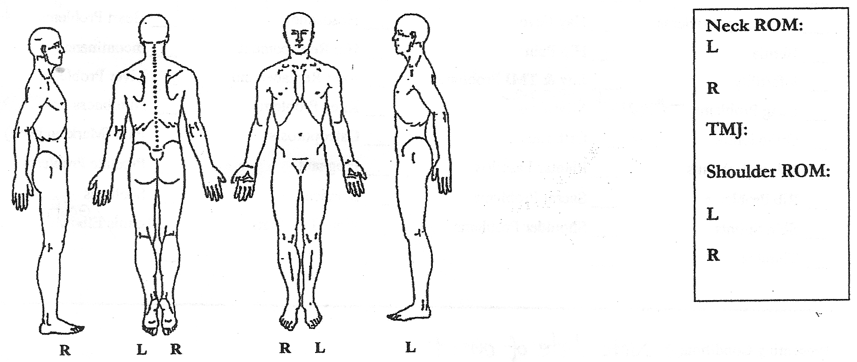
Pain intensity scale –
(2) Mild pain (annoying, nagging)
(4) Discomforting (troublesome, numbing)
(6) Distressing (miserable, agonizing, gnawing)
(8) Intense (cramping, dreadful, horrible)
(10) Excruciating (tearing, crushing, unbearable)

Current medications (it is sufficient to state purpose, such as cholesterol, high blood pressure, osteoporosis): _____________________________________________________________________________________________
Recent hands-on modalities received: _____________________________________________________________

I have stated, to the best of my knowledge, my known medical conditions. I understand that Bowenwork is given for the purpose of stress reduction, relief from muscular tension and/or spasm, facilitation of circulation and energy flow, and relief from stiffness. I understand that the practitioner does not diagnose illness or disease, nor treat specific physical or mental disorders. I will inform my practitioner of any changes in my condition, and will contact my practitioner should I have any concerns.

Signature_______________________________________________________________Date___________________

