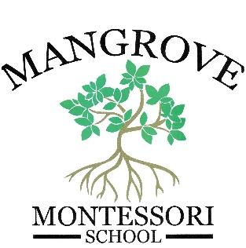

Sunscreen/Bug Repellent Permission Form

I give Mangrove Montessori personnel permission to apply sunscreen and/or insect repellent to my child _______________, whenever it is deemed appropriate by the staff members. I also agree that all sunscreen and insect repellent will be provided by me or my representative in the original container, with a valid expiration date, when applicable. The container(s) will be clearly labeled with my child’s name and will be given directly to an appropriate staff member.

Special instructions and/or specific restrictions related to my child.

____________________________________________________________

____________________________________________________________

________________________
Parent/Guardian Signature Date

________________________
Printed name of Parent/Guardian

