**Newsletter #4**

Welcome to Edition 4 of our 2019/20 LPCC newsletter.

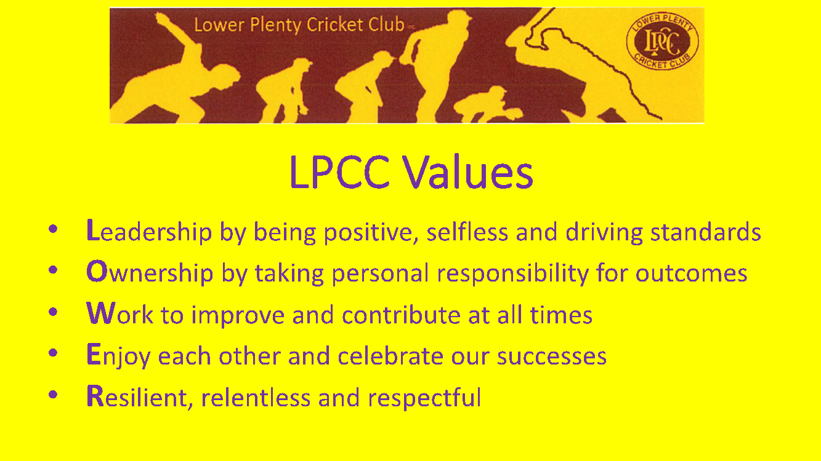

**News**

Season’s greetings to all Lower Plenty members and their families.

We ended 2019 with a bang. The **Christmas Party** held on 21 Dec was a big success with good attendance, activities for the youngsters, Santa arrived in a fire truck, Will Pyers provided the musical entertainment, and plenty of bargains at our silent auction.

We also held our $3k Reverse Drawand Ladies Relaxation Evening since our last newsletter – thanks to everyone who attended or helped pull these together.

**1st round after Christmas**

* Money Shield v Mill Park (home) 11 & 18 Jan
* C Grade v Old Paradians(home **@ Beale**) 11& 18 Jan
* F Grade v Whittlesea (home) 11 Jan
* G Grade v Macleod (away @Banyule Flats) 11 Jan

Junior matches recommence on Wed 29 & Fri 31 January.

**Latest results**

The last two rounds have seen losses to Lalor Stars and Bundoora United for the Money Shield team. Al Horner has returned to the side, making an immediate impact with two 40+ scores, and Sira and Zaf continue their good form – Zaf falling just 7 runs shirt of a ton v BU. The bowlers, led by Heata, are toiling away often unrewarded. We enter a run of winnable matches immediately after Christmas, so let’s get behind the lads.

**T20**

We went into match 3 with a 0-2 record, but what a performance v Barclay side Plenty on 10 Dec v Plenty! Led by marquee player Jevon Kett who smashed an amazing 130 of just 62 balls, we amassed 4/196 off our 20 overs. Pistol Carlyon, Max Hughes and Al Horner were all among the wickets as we dismissed Plenty for 130 to score a comfortable, well deserved victory.

The 2s notched their maiden C Grade win in style with an outright victory v Mill Park. Pikey picked up 5/15 in the 2nd dig and was well supported by young Al Campbell, Lithsi and Syed. With the bat, youngsters Chilli and Jimmy C are performing with support from Trav Lambert and a great cameo by Syed v Banyule.

The 3rds are making their charge, now sitting comfortably in the top 4. It’s been a pretty even effort by these boys – Charmer and Gilly have been among the runs – while all bowlers have contributed at stages including new boys Mo & Glen plus juniors Luke Robbo and Harry Reid.

The 4ths results are inconsistent – to be expected with a young and inexperienced side. Geoff continues to lead the way with the bat and Chess and Thanu providing good support. Youngsters Harry (42 no), Cal (43 no), Tynan (29 no) and Jack (70 no) are showing signs of batting improvement, as is Jack Nailer with the ball - very promising. Brodie James recently made his senior debut, scoring a well-made 11 and sharing a (brief) partnership with his dad Craig.

The 4ths hadn’t won a game for a couple of seasons, so we’re rapt to see them with 4 victories in the 1st half of 19/20 – well done guys.

**Junior report**

Well the heat brought a slightly frustrating end to what was an excellent first half of the season for our juniors.

The previous week was one of our best for the season with all four Friday teams winning comfortably and some great individual performances. The two Wednesday teams have also been progressing well under the guidance of long-term club members and key players, Brent Zerafa and Gaven Brown.

The Junior Blast program has also been going great guns with club stalwart Jason Meckharoff being ably supported by a pool of senior players.

We now have a very long break until the juniors’ re-start (29th January for the Wednesday teams and 31st January for the Friday teams) so please encourage the boys to keep training over the holidays. This will let us come back after the break with the same momentum we finished with. For those boys playing seniors, the season restarts on January 11th.

We have given senior debuts to a number of junior players this season, the latest being Brodie James (U14s) and we may have one or two more before the season is over. Many of these boys have now established themselves as senior players, especially in the 3rds and 4ths, and this is exactly what we want as a club – a clear pathway for all of our juniors to play senior cricket at LPCC and hopefully go onto play in our 1s and 2s, as a number of our U18s and U16s have been already this season.

In other good news, three of our juniors will be playing in the VMCU inter-association tournament in January as part of DVCA representative teams – Alex Campbell (U14s), Matt Carlyon and Will Addison (U18s). This is a fantastic achievement by these boys and we are very proud of them. Although we are not a large club, we generally manage to get a few boys into the DVCA rep teams each year and this is a great reflection on our junior coaches. I’d also like to note the boys who made the DVCA rep training squads but did not make the final teams – this is in itself a big achievement. I will be consulting with all coaches at the end of the season for their recommendations for rep squads for next season.

I’d like to thank all the junior families that attended our recent social events, the $3k draw and especially the Christmas Party. Both events were a lot of fun and we really appreciate the support shown by everyone.

A few final items for you:

1. MyCricket results and statistics – we (along with the rest of the country) have had some major technical issues with junior player data, which was caused by changes made by Cricket Australia to MyCricket. We now have a fix which will be put in place over the break.
2. Potential LPCC Girls’ team – we would love to enter a girls’ team as soon as possible (maybe even next season) and I’d like to gauge potential player numbers – if your daughter, niece, cousin, friend, teammate from footy, soccer..etc is keen to give cricket a try, please send details to [juniors@lowerplentycricketclub.com](mailto:juniors@lowerplentycricketclub.com) and we’ll see if we can get a team up.
3. Farewell to one of our 2018/19 U12 Premiership players – Charlie Klavins, who is relocating to NSW. Charlie was one of three players in that team who won a flag in their debut season so he will leave the club with some great memories.

See you in January

Luke Preston

**Social events**

We’ve got plenty of functions ahead – there’s something for everyone in this lot, so please take note and put the dates in your calendar.

**Steak & Punt Night**

This was originally pencilled in for 10 Jan but as many are still away we’ve pushed it back to**24 Jan** - the eve of the long weekend, with no 3s or 4s matches the next day.

New club member Carl Breitenbach is a competition BBQist, who does amazing things with beef and has volunteered to feed us all.

It’s a Moonee Valley night meeting and a long weekend - this is generally a great social night. Email us on [operations@lowerplentycricketclub.com](mailto:operations@lowerplentycricketclub.com) if you’re coming to help Carl prepare.

**Bogan Bingo**

This could be the social highlight of the year on **Sat 1 Feb.**

Bogan Bingo is not your ordinary bingo night. It is half game show and half party. The show is designed to get people in touch with their inner bogan.

There will be jokes, tributes, audience interaction, a spontaneous air guitar competition and a fashion parade.

Bogan Bingo is critically acclaimed - it’s been featured on television shows like Getaway, A Current Affair and Australia's Got Talent.

Tickets are $30 - it’s restricted to people aged 18 and above.Get your Tickets via this link: <https://www.trybooking.com/BHKRC>

**Pink Stumps Day**

We’ll wear the pink shirts when we take on Banyule at home on **Sat 15 Feb** to raise funds for the McGrath Foundation’s breast cancer awareness.

We’ve had a good response for match day shirt sponsors - 26 is the best we've managed thus far, so thanks to those who have chipped in.

We’re also hosting a luncheon on 15 Feb with guest speakers - it will be Damian Fleming (pending Big Bash commitments, but similar if he can't make it) plus a rep from the health industry.

Tickets are $100/head and all monies raised will be donated.

We’ll have some exciting auction items (but welcome any additions people might want to donate)

Please join us if you can - reply to [operations@lowerplentycricketclub.com](mailto:operations@lowerplentycricketclub.com) to help us confirm numbers for catering.

**Lions Den**

Sira and Eggy are plotting a special Lions Den event for **22 Feb**(Day 2 of Money Shield v Banyule).Details TBC

**Old Man v Redneck Cafe**

Becoming an institution at Lower - it's fine dining v the BBQ crowd as we wrap up the season for those not in finals.

Bogan v  Bourgeois: Melbourne v Merlot, Dim Sim v Double-cooked pork, Barnes v Bocelli…. which camp are you in?**Sat 1 Mar** at the club.  Come on down.

**Presentation Night**

Details TBC but we’re working on **28 March.**This year will be a sit-down meal, potentially at Greensborough RSL - we’ll confirm asap after we book.

This will be a special evening as we will be introducing a Lower Plenty Cricket Club **‘Hall of Fame’** and we will induct an initial three on-field legends (nominated by a selection panel).

It would be great to get as many members as possible to attend and make it a special night for three LPCC legends and their families.Again, reply to [operations@lowerplentycricketclub.com](mailto:operations@lowerplentycricketclub.com) to help us confirm booking numbers.

The full Social Calendar is available on our website at: <https://www.lowerplentycricketclub.com/2019-20-social-events>

**Sponsor of the Week**



Quest Apartments have come on board this season as a major sponsor of the LPCC.

Quest Bundoora serviced apartment style hotel rooms offer guests a relaxed and comfortable Bundoora accommodation experience perfect for short or long stays.

Quest Bundoora is located within an easy walk to University Hill Town Centre, Uni Hill Conference Centre, Brand Junction and Tram Route 86 to Melbourne CBD and Docklands, minutes from RMIT University Bundoora Campus, La Trobe University Bundoora Campus and Greensborough Watermarc Aquatic Centre.

Thanks Mark O’Shea and his team at Quest Bundoora.

**Club Apparel**

The club has a range of club apparel available – playing shirts, social shirts, shorts, hoodies, beanies, stubby holders etc.

See Josh Ryan for orders or requests.

**Good Sports**

Sporting Club's such as ours play a significant role in the community and have a responsibility to their members and their families. We have chosen to join over 9000 clubs across Australia taking part in the Good Sports Program. Through Good Sports we are committed to managing alcohol responsibly and ensuring smoke free areas, which we believe will help us to provide a healthy, safe and family friendly environment. Together, we are helping inspire a healthier sporting nation.

Speak to the Club Committee about what being a Good Sports Club is all about or visit [Good Sports](https://www.goodsports.com.au/)

**Business Partners**

The LPCC thanks the following generous business partners, whose support is vital to sustain our operations.

We encourage all club members to be aware of these organisations and utilise their services whenever possible.

















**Genesis Cricket Australia**