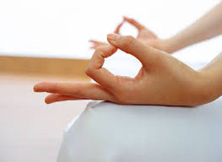
Dynamic Hasta Mudra (moving hand seal)
We have been practicing this mudra during the autumn to remind us of the cycle of the seasons and to recognise the inevitable changes occurring throughout our own life-cycle. It is a lovely practice to prepare you for both meditation and relaxation, but can be enjoyed at any time of the day, and in any position, for example, lying down or sitting. It promotes concentration and creates inner relaxation, promoting brain activity and relaxing the nerves. The added single syllable mantras can be said inwardly or out loud on the exhalations.
Rest the backs of hands comfortably on legs. During each exhalation, place one of your fingertips on the tip of your thumb, while inhaling, extend the fingers again.
Saaa means ‘infinity, totality,’ and is used when the index finger and thumb connect
Taaa means ‘life, birth’ and is used when the middle finger and thumb connect
Naaa means ‘death, transformation’ and is used when fourth finger and thumb connect
Maaa means ‘rebirth’ and is used when the little finger and thumb connect.
The second time of doing it, the thumb nail touches the tips of the fingers, and the third time, press your finger into the palm with the thumb over the top.

You could do one, two or three rounds, either using ujjayi (victorious) breath, or with a slow, even, relaxed breath.

From Mudras – Yoga in your Hands by Gertrud Hirschi
Weiser Books (2000)

Clare Badham
October 2014

