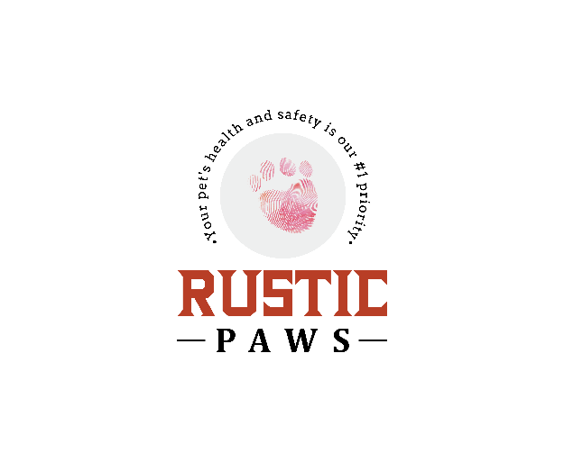
GROOMING CONSENT FORM

Thank you for choosing Rustic Paws to be your pet’s beauty spa. Your pet is very important to us, we would like to assure that every effort is made to make your pet’s grooming experience as safe and pleasant as possible. In order to maintain a safe, comfortable environment, we do require all pets to be current on their vaccinations and to wait at least 48 hours after shots before checking in. Please provide us with a copy of your pet’s vaccination record. Before grooming, please read and agree to our terms of service:

Health/Medical Problems or Senior Dogs:
Grooming procedures can sometimes be stressful especially for a senior dog or dogs with health problems. Because of this, grooming can expose hidden medical problems as well as aggravate a current one, whether it be during or after the groom. Because senior dogs and dogs with health problems have a greater risk of injury, these dogs will be groomed for cleanliness and comfort as Rustic Paws will not compromise any dog's health and/or wellbeing to achieve “the perfect groom”. The dog owner will advise Rustic Paws of any medical, physical, emotional issues, allergies, sensitivities, or pre-existing conditions. These conditions may include, but are not limited to prior surgeries, hip and/or joint issues, warts, moles, ear infections or skin problems. The owner will also inform Rustic Paws of new conditions as they arise. Rustic Paws will not be responsible for accident or injury to an elderly or health-compromised pet during their grooming. By signing below, the owner is stating that Rustic Paws has permission to groom their senior dog and has discussed any and all (past and present) health problems.

Fleas/ Ticks:
If fleas are found on your pet, it is Rustic Paws policy to give a flea bath at an additional minimum cost of $15.00. We will notify you if possible. This cost covers the special shampoo; time and extra clean up to insure no fleas or ticks are active in our spa. Flea shampoo kills the fleas on the pet, if fleas are in the home/pet area, the flea shampoo will not protect the pets(s) from them once they leave the unit. If Ticks are found we will remove them for no extra charge and the owner will be notified.

Matted Dog Policy:
Pets with matted coats will require extra attention. If the matting is minimal and the pet responds well we may brush them out for an extra fee ($17+). If we do not believe we can remove the mats in a timely manner or we feel your pet is in pain, we will not continue and will clip short/shave. We firmly believe grooming should be an enjoyable experience and will not put your pet through the discomfort of unnecessary dematting. We will notify you before shaving your dog, if permission to shave down is denied, your pet will not get a bath or haircut and must be picked up as is. There is a greater risk of nicking, scratching, cuts etc; to a matted dog during the grooming process. In addition, the skin may appear red, itchy and irritated due to the lack of oxygen reaching in and under the mats. Rustic Paws will not be held responsible for any injury sustained while grooming a matted dog, including any after effects. Rustic Paws will be happy to demonstrate some effective brushing techniques for matting prevention. Regular brushing at home with a brush and comb as well as keeping your pet on a 4-6 week grooming schedule will help prevent matting.

Accidents:
Although accidents are very rare, there is a risk when dealing with pets. Grooming equipment are sharp, and although we use extreme caution and care in all situations, possible problems could occur including cuts, nicks, scratches, quicking of nails, etc. In most cases this can happen when a pet is wiggling or moving around. Any incident, no matter how small will be communicated to the pet owner. If necessary, Rustic Paws will transport your pet to a veterinarian. Any veterinary bills resulting from a pet being matted, elderly, aggressive, a difficult temperament or from a preexisting or unforeseeable condition will be the sole responsibility of the owner. Your pet’s safety and comfort is our number one priority. In the event an accident does occur, you will be notified of the accident.

Use of Muzzle:
Muzzling does not harm your pet and protects both the pet and the groomer. In some cases, muzzling may even calm a stressed animal, allowing the grooming process to continue. If your pet still acts in a way that is dangerous, Rustic Paws has the right to stop grooming services at any time and a service fee will be collected. We do not muzzle unless your pet gives us a reason to.

Dangerous/Aggressive Animals or Behavior Issues:
Owner MUST inform Rustic Paws if your pet bites, has bitten, is aggressive, unpredictable and/or has any other behavioral issues. If owner fails to notify us of any potential danger or behavioral issue, you can and will be liable for all medical fees, out of work compensation, as well as any and all property damage. We will make every attempt to groom uncooperative pets, but we may not be able to complete grooming on pets that pose a threat to themselves, other pets or our groomers. We reserve the right to muzzle any dog for their safety, and ours. Extremely aggressive and unruly pets will NOT be groomed. If a dog is felt to be exhibiting behavior that is unsafe in regard to itself or the groomer, it may be in the best interest of the pet that the groom be stopped. A fee will be charged dependent on work completed up to that point. All bites will be reported to the local authorities as required by law. Rustic Paws has the right to refuse grooming services, stop grooming services, or cancel grooming services at any time before, during, or after grooming and client will be charged a grooming fee for what was done up until that point. We never sedate your dog.

Late pick-up:
When dropping off your pet we will give a timeframe of when we anticipate completion of services. Please keep in mind that grooming can be a very time consuming and unpredictable process depending upon the dog’s behavior and the condition of the coat, as well as when clients arrive for their appointments. We will do our best to manage to the approximated time given but please understand that factors outside of our control can influence how long the process may take. All pets brought in for grooming must be picked up within one (1) hour of the time the client is informed the pet is ready. Pets remaining after that time a fee of $15 will be charged. We do NOT have boarding services at Rustic Paws and we are not hold responsible for anything that happens while your pet is waiting to be picked up. Unfortunately, we can’t keep pets that are noisy longer than their grooming time; all pets that have been classified as noisy will be done within 3 hours and MUST be picked up within 15 min of call time.

No-shows/Cancellations:
Please give us at least a 24-hour notice if you cannot make it to your appointment. The 1st time you are a no call/no show we will add a $20.00 charge to your next grooming appointment. The 2nd time you are a no call/no show we will add a $35.00 charge to your next grooming appointment and you will be required to make a down payment of 50% of estimated grooming fee. After the 3rd no call/no show you will be required to prepay for all your future appointments with a charge of $50.00 applied to first groom appointment.

Satisfaction:
Your satisfaction is important. If you are unhappy for any reason, and would like something adjusted, we will be happy to make any adjustments when you pick-up your pet from his/her appointment. Once, however, you take your pet home from the appointment, we will only accept return visits for adjustments 24 hours after your appointment. Any adjustments after will be charged a grooming fee of some kind. Rustic Paws may take pictures of your pet, before and after grooming, for my website, advertising and education.

By signing below, you indicate that you understand and agree to our terms of service; that you understand and agree to release and hold harmless Rustic Paws, its owners, employees and affiliates from and against any and all liabilities, expenses, damages, and costs (including attorney fees) resulting from any service provided or injury (including death) to your pet(s) while in our care or afterward.

(owner’s printed name)

(owner’s signature)

(pet’s name)

Miscellaneous:

Are there any specific issues your dog has had with prior grooming?

Any special instructions you would like to advise us about?

Any other information that your groomer should know or be made aware of?

April Becker DBA Rustic Paws

(date)

