Intentional Acupuncture
Intake Form

Name: Last_____________________ First: ______________________ Gender: F M

Date of Birth ____/____/_____ Age _____ Email Address: ______________________

Address ________________________________________________________________

City___________________________________ State_________ Zip Code___________

Telephone Home ___________________________ Cell _________________________

In an Emergency, Notify: Name____________________________________________

Phone Number_____________________________ Relationship___________________

- Main problem you are seeking treatment for today: ____________________

- How long ago did this problem begin:___________________________________

- Have you been given a diagnosis for this problem? When?__________________

- Are you currently receiving treatment for your problem?____________________

- If so, please describe:________________________________________________

- Name of Practitioner: ________________________________________________

- Is this Practitioner aware you are seeking Acupuncture for this condition? Y N

Past Medical History

Illnesses:________________________________________________________________

________________________________________________________________________

Surgeries:_______________________________________________________________

________________________________________________________________________

Significant Trauma (auto accidents, falls,…)____________________________________

________________________________________________________________________
Do you have, or have you ever had any infectious diseases? Y N

If yes, please describe:_____________________________________________________

Medications (prescription, over the counter, vitamins, herbs,... taken within the last three

months) ________________________________________________________________

_______________________________________________________________________

Allergies: _______________________________________________________________

________________________________________________________________________

Family Medical History :General Health

Mother: ________________________________________________________________

Father: _________________________________________________________________

Brother(s): _____________________________________________________________

Sister(s): _______________________________________________________________

If any of the above is deceased, what was the cause? _____________________________

________________________________________________________________________

PERSONAL HISTORY

Childhood Health: ________________________________________________________

_______________________________________________________________________

Current Emotional Health: Rate on a scale of 1 (none) to 10 (significant amount)

Mood Swings:_____________ Nervousness: ________________

Mental Tension: ___________ Quality of Life: ______________

Quality of Significant Relationship: ________________________

Predominant Emotion: _________________________________________

Occupation: _________________________________________________________

Work-related Stress Level: (1-10)_______ Marital Status: S M D W
Other Life Stressors: __________________________________________________

Hobbies and Recreational Habits: ________________________________________

____________________________________________________________________

Do you have a regular exercise program? Y N ____________________________

Smoker? Y N ______________ Alcohol intake: _________________________

Neuropsychological (please circle any that you are experiencing Now, and Underline any you have experienced in the past)

seizures area of numbness anxiety concussion lack of coordination

dizziness poor memory depression fainting loss of balance

migraines disorientation headaches vertigo easily angered

Have you ever been treated for emotional problems? Y N

Have you ever considered suicide? Y N Have you ever attempted suicide? Y N

Any other problems or nervous habits? _____________________________________

Pregnancy and Gynecology

Age at First Menses _____ Days Between Menses_______ Duration of Menses______

Heavy Flow ___ Light Flow ___ Spotting Between Menses ___ Irregular Menses ____

Clotting _____ PMS Symptoms ______ Breast Lumps _____ Nipple Discharge _____

Painful Periods _______ Vaginal Discharge ________ Difficulty Conceiving ______

Number of Pregnancies____ Number of Births _____ Miscarriages ____ Abortions___

Difficult Pregancies _____ Difficult Labor and Delivery ______

Birth Control? Y N What type? _____________________________ How long? ______

First Date of Last Period: ___/___/______ Date of Last PAP Smear ___/___/_____

General (circle any you have experienced in the last three months)

Fever Change in Appetite Dream Disturbed Sleep Tremors

Chills Night Sweats Day Sweating Weight Loss

Fatigue Poor Sleep/Insomnia Depression Weight Gain

Seizures Emotional Changes Poor Appetite Headaches

Bruising Poor Balance Muscle Weakness Joint Pain

Thirst for Hot Drinks Thirst for Cold Drinks

Sudden Drop in Energy-time of day? ____________ Hours of Sleep Per Night ______

Head (circle any you have experienced in the last three months)

Eye Pain/Strain Floaters in Vision Glasses Contacts Tearing Dryness

Impaired Hearing Ear Ringing Earaches Ear Itching Headaches Sinus Pressure

Nose Bleeds Frequent Sore Throats Teeth Grinding TMJ/ Jaw Pain Hay Fever

Cardiovascular (circle any you have experienced in the last three months)

Chest Pain Low Blood Pressure High Blood Pressure Irregular Heartbeat

Dizziness Difficulty Breathing Swelling of Hands Palpitations

Fainting Cold Sweats Swelling of Feet Cold Hands/Feet

Respiratory (circle any you have experienced in the last three months)

Difficulty Breathing Shortness of Breath Pain with Deep Breath Chronic Cough

Asthma Bronchitis Coughing Up Blood Phlem Production

Pleurisy Pneumonia Frequent Common Cold

Easily Winded with Exertion Difficulty Breathing when Laying Down

Gastrointestinal (circle any you have experienced in the last three months)

Nausea Abdominal Pain Vomiting Constipation Indigestion Belching

Ulcers Blood in Stool Bad Breath Diarrhea Hemorrhoids Bloating

Gas Cramping Gall Stones Hepatitis B or C

Genito-Urinary (circle any you have experienced in the last three months)

Pain on Urination Decrease in Urine Output Urgent Urination Frequent Urination

Blood in Urine Urinary Incontinence Waking to Urinate at Night UTI

Kidney Stones Yeast Infections Prostate Enlargement Impotency

Musculoskeletal (circle any you have experienced in the last three months)

Muscular Weakness Muscle Cramps Muscle Spasms Muscular Atrophy

Injuries/Falls Sprains/Strains Broken Bones Joint Instability General Aches

Please circle on the diagram any areas of pain or injury. Please try to describe the type

and quality of the pain:___________________________________________________

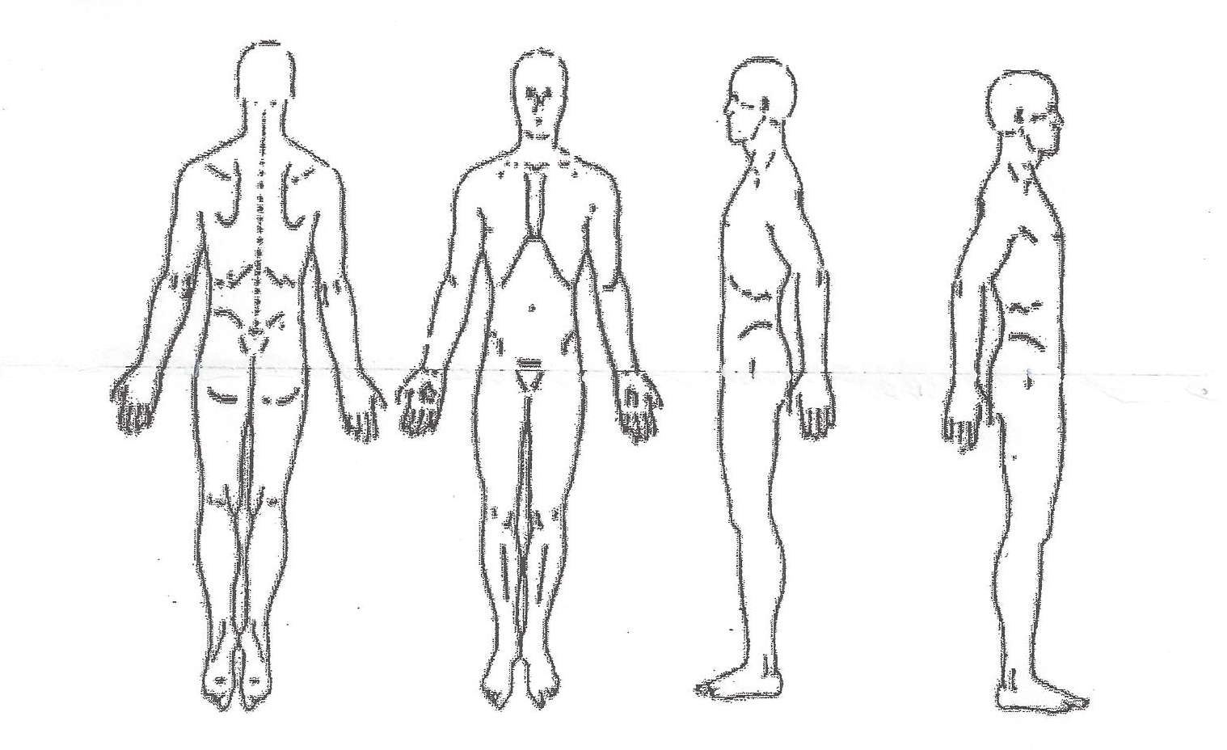

X______________________________________________________________________
Patient’s Signature Today’s Date

