Newsletter #5

Welcome to Edition 5 of our 2019/20 LPCC newsletter.

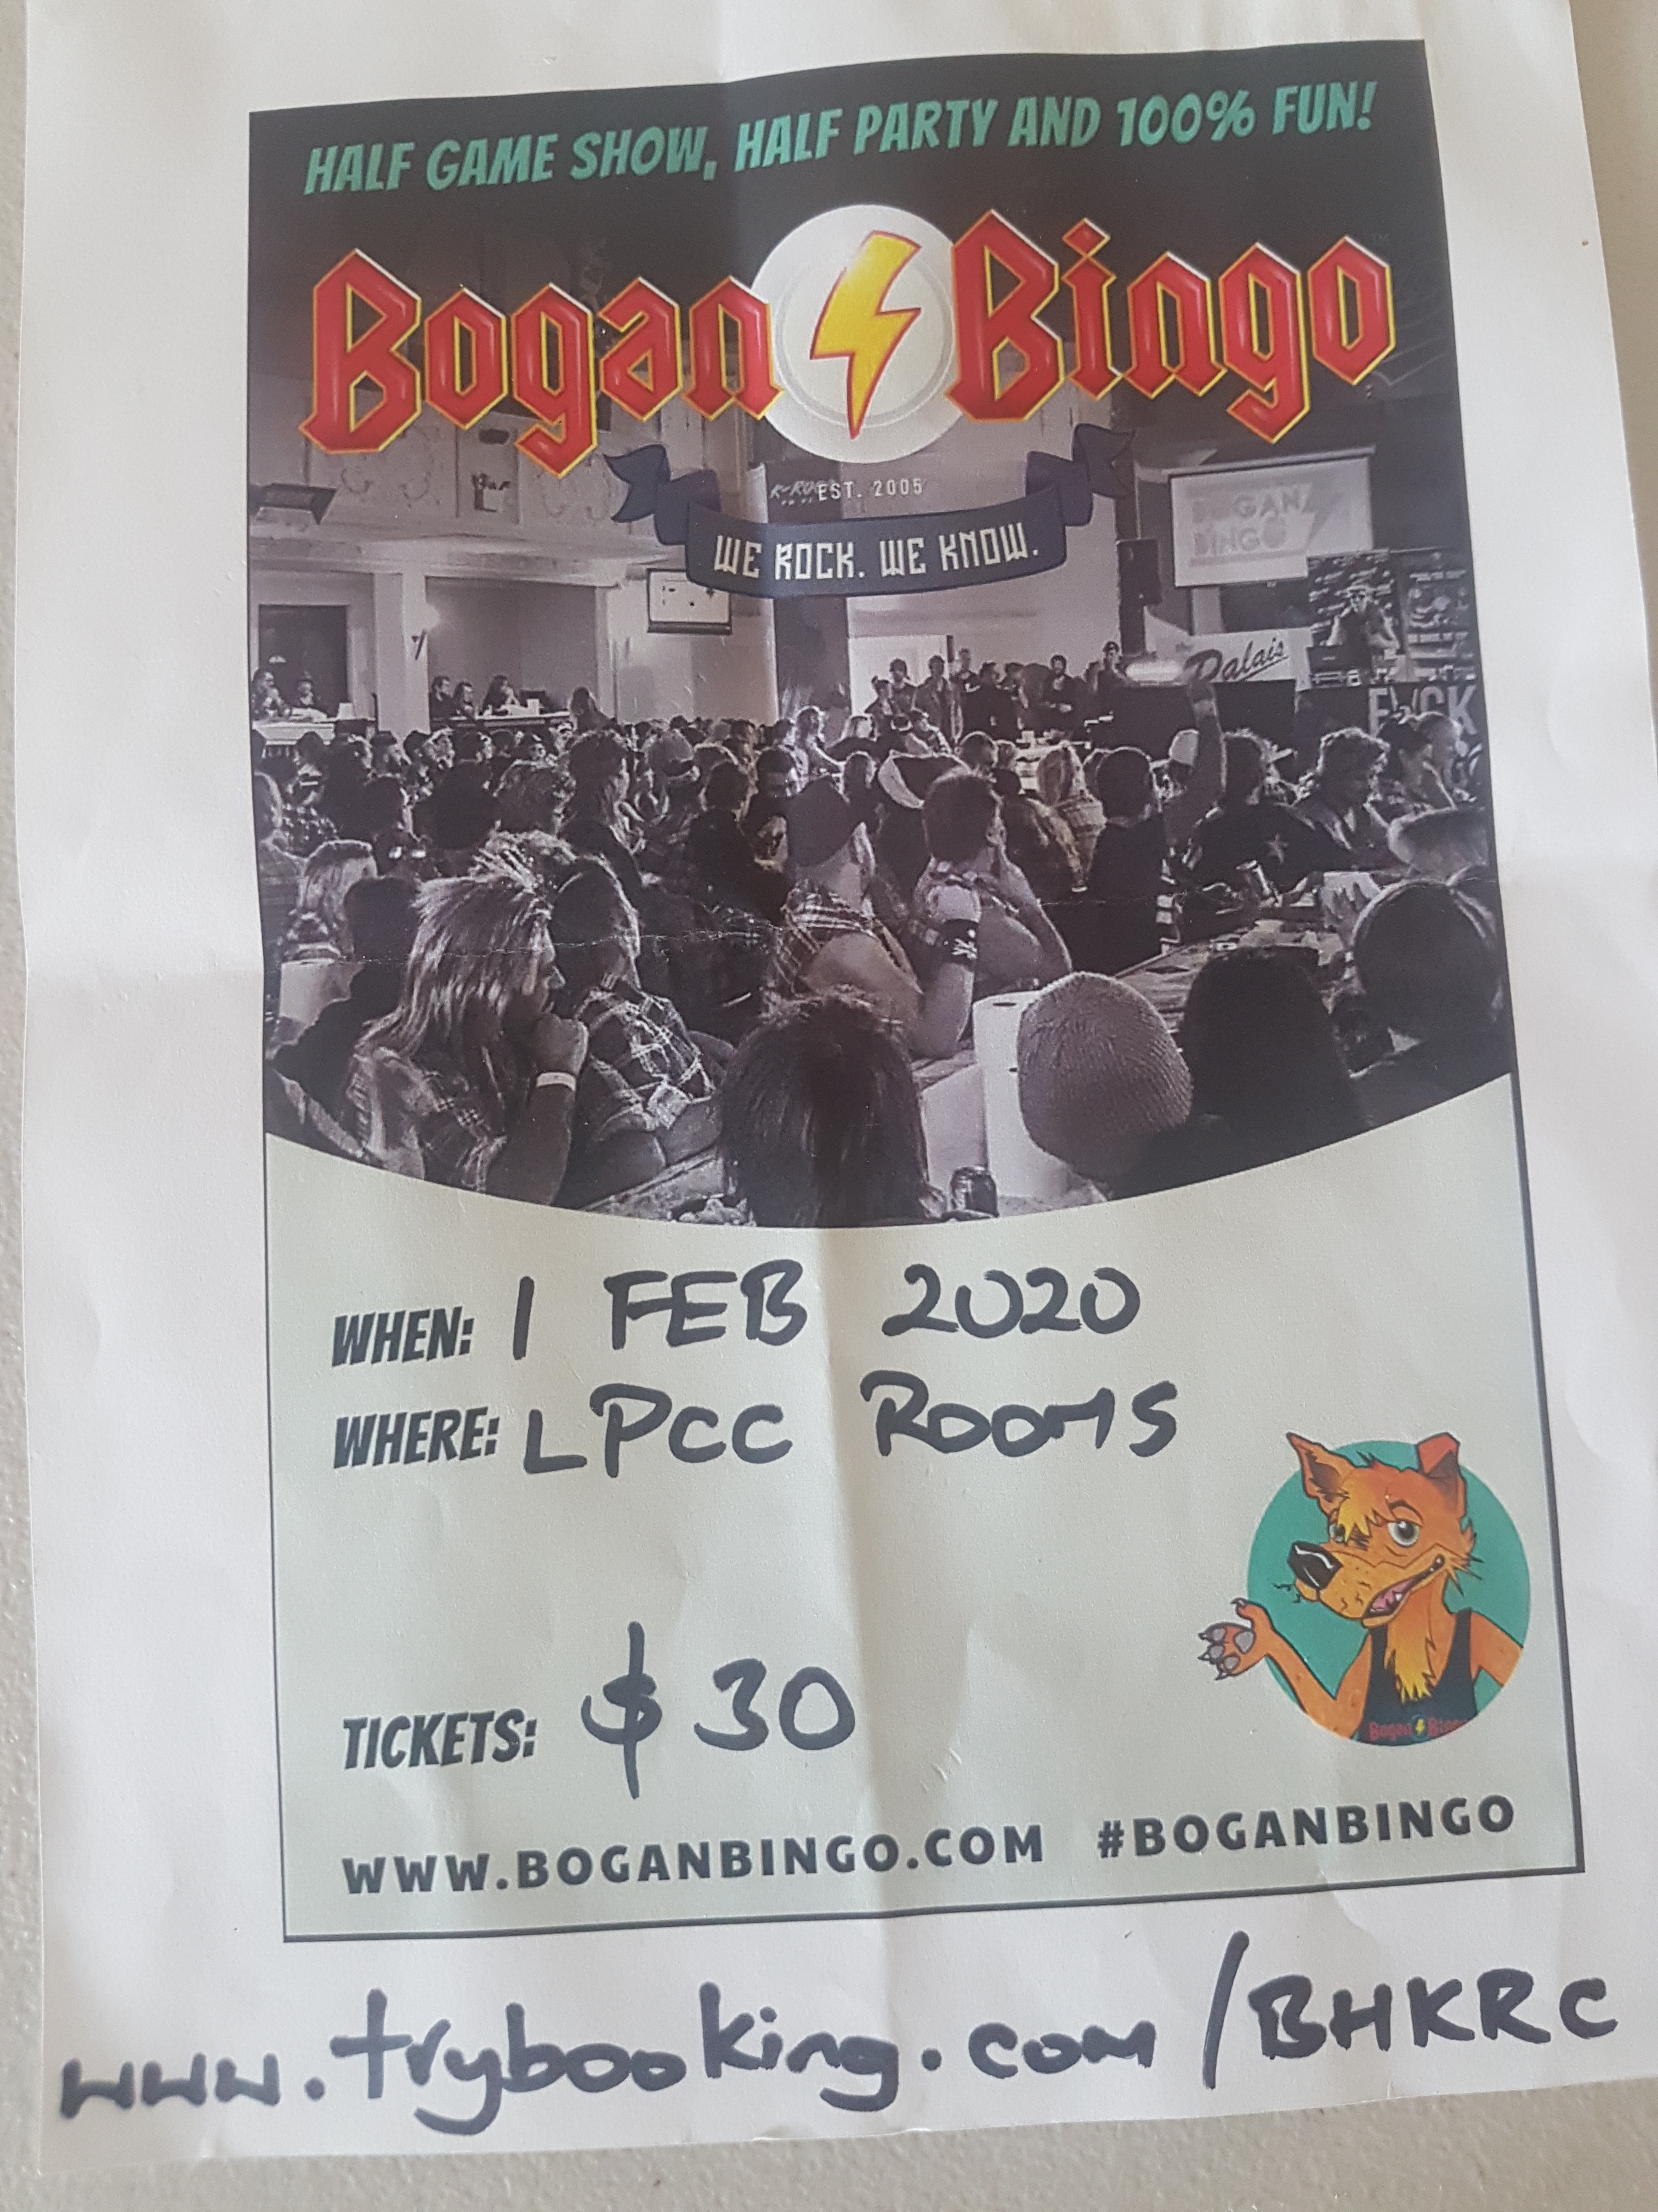

It had to happen… Bogan Bingo finally comes to Lower.

This Saturday night (1 Feb) from 7pm. Bring your mullet, moccies and flannels (and your mates). This will be a LOT of fun, so make the effort to attend and make it a ripping night.

$30 / head, with VB and Jack Daniels at bar prices. (Ok, we’ll stock other beverages as well…)

News
Please make an effort to attend the above function. It will be the event of the year if we want it to be. We’re on a roll after a cracking Steak & Punt night last week – more below.

The start to 2020 has delivered a few firsts for the Lower lads. Among these:

- Our Money Shield boys cracked it for their first win,
- Lithsi Calder and Max Hughes played their first A Grade games,
- Jimmy Carlyon notched the club’s first century for the season, and his first of many.

The Juniors start back this week, weather permitting but over the break, we had three players participate in DVCA junior representative sides:
- Matt Carlyon and Willoughby Addison played in the U18 team which made the semi-final, and
- Alex Campbell was a strong contributor on the U14 side that missed out on finals

Next round
- Money Shield v Old Paradians (away)
- C Grade v Bundoora United (away)
- F Grade v Heidelberg (home @ Lower)
- G Grade v Laurimar (home) 11

Latest results
The last two rounds have produced extreme highs and lows for the senior team.

Our win against Mill Park was outstanding and got us of the bottom of the ladder. Debutante Lithsi led the bowling with 4, with great support from Bill Jenkin with 3 (that is not a typo!). All the boys did well with the bat, with Sira and Horner bringing it home beautifully after it got a little tense at 5 down. Great effort lads, and we celebrated accordingly.

Unfortunately, we couldn’t back it up the next week in the one-dayer v Mernda. !33 runs wasn’t quite enough, though we made them work for it going to down by just two wickets in a thriller. Max Hughes showed great promise, taking 2-11 in his debut match.

We find ourselves back in the relegation mix, so this week’s match v OP is vital. We’d appreciate all the support we can get.

The 2s have completed two comfortable wins post-Christmas, which has been great but also frustrating as performances like these earlier may have seen us in the finals mix. We accounted for OP’s in Round 9, with Maxie Willis taking a 3fa before Jimmy & Gilly smashed their attack, supported by Chilli & Doc – passing them 4 down.

The next match was the Jimmy Carlyon show v Mill Park. When he was our 6th (and last) man out at 209, he’d notched 135 of them in a masterful display. The kid’s last three knocks have been 79, 55 and 135 – pretty compelling… After Jim’s performance, the spin-twins Willo and Max took 5 between them to make sure we were never in danger.

There were no matches for 3 s or 4s over the Oz Day weekend but they’ve both had 2 one-dayers since Chrissie.

The 3s have slipped out of the top 4 following consecutive defeats. The home match at Central v Whittlesea saw Captain Carl & Occa both score 40’s but not enough to defend as it turned out - Al Campbell being our best bowler with 2 wickets.

116 v Riverside the following week (Max Hughes 31) was also not good enough as they passed us 4 down.

Geoff’s 4s chased a whopping 201 in their first one back – this would have been much more had it not been for young Alex Preston taking an impressive 3-19 off 7 (look out for this kid!) The old brigade; Geoff, Jamie Chilcott, Thanu, and Craig James all batted well as we got to a respectable 139 but the task was too big.

The next round was tough. Tynan and Jack led the batting to finish on 6/82 at Banyule Flats. With the ball…. yep, Alex Preston did it again: 3-11 off 7, and well supported by Thanu with 2fa.

We’re clearly seeing plenty of development among our younger players, in all grades, and this is particularly pleasing.

Social events

Steak & Punt Night
This was a great success last Friday. Carl Breitenbach did an amazing job, cooking 40 magnificent scotch fillets that were appreciated by all. Angie Forde matched his expertise with beautiful potatoes, salads and a grazing board to compliment.

Thanks Carl and Angie – you’ve assured this will be a must-attend event next season.

Bogan Bingo
Per the flyer above, this could be the social highlight of the year on Sat 1 Feb.

Get in touch with your inner-bogan. Mullets, moccasins, flannels etc. Maybe contact Darren Kane if you’d like to borrow something from his wardrobe?

There will be jokes, tributes, audience interaction, a spontaneous air guitar competition and a fashion parade.

Tickets are $30 – having spoken with organisers we’ve decided to allow 16-18 year olds to attend (with parent’s permission).

Get your Tickets via this link: https://www.trybooking.com/BHKRC

Pink Stumps Day
We’ll wear the pink shirts when we take on Banyule at home on Sat 15 Feb to raise funds for the McGrath Foundation’s breast cancer awareness.

We’re still planning to host a luncheon on 15 Feb with guest speakers (unfortunately Damien Fleming now has a clash, so we’re sourcing a replacement) but we need to be guided by potential numbers if it is to work. Please let us know if you might attend and support this worthwhile cause.

Tickets are $100/head and all monies raised will be donated.

Please reply to operations@lowerplentycricketclub.com to help us confirm if it’s viable.

We’re raffling a beautiful pink Genesis cricket bat (value $900), a Quest Apartments voucher (value $500) and an Auto Clinic car service voucher (value $100), all donated by generous club sponsors. Drawn on 15 Feb, tickets are now available from the club: $10 each or 3 for $20. All proceeds go to the McGrath Foundation.

Lions Den
Sira and Eggy are plotting a special Lions Den event for 22 Feb (Day 2 of Money Shield v Banyule). Details TBC, but keep it free.

Old Man v Redneck Cafe
Becoming an institution at Lower - it's fine dining v the BBQ crowd as we wrap up the season for those not in finals.

Bogan v Bourgeois: Melbourne v Merlot, Dim Sim v Double-cooked pork, Barnes v Bocelli…. which camp are you in? Sat 1 Mar at the club. Come on down.

Presentation Night
It’s a lock - 28 March at Greensborough RSL. $40 for a two-course meal and drinks at bar prices.

This will be a special evening as we will be introducing a Lower Plenty Cricket Club ‘Hall of Fame’ and we will induct an initial three on-field legends (nominated by a selection panel).

It would be great to get as many members as possible to attend and make it a special night for three LPCC legends and their families. Again, reply to operations@lowerplentycricketclub.com to help us confirm booking numbers.

The remaining 19/20 Social Calendar is available on our website at: https://www.lowerplentycricketclub.com/2019-20-social-events

Sponsor of the Week

We love supporting local businesses in our community and Lower Plenty IGA is a long-time partner of the LPCC.

Drop in to see Jack and Cornell in the Main Rd shopping centre for groceries and/or great price beer, wine and spirits.

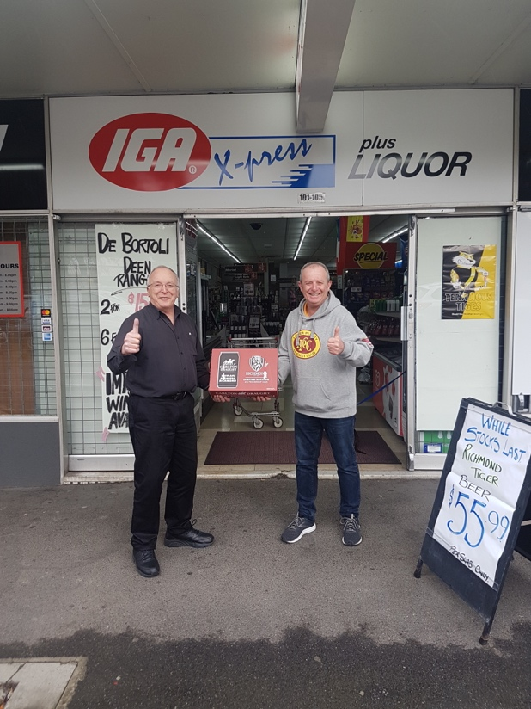

Club Apparel
The club still has a range of club apparel available – playing shirts, social shirts, shorts, hoodies, beanies, stubby holders etc. See Josh Ryan for orders or requests.

Good Sports
Sporting Club's such as ours play a significant role in the community and have a responsibility to their members and their families. We have chosen to join over 9000 clubs across Australia taking part in the Good Sports Program. Through Good Sports we are committed to managing alcohol responsibly and ensuring smoke free areas, which we believe will help us to provide a healthy, safe and family friendly environment. Together, we are helping inspire a healthier sporting nation.

Speak to the Club Committee about what being a Good Sports Club is all about or visit Good Sports
Business Partners

The LPCC thanks the following generous business partners, whose support is vital to sustain our operations.

We encourage all club members to be aware of these organisations and utilise their services whenever possible.

Genesis Cricket Australia

