Weston on the Green  Neighbourhood Plan | 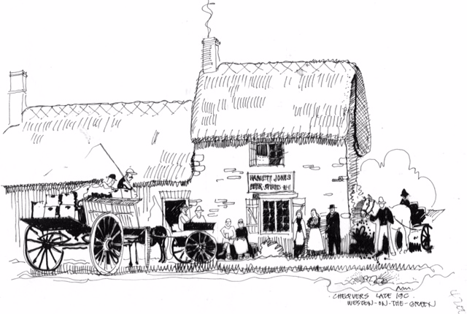

The Parish Council, as the legal body for submitting the Neighbourhood Plan to Cherwell District Council, formally presented the Plan at the end of March 2017.

The Executive Summary, along with information on where the complete document is available (either on our website or as a hard copy) was delivered to the whole village. We asked for feedback and we have had a number of responses, all of which were discussed at the May Steering Group. We will respond to every comment and amend the Plan where appropriate.

You can still make comments on the Plan by emailing the Chair at diane@wotgneighbourhoodplan.co.uk or by delivering your comments to the Village Shop. If you would like to see a hard copy of the Plan, there is one in the Church or email the Chair at the above email.

We are waiting to hear back from CDC’s Planning, and all the consultees for the NP. The Steering Group has met once to discuss changes to the plan and will make further changes as advised by the CDC.

Once these amendments are incorporated, we will formally give our plan to Cherwell District Council and the rest of the process is in their hands.

There is formal consultation period to consultees such as Heritage England and Natural England. Once this is finished it will be submitted to the External Examiner for review and recommendations. If the External Examiner authorises the Plan it will go to the village to seek approval via a referendum. We will need your support at this stage as the strength of the vote will support the Parish Council actions plans for the next several years.

As always, we will keep the village informed of all these stages via the website at http://www.wotgneighbourhoodplan.co.uk/ or go to Facebook.com, and search for Weston on the Green Neighbourhood Plan.

Dates of the next Steering Group Meetings
NB: these are draft dates and are to be confirmed. Notices will be put up around the village before each meeting.

15th June 2017
13th July 2017

They are all held at 7.30 pm in the Village Hall and open to the public.
Alex Reid

