**Little Precious Angels Childcare 2 LLC**

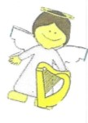

Thank you for choosing Little Precious Angels Childcare 2 LLC!

Our motto is” **Little Precious Angels, they have wings…. we give them the knowledgeable flight”.** We are committed to developing each child to their fullest potential.

At Little Precious Angels Childcare 2 LLC, we understand how difficult it can be for parents to balance work, children, and other commitments and responsibilities in their daily lives. For this reason, we strive to offer a childcare program that will enrich your child’s development (social, academically, physically, emotionally, and more) while putting your mind at ease that your child is being well taken care for. There is a large variety of toys, books, puzzles and more for children to learn, play and explore the world around them. This experience takes place in a clean and safe environment. The curriculum emphasizes learning as a fun and interactive place to grow. We want all of our children to be successful, this is why we encourage them to try. We applaud effort, not perfection in everything they do.

Please carefully read the Parent Handbook and fill out the enrollment packet. It is very important that you are informed of our policies and procedures. We look forward in being your childcare provider, working together and watching your child learn and grow.

Welcome to Little Precious Angels Childcare 2 LLC.

 

# Enrollment Agreement Packet

**What You Need to Start**

**Private Pay**

*What you need to start*

* Enrollment Forms
* Shot Records/Vaccination Records
* Physical (must state child can attend Childcare)
* $35.00 non-refundable Registration fee (family fee)
* Deposit of one-week tuition for each child attending
* First week’s tuition for each child attending
* Allergy Form with an action plan from child’s physician

All payments are do before service can start.

If you have any questions, please contact the center director at 314-296-3561

**State Subsidy**

*What you need to start*

* Enrollment Forms
* Shot Records/Vaccination Records
* Physical (must state child can attend Childcare)
* $35.00 non-refundable Registration fee (family fee)
* Deposit of $50.00 for each child attending-Refundable with two weeks’ notice of leaving, deposits will be refunded 30 days after the last day of service.
* Sliding fee for the month, must be paid before service for days approved by State
* Allergy Form with an action plan from child’s physician

All payments are do before service can start.

Children on State subsidy are required to attend Little Precious Angels Childcare 2 LLC on all approved times given by the State of Missouri. (Example: if you are approved for 18 days per month, your child is required to be in attendance 18 days per month).

If you have any questions, please contact the center director at 314-296-3561

Amount Due:

Registration: **$35.00**

Deposit: $_____________

Tuition: $______________

Total: $____________________

## Enrollment Agreement Little Precious Angels Childcare 2 LLC

Completion of this agreement is required for enrollment. This form will enable us to better understand your child and meet his/her needs. Much of the information requested is necessary to comply with state childcare licensing regulations.

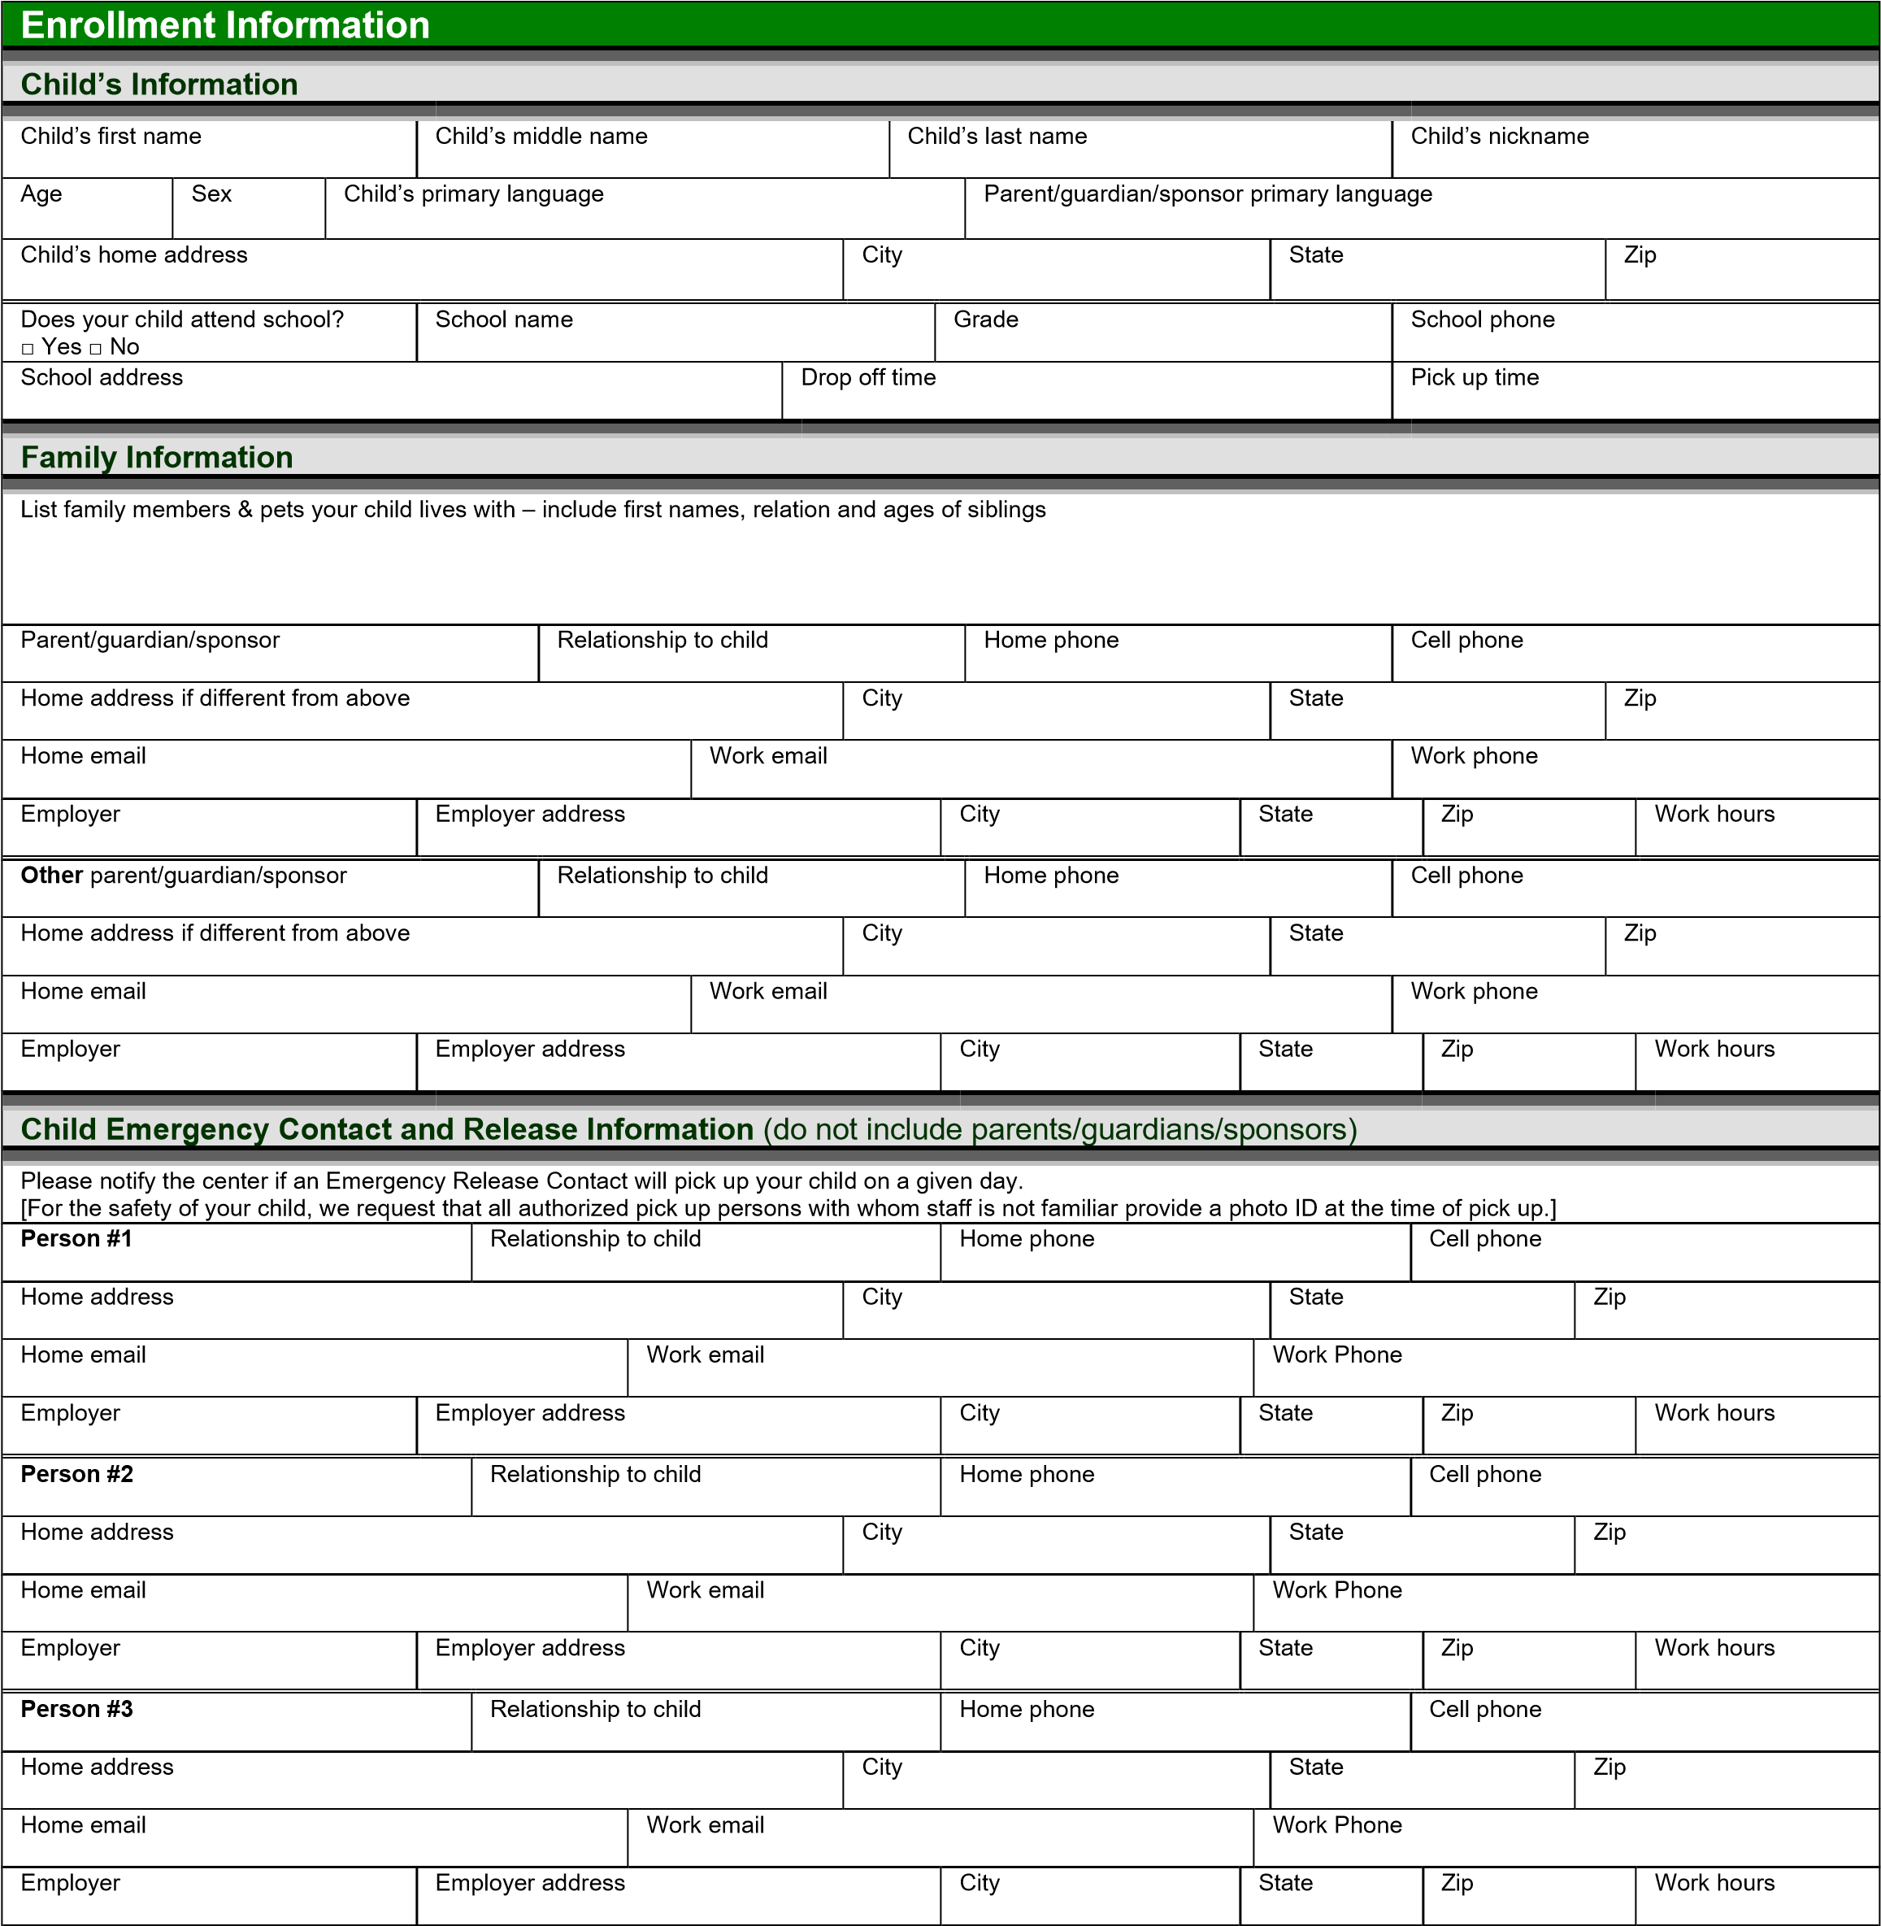

The persons designated in this section will be contacted by us if you cannot be reached in the event of a medical or other emergency. Our staff will only release your child to you or to those persons listed above. If you want a person who is not identified above to pick up your child, you must notify our staff in advance, in writing. Your child will not be released without prior authorization.

Parent initial _________ Staff initial _________ Date ___________________

|  |
| --- |
| **Child Pickup Authorization** |
| **Non-Emergency** |
| Additional persons who may pick up child/ren on a less frequent basis: |

|  |
| --- |
| **Name:** |
| **Address:** |
| **Relationship:** |
| **Phone Number:** |
|  |
| **Name:** |
| **Address:** |
| **Relationship:** |
| **Phone Number:** |
|  |
| **Name:** |
| **Address:** |
| **Relationship:** |
| **Phone Number:** |
|  |
| **Name:** |
| **Address:** |
| **Relationship:** |
| **Phone Number:** |
|  |
| **Name:** |
| **Address:** |
| **Relationship:** |
| **Phone Number:** |
|  |
| **Name:** |
| **Address:** |
| **Relationship:** |
| **Phone Number:** |
|  |
| **Name:** |
| **Address:** |
| **Relationship:** |
| **Phone Number:** |

Notes:

## Little Precious Angels Childcare 2 LLC

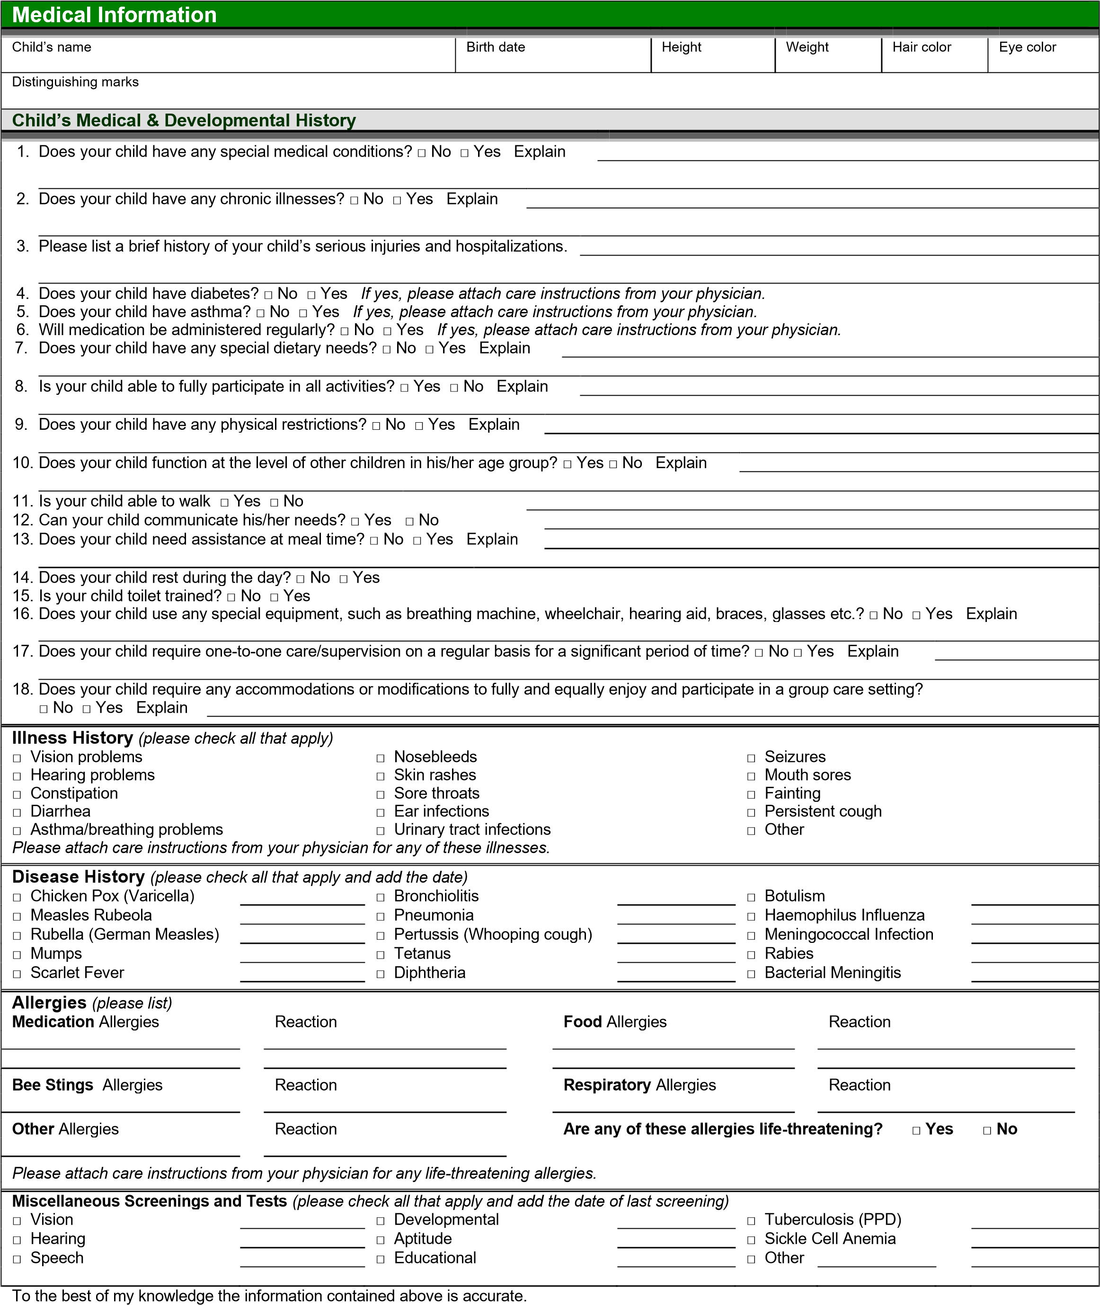

Parent initial _________ Staff initial _________ Date ___________________

## Little Precious Angels Childcare 2 LLC

|  |  |  |  |  |  |  |  |  |  |  |  |  |  |  |
| --- | --- | --- | --- | --- | --- | --- | --- | --- | --- | --- | --- | --- | --- | --- |
| **Medical Information** *(***continued)** | | | | | | | | | | | | | | |
| Child’s name | | | | | | | Birth date | | | | | | | |
| **Child’s Medical Care Provider** | | | | | | | | | | | | | | |
| Primary physician’s name | | | Primary physician’s practice name | | | | | | | | Phone | | | |
| Physician’s practice address | | | | | | City | | | State | | | | Zip | |
| Preferred hospital/clinic for emergency care | | | | | | | | City | | | | | State | |
| Dentist’s name | | | Dentist’s practice name | | | | | | | | Phone | | | |
| Dentist’s practice address | | | | | | City | | | State | | | | Zip | |
| **Child’s Insurance Provider** | | | | | | | | | | | | | | |
| Child’s health insurance provider name | Policy number | | | Secondary health insurance provider name | | | | | | | | Policy number | | |
| **Child’s Immunization History** *(please attach a copy of your child’s immunization records)* | | | | | | | | | | | | | | |
| Below is a list of immunizations that your child may have received. Immunizations in bold are required by our state. **[Check with your state requirements. You may do this a**[**t http://www.immunize.org/states/**](http://www.immunize.org/states/) **Bold any immunization below that is a requirement.]** | | | | | | | | | | | | | | |
| Anthrax | | Influenza | | | **Pneumococcal disease** | | | | | Smallpox | | | | |
| **Diphtheria** | | Lyme Disease | | | **Polio** | | | | | **Tetanus** | | | | |
| **Hemophilus Influenzae type b (Hib)** | | **Measles** | | | Rabies | | | | | Tuberculosis | | | | |
| Hepatitis A | | Meningococcal disease | | | Rotavirus | | | | | Typhoid Fever | | | | |
| **Hepatitis B** | | **Mumps** | | | **Rubella** | | | | | **Varicella (Chickenpox)** | | | | |
| Human Papillomavirus (HPV) | | **Pertussis (Whooping Cough)** | | | Shingles (Herpes Zoster) | | | | | Yellow Fever | | | | |
| **Additional Medical Policies Initial** | | | | | | | | | | | | | | |
| 1. *Prior to enrollment, I must provide the center with updated medical and immunization information for my child. This information is to be kept current and updated in accordance with state childcare regulations. 2. I agree to provide information to the childcare center about my child’s conditions, illnesses, allergies or other needs.      1. *If my child becomes ill with a reportable contagious disease, I understand that he/she will not be able to return until I bring in a physician’s note stating that he/she is no longer contagious. 2. If my child becomes ill during his/her time at the childcare center, the staff will contact me to pick up my child. I will arrange for pick up as soon as possible and no later than 2 hours after being contacted. If I cannot be reached, the staff will contact those listed in the *Child Emergency Contact and Release*. 3. * I have been notified that I may request notice at initial enrollment or any time there after whether there are children currently enrolled in or attending the facility for whom an immunization exemption has been filed. __________ | | | | | | | | | | | | | |  |
|  |
|  |
|  |
|  |
| **Emergency Medical Authorization & Consent Initial** | | | | | | | | | | | | | | |
| 1. In case of a medical emergency, the staff will attempt to contact me, those listed in the *Child* *Emergency Contact and Release*, and lastly my physician.      1. In case of a medical emergency, I agree that my child may receive first aid and/or CPR.      1. *In case of a medical emergency, I permit the transportation of my child to a local hospital or other urgent care facility, if necessary, by paramedics or other emergency personnel.   4. In case of a medical emergency, I will be responsible for the emergency medical expenses.    5. In case of an accidental ingestion of a poisonous substance, I consent to my child being treated as directed by the Poison Control Center. | | | | | | | | | | | | | |  |
|  |
|  |
|  |
|  |
|  |
|  | | | | | | | | | | | | | | |
| **Initial** I give my permission to this center to apply □ sunscreen and □ insect repellant to my child. *Please check which products you will permit.* | | | | | | | | | | | | | | |
| I understand that I must supply my own sunscreen and/or insect repellant with a valid expiration date, and it will be labeled with my child’s  name. I also understand a medical authorization form must be filled out and updated every month. (Required by Law) | | | | | | | | | | | | | | |
| I □ have □ do not have special instructions for the application process. | | | | | | | | | | | | | | |
|  | | | | | | | | | | | | | | |

Parent initial _________ Staff initial _________ Date ___________________

## Little Precious Angels Childcare 2 LLC

|  |  |  |  |  |  |  |
| --- | --- | --- | --- | --- | --- | --- |
| **Rate Agreement and Contract** | | | | | | |
| Child’s name | | | | | | Birth date |
| **Hours of Operation** | | | | | | |
| Regular operating hours are 6:00am – 9:00pm Monday -Friday except closings for various holidays, and inclement weather as described in the Family Handbook. Please consult the current calendar for holidays. There is no reduction in tuition as a result of center closures.    The procedure to notify families should severe weather or other conditions prevent the program from opening on time or at all will be announced on Fox 2 News (314-213-2272) and/or KMOX If it becomes necessary to close early, we will contact you or someone listed in the *Emergency Contact and Release*, and it will be your responsibility to arrange for your child’s early pick up. | | | | | | |
| **Scheduled Attendance** | | | | | | |
| The days and hours that I wish to contract for childcare are as follows: | | | | | | |
| Day of week | Start time | AM/PM | End time | AM/PM | Comments | |
| Monday |  |  |  |  |  | |
| Tuesday |  |  |  |  |  | |
| Wednesday |  |  |  |  |  | |
| Thursday |  |  |  |  |  | |
| Friday |  |  |  |  |  | |
| I would prefer to make tuition payments on a □ weekly □ bi-weekly □ monthly basis. | | | | | | |
| **Fee Policy** (to be completed by staff; reviewed and initialed by the parent/guardian/sponsor after completion) | | | | | | |
| * Starting on **___________________** a fee of **$_______________** is due □ weekly. **Initial**   □ bi-weekly. □ monthly.     * Tuition is due and payable by the 1st □ Every Friday before or Monday of Service day of the month (before service) □ the 1st and 15th of the month or next business day. □ first business day of the month.      * Tuition is not subject to discounts for holidays, emergency closures (i.e., weather), or absence other than hospitalization, contagious illness, or absence at the request of a doctor (a written doctor’s note is required to receive credit).      * I agree to pay the full tuition in advance of services rendered.      * I agree to pay the full tuition fee even if my child is absent for one or more days.      * A late fee of $25 is due if tuition is not received on time.      * A non-refundable registration fee of$35 is due yearly.      * A late pick up fee of$10 for every 15 minutes or part of 15 minutes per child (not to exceed $80 per child) is due if my child is not picked up before closing, payment is due before child/ren can return.      * Accounts two weeks in arrears may result in immediate termination of service.      * My child may have the opportunity to participate in a special program or field trip that may have an additional fee due before the day of the event. A specific permission slip may be required.      * All returned checks or ACH transactions (automatic debits) will be charged a fee of $35. Two or more returned checks or ACH transactions will result in my account being placed on “money order only” status.      * A 2-week written notice is required for any child being withdrawn from the program. Failure to provide notice in writing will result in forfeiture of deposit.      * A receipt for income tax purposes □ will □ will not be provided. | | | | | | |
|
|
|
|
|
|
|
|
|
|
|
|
|

|  |  |
| --- | --- |
| **Other Agreements** |  |
| **Private Employment Acknowledgement and Release** |  |
| Any arrangement/employment between me and staff of this center (i.e., babysitting), outside of the programs and services offered by this center, is an individual endeavor and private matter not connected to or sanctioned by this center. This center shall remain harmless from any such arrangement. | **Initial** |
|  |
| **Media Release** |  |
| Occasionally, photos will be taken of the children at the center for use within the center or on our website and/or newsletters. Please indicate that you authorize the use and reproduction of photographs of your child in conjunction with the program. | **Initial** |
|  |

Parent initial _________ Staff initial _________ Date ___________________

## Enrollment Agreement Little Precious Angels Childcare 2 LLC

|  |  |
| --- | --- |
| **Other Agreements** *(continued)* | |
| Child’s name | Birth date |
| **Walking Excursions and Outside Play Initial** | |
| **_______**   1. *I give my permission for my child to participate in supervised walking excursions near and around the center and field trips and   excursions away from the center.   1. *I understand I will be notified in advance when planning trips and Little Precious Angels Childcare Staff will transport my child.      1. **I understand children of all ages, including infants must participate in outside activities. I** understand that injury can and may occur to your child, and hereby authorize Little Precious Angels Childcare Staff, to seek and consent to emergency medical attention for your child as needed. Parent/Guardian further agree to be liable for and pay all costs incurred in connection with such medical attention.   _______ | |
|
| **Handbook Acknowledgement** | |
| **Initial**  I understand and agree that it is my responsibility to read and familiarize myself with policies and procedures outlined in the Family Handbook and agree to abide by them.      I understand that it is my responsibility to go directly to management with any questions I may have regarding the policies and procedures and information contained in this Enrollment Agreement.      Information contained in the Family Handbookmay be subject to change. | |
|
|
|
|  | |
| Child’s name | Birth date |
| **Rules, Policies, Licensing** | |
| **Initial**   1. *I have received a copy of this facility’s policies pertaining to the admission, care and discharge of children.      1. **\*I Have been informed that a copy of Licensing Rules for childcare homes or Licensing Rules for group childcare**   **homes and centers are available at the facility for review. ______**   1. **\*The Provider and I agreed on a plan for continuing communication regarding my child’s development, behavior, ______ and individual needs.**      1. **\*I have been informed and received a copy of the facilities Safe Sleep Policy when enrolling a child less than one (1) year of age ______**      1. **I understand children of all ages, including infants must participate in outside activities. I** understand that injury can and may occur to your child, and hereby authorize Little Precious Angels Childcare Staff, to seek and consent to emergency medical attention for your child as needed. Parent/Guardian further agree to be liable for and pay all costs incurred in connection with such medical attention.   **Initial ______** | |
|
| **Handbook Acknowledgement** | |
| **Initial**  I understand and agree that it is my responsibility to read and familiarize myself with policies and procedures outlined in the Family Handbook and agree to abide by them.      I understand that it is my responsibility to go directly to management with any questions I may have regarding the policies and procedures and information contained in this Enrollment Agreement.      Information contained in the Family Handbookmay be subject to change. | |
|
|
|

|  |  |
| --- | --- |
| **Contract Approval** |  |
| I certify that I have read, understand, and accept all of the terms and conditions described in this *Enrollment* *Agreement*.      Primary Parent/Guardian/Sponsor Signature Date Center Staff Signature | Date |
|

**\*State Required Initials/Signatures**

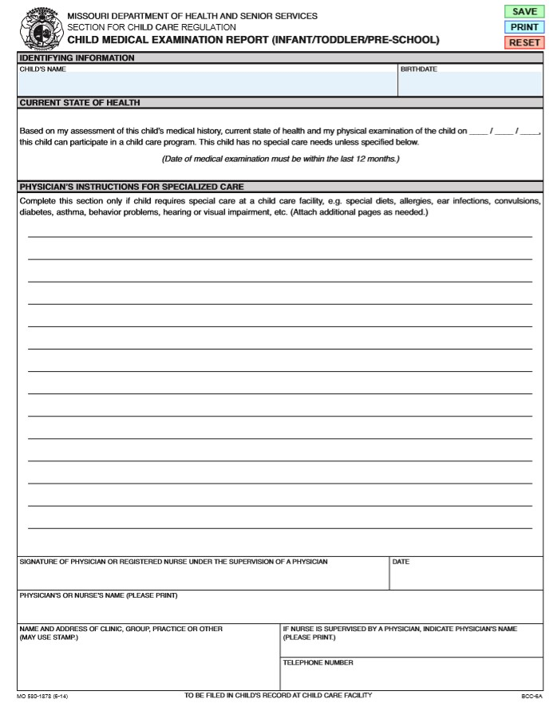

**Child and Adult Care Food Program**

**Parent Letter – Non-Pricing Child Care Centers**

**July 1, 2019 through June 30, 2020**

Dear Parent or Legal Guardian:

Our center is currently participating in the Child and Adult Care Food Program. This program reimburses th center for the partial cost of meals provided to children and allows the center to provide nutritious meals without increasing the center’s fees to you. If your yearly income is equal to or below the amount listed for your family size on the chart below, your child is eligible for free or reduced meals. If the income is higher than the amount listed for your family size, you do not need to complete the income application.

|  |  |  |  |
| --- | --- | --- | --- |
| **Family Size** | **Yearly Income** | **Family size** | **Yearly Income** |
| 1 | $23,107 | 5 | $55,815 |
| 2 | $31,284 | 6 | $63,992 |
| 3 | $39,461 | 7 | $72,169 |
| 4 | $47,638 | 8 | $80,346 |

For each additional Family Member, add +$8,177

To apply for free or reduced-priced meal benefits for your child/ren, you must complete the attached Income Eligibility Form (IEF). Your application for free or reduced-priced meal benefits cannot be approved unless the attached application is completed according to the directions provided; however, you are not required to complete the IEF. Notify the center should the household income decrease and/or if the household size increases. A participant may be eligible for free or reduced-priced meals. The application is valid until the last day of the month in which the form was approved/dated/signed one year earlier.

Sincerely,

Little Precious Angels Childcare 2 LLC

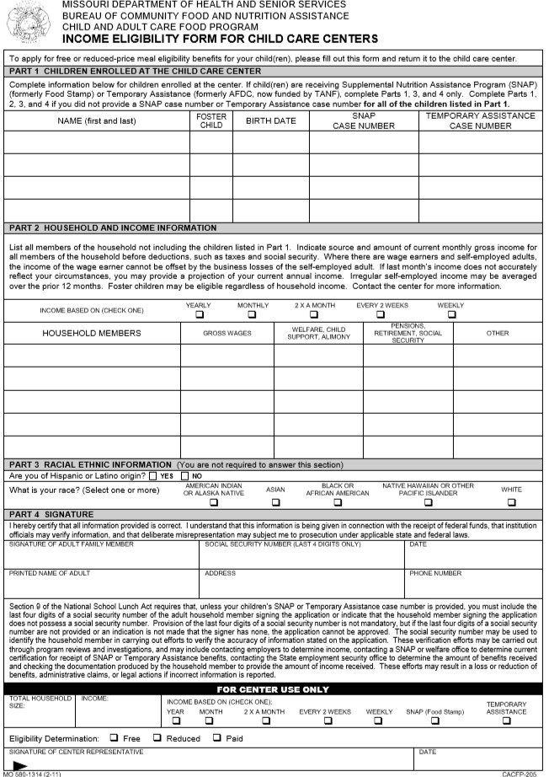

### School Age Child Care Supplemental Enrollment Form Little Precious Angels Childcare 2 LLC

Completion of this agreement is required for enrollment. This form will enable us to better understand your child and meet his/her needs. Much of the information requested is necessary to comply with state child care licensing regulations.

|  |  |  |  |  |  |  |  |  |  |  |
| --- | --- | --- | --- | --- | --- | --- | --- | --- | --- | --- |
| **Enrollment Information** | | | | | | | | | | |
| **Child’s Information** | | | | | | | | | | |
| Child’s first name | | | Child’s middle name | | | | Child’s last name | | Child’s nickname | |
| Age | Sex | Child’s primary language | | | | | Parent/guardian/sponsor primary language | | | |
| Child’s home address | | | | | City | | | State | | Zip |
| Does your child attend school?  □ Yes □ No | | | School name | | | Grade | | | School phone | |
| School address | | | | Drop off time | | | | | Pick up time | |
| Child will be attending: □ Morning Care □ Afternoon Care | | | | | | | | | | |
| My Child is allowed to walk (3rd grade and older*): □ To School from Child Care □ From School to Child Care | | | | | | | | | | |
| *Note: Little Precious Angels Childcare 2 LLC is not liable for the child until he/she arrives at the program or after the child has left the program to walk to/from school. | | | | | | | | | | |

## After School Activities Information

Complete the information below to provide us with details about after school activities your child is participating in. Please complete a separate Transportation and School Activity form for each activity.

|  |  |  |  |  |
| --- | --- | --- | --- | --- |
| **Transportation and After School Activity** | | | | |
| My child is transported to school via: | | My child is transported from school via: Bus #: | | |
| Parents are responsible for informing child care center in writing if your child(ren) will be participating in an after school activity: | | | | |
| Child participates in the following after school activities (list all): | | | | |
| Type of Activity: | | | | |
| Day of the week child is attending activities (circle all that apply): M Tu W Th F | | | | |
| Time period of activity:  Day:  Start Time:  End Time: | Day:  Start Time:  End Time: | Day:  Start Time:  End Time: | Day:  Start Time:  End Time: | Day:  Start Time:  End Time: |
| Name of authorized person to pick up / drop off your child for the extracurricular activity: | | | | |

|  |  |  |  |  |
| --- | --- | --- | --- | --- |
| **Transportation and After School Activity** | | | | |
| My child is transported to school via: | | My child is transported from school via: Bus #: | | |
| Parents are responsible for informing child care center in writing if your child(ren) will be participating in an after school activity: | | | | |
| Child participates in the following after school activities (list all): | | | | |
| Type of Activity: | | | | |
| Day of the week child is attending activities (circle all that apply): M Tu W Th F | | | | |
| Time period of activity:  Day:  Start Time:  End Time: | Day:  Start Time:  End Time: | Day:  Start Time:  End Time: | Day:  Start Time:  End Time: | Day:  Start Time:  End Time: |
| Name of authorized person to pick up / drop off your child for the extracurricular activity: | | | | |

Your child’s safety is our number one priority. Little Precious Angels Childcare 2 LLC will not release children from the program without the above information **in writing**.

Primary Parent/Guardian/Sponsor Signature Date

1