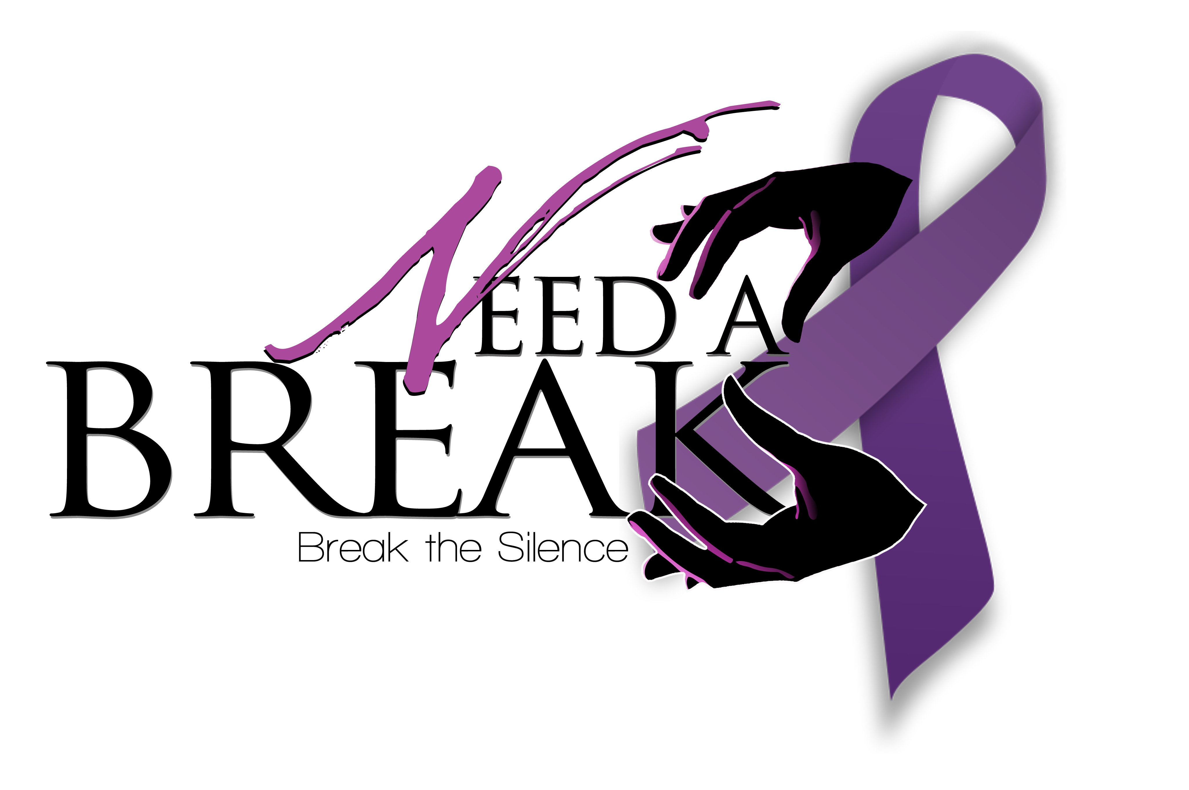
PLEASE MAIL THIS FORM
WITH YOUR DONATION TO:

Need A Break Inc.
P O Box 764203
Dallas, Texas 75376-4203
©2011 Exhaling to New Life Thank you for supporting Need A Break Inc. Organization Tax ID Number 20-3253884
Donation Receipt from Need A Break Inc.
Questions? Contact the Need A Break Inc. 1-800-458-5369

Company Name: | ________________________________________
Donor Name: | ________________________________________
Address: | ________________________________________
City: | ________________________________________
State/Province: | ________________________________________
Postal code | ________________________________________
Phone: | ________________________________________
Total pledge amount: | ________________________________________
Type of donation: | _____________________________________________
Description: | _____________________________________________
Value: | _____________________________________________
Thank you for your generous support!
INSTRUCTIONS:
- Send only one check per donation form.
- Please make all checks payable to Need A Break Inc.
- All donations are non-refundable and non-transferable.
- All donations are tax deductible to the extent allowed by law.
- We cannot accept cash donations.

Donation Receipt

