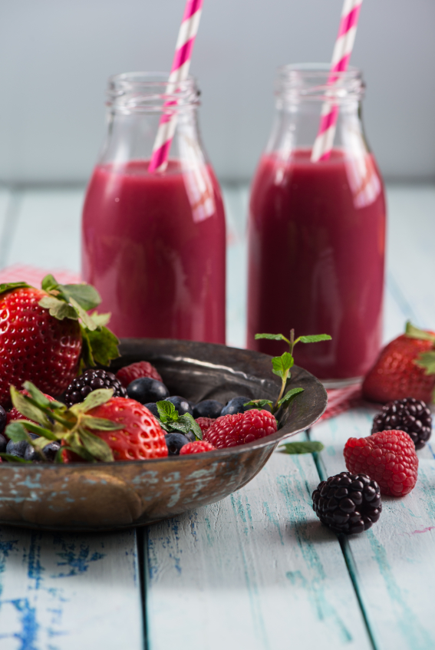

Low Sugar

VEEFIT’s
SMOOTHIE
CHALLENGE

HELLO, SMOOTHIE LOVER (or soon to be smoothie lover)!

How many times have you had a smoothie only to feel that crash and burn a little later? Are the smoothies you find on the Internet more like desserts than something that will leave you feeling satisfied and full of energy?

I have struggled for years off and on with bloating, headaches and exhaustion due to sugar addiction until I kick my sugar addiction, and that means giving up even the sweet fruits until my body balances. Its true, I am human lol, I have succumbed to my love of sugar at times of high stress, sadness or my favorites being right in front of me for the taking etc…but now I can stop eating sugar immediately after because I know how to balance my body before the addiction can kick in!

Are you excited? All you need is a little UMPH, a blender, and some willingness because I am going to support you every step of the way…if you decide to work with me! This Challenge is a start for you on your own….if you like this low sugar Smoothie Challenge please contact me to try out my
HOW TO QUIT SUGAR FOR LIFE PROGRAM!!!

As a health and wellness coach, specialising in overcoming sugar addiction, healing leaky gut syndrome, holistic pain management & increasing energy, I am here to guide you towards making the right food choices in order to boost your metabolism and improve your digestion.

It is time to smoothie it up – make em’ taste great without the sugar. I swear this will be life changing because once you are consuming low sugar smoothies, your day will flow, and you will shine!
THE UMPH

Get excited and get ready. First look at the smoothie list and then download your shopping list.

Next plan out your week and shop for your ingredients because the smoothie challenge is ON.

Next, get your blender ready for some action.

The challenge is simple – you will add one smoothie a day to your life.

If you want to double the challenge, then you can add two smoothies a day. You can have a smoothie for breakfast and a smoothie for your afternoon snack when you feel tired. Two smoothies a day means you are really taking it up a notch.

WHY BLEND?
The health of your body depends on your digestion. When you blend your foods, you are supporting the digestive process.

Your body does not have to work so hard to break down the nutrients as they are in a pre-digestible state.

You get liquid energy, chock full of live and rich enzymes, ready to hit your bloodstream and give you the vitamins and nutrients you deserve.

CHOOSING A BLENDER:
- Vitamix is a super-powerful blender with a very strong motor that can not only blend smoothies but can also make nut butter and even soups. However, it is an investment at around $450, you can snag a refurbished one from vitamix.com.

- Blendtec is another option similar to Vitamix and costs about $400+.

- Nutri bullet is an amazing alternative and costs only $99.

- A blender at Masters, Wal-Mart or Target will typically cost you around $40, but avoid using it for crushing ice unless the package states it can handle it.

I AM CURRENTLY USING A KITCHENAID BLENDER WITH A CHOP ICE BUTTON THAT WORKS GREAT - $ 100!!!

MAKING THE ULTIMATE SMOOTHIE

- Choose the liquid – water, coconut water or dairy-free milk (if counting calories then water is the obvious choice!!)
- Choose your greens – kale, spinach, parsley, Swiss chard, collards or lettuce
- Choose your fruit – berries
- Choose your fat/protein – hemp seeds, hemp or pea protein powder, nut butter, avocado, coconut oil, flax or chia seeds
- Superfoods – coconut oil, maca, raw cacao, bee pollen, or shredded coconut

CHALLENGE tips
- Keep it simple. Follow the smoothies in order from day 1 through day 7.
- Post a picture of your smoothie every day and whatsapp it to me
- Keep a food diary of how you feel drinking your low-sugar smoothie.
- Double dip that baby and drink a second smoothie. Make a double batch in the AM and you can upgrade your second smoothie by adding shredded coconut, raw cacao nibs or bee pollen.
- Add some protein to stabilize your blood sugar and fuel your body. My favorite proteins are – hemp, pea, sprouted brown rice – Garden of Life Raw Protein OR I love the Collagen proteins from Perfect Keto!
- If you are short on time in the morning, make your smoothie the night before. I hear it over and over …. “I don’t have time!” ….make it night before!!! No excuses!
- Superfoods are AWESOME and if you want to supercharge your life then check out the ones I mentioned above – even one teaspoon of bee pollen, loaded with amino acids - can change your day.
7 days of
smoothie love
- REMEMBER IF YOU ARE COUNTING CALORIES USE WATER AS YOUR LIQUID BASE!

DAY 1

GREEN SMOOTHIE MADNESS
1 cup water or almond, hemp, or coconut milk
½ avocado
½ cup berries
1 cup kale or baby spinach
1 tablespoon ground flax seeds
1 tablespoon chia seeds
1 teaspoon cinnamon
1 tablespoon raw cacao
½ teaspoon vanilla (optional)
Stevia to taste (1-2 drops)
3 to 4 ice cubes

Day 2

SPINACH POWER
1 cup water or almond, hemp or coconut milk
3 tablespoons pumpkin seeds
1 cup frozen blueberries
1 cup spinach
1 tablespoon ground flax seeds
1 tablespoon chia seeds
1 teaspoon cinnamon
Stevia to taste (1-2 drops)
3 to 4 ice cubes (optional)

Day 3

BERRY BLISS SMOOTHIE
1 cup water or almond, hemp or coconut milk
½ cup of frozen berries
½ avocado
1 cup kale
1 tablespoon ground flax seeds
1 tablespoon chia seeds
1 teaspoon ginger (optional)
1 teaspoon cinnamon
3 to 4 ice cubes (optional)

Day 4

CHOCOLATE-COVERED BERRIES SMOOTHIE
1 cup water or almond, hemp or coconut milk
½ avocado
½ cup of frozen berries
1 cup spinach
1 tablespoon ground flax seeds
1 tablespoon chia seeds
1 tablespoon raw cacao
3-4 ice cubes (optional)
½ dropper of vanilla stevia
3 to 4 ice cubes

Day 5

CHOCOLATE AND KALE SMOOTHIE
1 cup coconut, hemp, or almond milk
1 avocado
½ cup berries
1 cup of kale
3 tablespoons of cacao nibs
1 tablespoon of raw cacao
5 to 6 ice cubes

Day 6

CHIA SMOOTHIE
1 ½ cup almond, hemp or coconut milk
1 cup frozen berries
½ avocado
2 tablespoons chia seeds
1 handful of greens (spinach or kale)
¼ teaspoon cinnamon
4 to 5 ice cubes

Day 7

Raw Love ☺
1 ½ cup almond, hemp or coconut milk
½ avocado
1 cup spinach
½ cup frozen berries
¼ teaspoon cinnamon
1-inch piece of fresh ginger
1 tablespoon shredded coconut
Ice (optional)

LIFE WILL NEVER BE THE SAME
ONCE YOU BEGIN THE
VEEFIT SMOOTHIE CHALLENGE…Please read on for information on my new

How to quit sugar for life program!!

OK – You’ve successfully completed my Low Sugar Smoothie Challenge – WELL DONE!…So now you are prepped and ready for my new Program (drumroll please!!)

HOW TO QUIT SUGAR FOR LIFE!

Do you ever feel like you are constantly not fitting into your clothes no matter what you do?

It can leave you feeling off for the entire day and not to mention completely uncomfortable.
That icky bloated feeling, trapped gas, puffy eyes, achy joints, unpleasant taste in your mouth, not to mention exhaustion….to name a few of the side effects of eating sugar!

Those feeings just hold you back from really enjoying your life!!

Are you ready to finally say good-bye to ALWAYS catching that cold, feeling tired and sore all the time or coming down with brutal headaches?
Of course, you are! That is why I have designed my new program to help you rid your body of the culprit (the one you didn’t know was causing you all the damage) once and for all!

Learn How to “Quit Sugar For Life” and take back your health with this special program designed with your health in mind. My new program will help you take back your health and finally feel free to enjoy life everyday!

HERES HOW!
GO TO MY WEBSITE WWW.VEEFIT.COM CLICK ON THE HEALTH COACHING TAB THEN PROGRAMS! READ ALL ABOUT IT!

