43rd Monmouthshire Light infantry 1815  The most exciting hobby in History | ORDER Form
Your membership number must appear on all related
correspondence,

To:

DATE | membership No# | SHIPPED VIA | Pref: collection event
 |  | Posted /collected at event

QTY | UNIT | DESCRIPTION | UNIT PRICE | TOTAL
 | 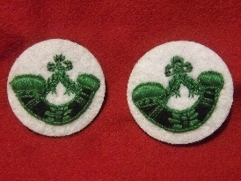 | TURN BACK BUGLE | £6.00 each  £12 the pair
 | 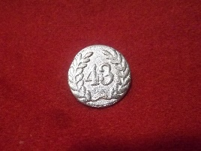 | OTHER RANKS BUTTONS  Full uniform set of 32 buttons  2 shoulder straps , 2 back  10 front lace , 8 cuffs 4 /4  8 pockets 4/4  1 shako cockade, 1 spare | 50p per button
 | 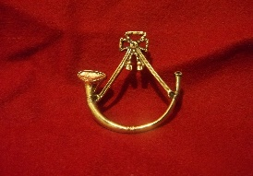 | SHAKO BUGLE BADGE | £17.00
 | 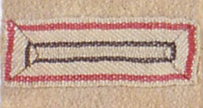 | REGIMENTAL LACE | £1.00 per meter
 | 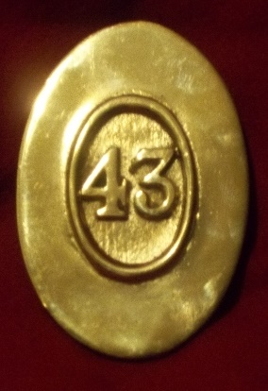 | CROSS BELT PLATE | £20.00
 | 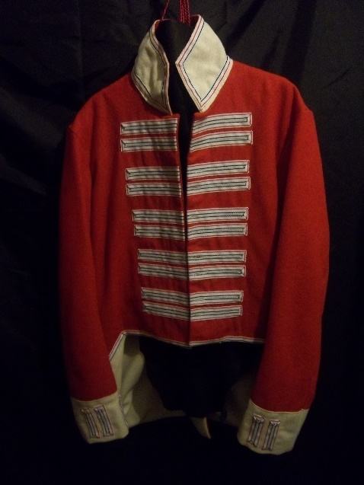 | REGIMENTAL JACKET INC WINGS  CONTACT FOR CURRENT STOCK.  MEASUREMENTS :  CHEST:  WAIST:  SLEEVE:  SHOULDER TO SHOULDER:  NECK TO WAIST | £70.00
 |  | SUBTOTAL
 |  | SHIPPING & HANDLING |  | 5.00
 |  | OTHER
 |  | TOTAL

Please make cheques payable to the 43rd MLI.
For Bank Transfers

Lloyds TSB Bank
The Strand LONDON
A/C 01438523 43RD MLI
Sort code 30-91-79
BIC: LLODGB21216
IBAN: GB87 LOYD 3091 7901 4385 23

For post

Mr David Bell
All Saints Annex Austral Street London SE1 6HZ

 |  | placed by | Date
Our website also contains a number of useful links to suppliers of more general but useful items.

Notes:

