WRAP Workbook

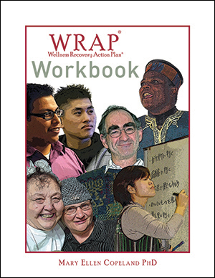
$5.00
This book contains the WRAP forms, forms for the lists and for the action plans, as well as forms for the Crisis Plan (Advance Directive) and Post Crisis Plan. It also has brief descriptions of each part of WRAP.
Many people don't like writing in a book like the red WRAP book, WRAP Plus or WRAP for Life. They want to keep those books tidy for easy reference and for sharing with friends and supporters. They also were afraid that if they wrote in those books, their writing would not be confidential. While many people have their WRAP in a loose-leaf binder or notebook and others use the on-line course or the WRAP app, there are many, many people who requested this book of forms.

Wellness Recovery Action Plan® (WRAP®)

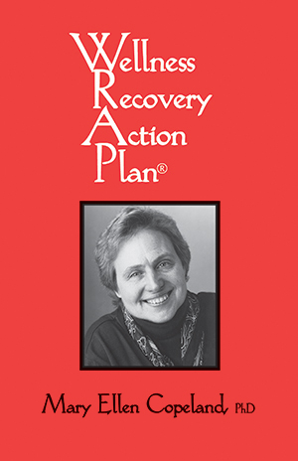
$10.00
This book has broad applicability and is used world-wide as a basis for recovery. It is a popular personal guide for developing a Wellness Recovery Action Plan (WRAP). Agencies can purchase this book for distribution to people working with a care provider in WRAP groups or for individuals who are working to develop their own WRAP.
WRAP presents a system developed and successfully implemented by people with all kinds of physical, emotional and life issues. It has helped them practice self-help skills more easily to help monitor how they are feeling, decrease the severity and frequency of difficult feelings, and to improve the quality of their lives.

In addition, this book also helps people:
- Develop their own list of activities for everyday well-being
- Track triggering events and early warning signs
- Prepare personal responses for when they are feeling badly
- Create a plan for supports to care for them if necessary
Wellness Recovery Action Plan (WRAP) is a required text for the Mental Health Recovery and WRAP

WRAP Plus

$19.95
$16.00 On Sale!
WRAP Plus is the go to book for all things WRAP! This easy to read volume is loaded with real life examples, making it a wonderfully relatable resource. The information in this book, along with our other resources, are based on years and years of interviewing people who experience serious mental health issues in their lives.
WRAP Plus is an extensively updated version of the book, Living Without Depression and Manic Depression. The original book was published in 1994 and was based on a study I did of the skills and strategies of people who have gotten well and stayed well over time. This was at a time when recovery from mental health issues was not even considered to be possible.

Recovery is now a word that is used in mental health all the time, but I didn’t want the original text with all its great information to cease to be. It was too important for too many people and led many out of the depths of despair into a rich and rewarding life. So, WRAP Plus was born. I added lots of updates about recovery and WRAP to make this a truly comprehensive resource for people dealing with all kinds of mental health challenges.

This is a required text for the Copeland Center's Mental Health Recovery and WRAP

WRAP® for Your Computer
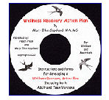
This CD is designed for use by teens (ages 12-20) and adults. This learning format is particularly useful for people who want to develop their Wellness Recovery Action Plan on their computer.
The WRAP CD has two files - one is WRAP for Adults and one is WRAP for Teens (although some adults might prefer that simplified version). Each of these files includes complete instructions for developing a WRAP plan and forms that you can fill out and leave on your computer or print out. It is designed so that you can move easily between the instructions and the forms.
The software program is useful for tailoring programs or emphasizing points. It gives you the flexibility to adapt to different programs or individual needs.
The WRAP software is well suited to support facilitation of WRAP groups and the review of the WRAP process. Refer to the listing for Wellness Recovery Action Plan for more information on WRAP.

Guided Relaxation with Mary Ellen Copeland - Audio Download

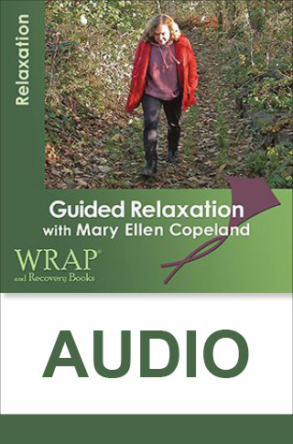
$1.99
This audio recording from WRAP: Wellness Recovery Action Plan author Mary Ellen Copeland, PhD, will help you relax anytime you’re feeling nervous, tense, or irritable, or when you just need a “break” in your day.
Use this relaxation and stress reduction program as a way to feel better.
It is a great addition to your Wellness Toolbox.
Mary Ellen personally guides you through a full-body relaxation exercise accompanied by a soothing music.
Her guided imagery technique draws upon your imagination to direct your focus in a way that is both relaxing and healing.

Who this Item is for

This full-body relaxation exercise is perfect for anyone looking to release tension and promote feelings of wellness and peace.

Special Features
- The recording can be played on any computer, MP3 player, smartphone, or tablet

- Purchase now for immediate download. Please note this is a downloadable product. After checkout, you will be notified about how to download the program

The WRAP app

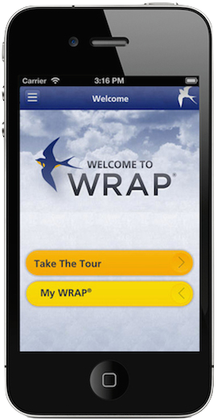
The WRAP® App is for anyone, any time, and for any of life’s challenges.

Using a WRAP involves listing your personal resources (Wellness Tools), and then using these resources to develop Action Plans.

You decide how and when to use your WRAP.

The Wellness Recovery Action Plan® (WRAP) is an evidence-based system that is used world-wide by people who are dealing with mental health and other kinds of health challenges, and by people who want to attain the highest possible level of wellness.

WRAP was developed by a group of people who have a lived experience of mental health difficulties; people who were searching for ways to resolve issues that had been troubling them for a long time.

With the WRAP App you can:
- Develop a Wellness Toolbox
- Create Daily Maintenance Plan
- List Triggers and create an Action Plan
- List Early Warning Signs and create
an Action Plan
- List When Things Are Breaking Down
and create an Action Plan
- Create a Crisis Plan
- Create Post Crisis Plan
The WRAP App guides you in creating and using your WRAP day to day. Use the WRAP App and take control, with your personalized action plans that help you feel better, get well, and stay well for life.
Here’s what people are saying about the new release of the WRAP app:

“This is such a helpful tool. Now I have room to fully express my thoughts in all the fields. Thank you for listening to feedback.”

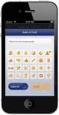
“Great app! Love that I can manage my WRAP on the go from my phone! The new version you released with the increased character limit makes this App so much better! Thank you.”
“My WRAP is always with me. I am from the digital generation so this app is for me. A great tool that helps you help yourself.”

“Great wellness tool. It is great to have my WRAP in my pocket. It is easy to use and share. I love it!”

“WRAP – I’m glad I found this app, it makes it so much easier to have it with me all the time and on hand when I need it as I can’t carry the book with me at all times. Great for helping with mental health issues and how to deal with them,. A++++”

The WRAP® app allows you the convenience of accessing and updating your WRAP anytime and anywhere. It’s convenient and easy to use, leaving you secure in knowing it’s right at your fingertips.

$4.99

WRAP AND RECOVERY BOOKS

Mission
WRAP and Recovery Books was established by Dr. Mary Ellen Copeland to develop, distribute, and make available to everyone, the recovery and wellness skills and strategies, including the Wellness Recovery Action Plan that she discovered through her research.
I now feel like a whole person for the first time in my life. -WRAP User

Goals
The goals of Mental Health Recovery and Wrap are to teach participants recovery and self-management skills and strategies:
- promote higher levels of wellness, stability and quality of life
- decrease the need for costly, invasive therapies
- decrease the incidence of serious mental health challenges
- decrease traumatic life events
- increase understanding of these mental health challenges and decrease stigma
- raise participants' level of hope and encourage actively working toward wellness
- increase participants' sense of personal responsibility and empowerment

Objectives
The following topics are covered using a workshop style, including presentations, demonstrations, interactive discussion, and related activities:
- hope, personal responsibility, education, self-advocacy, and support
- accessing good health care and managing medications
- self-monitoring using WRAP: A Wellness Recovery Action Plan (an individualized system for monitoring and responding to symptoms to achieve the highest possible levels of wellness)
- wellness tools, include finding and keeping a strong support system, peer counseling, focusing, relaxation exercises, diet, light, exercise, sleep, journaling, music, etc
- dealing with the effects of trauma
- suicide prevention
- building self-esteem
- changing negative thought patterns to positive
- building a lifestyle that promotes wellness
Phone: 978-261-1444 ordering Questions: books@mentalhealthrecovery.com
General Inquiries: info@mentalhealthrecovery.com

