"Tonight is the night, if ever one was"
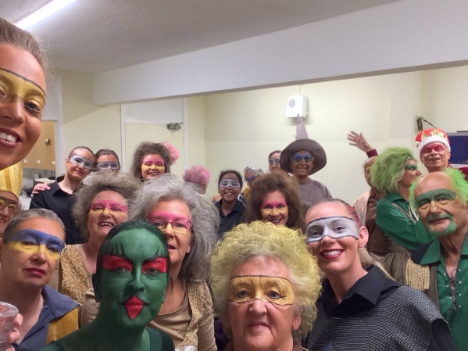

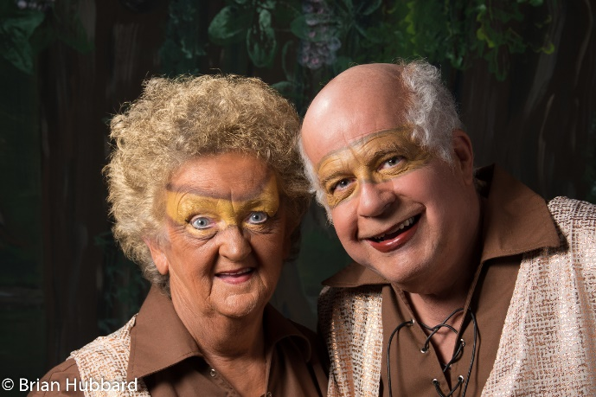
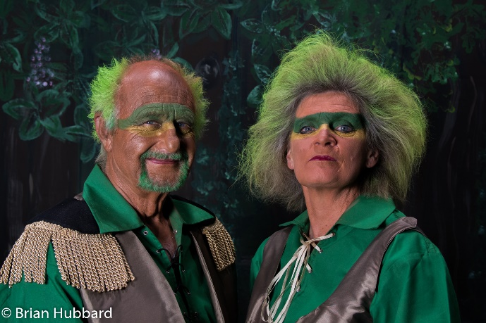
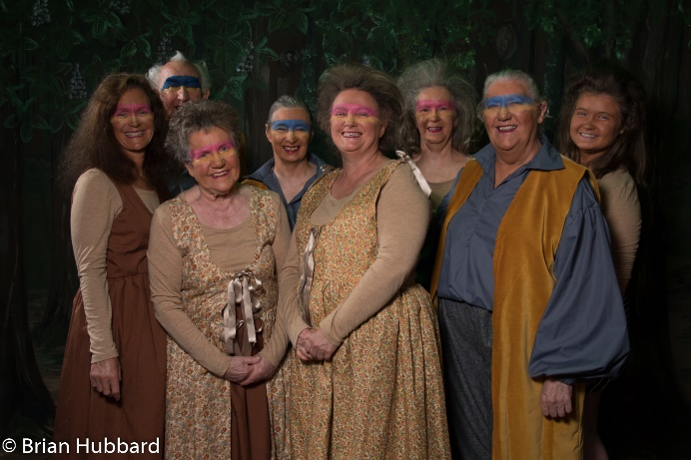
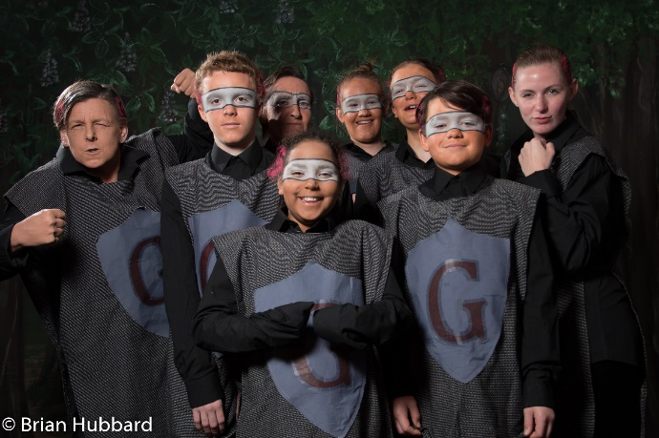
Backstage on the Public Hall is quite frequently busy, with one small room for the entire cast and the kitchen repurposed as a make-up department. For Trolls, with a cast of 29 all needing hair, makeup, and a place to sit down in the interval, we find a new meaning to the word "chaos". For the first dress rehearsal, we barely all make it into costume by our scheduled start time, but practice makes perfect, and by the time we open, we are all ready with whole minutes to spare.

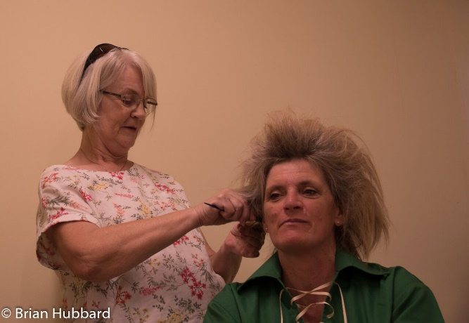
The fantasy world of Trolls called for a special approach to hair and makeup. Jen offered her services and created slightly different looks for everyone on stage, refusing to be beaten by even the most stubborn hair. Every hair was back combed within an inch of its life, and with multi-coloured spray, chalk, and (somewhat creatively) blue face paint playing a part, she did a fantastic job of helping bring the community of Trolls to life. Not a single wig was used, and the final effect was stunning.

On make-up, the wonderful Katy was ably assisted by the fabulous grouping of Olivia, Paul, Jayne and Krysia to ensure that everyone was fully troll-ified in time to start. In addition to the individual looks for the Trolls, a lot of green and blue paint was used to help bring the Goblin and Elf to life. We're sure anyone who saw the show would agree that these two characters looked amazing! And with hair and makeup looking as great as it did, it made bringing the story to life far easier for the cast.
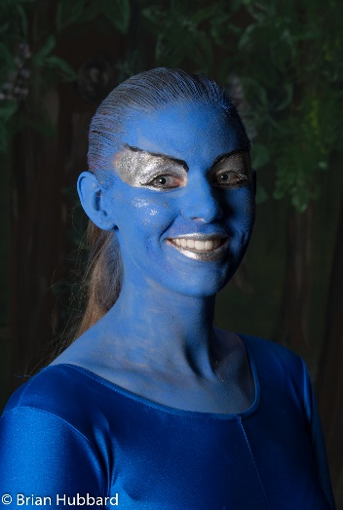
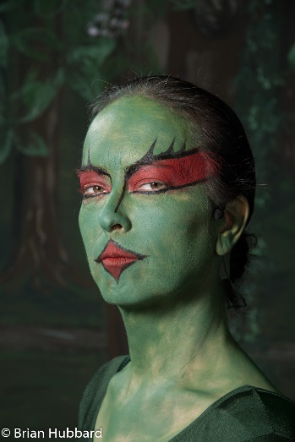
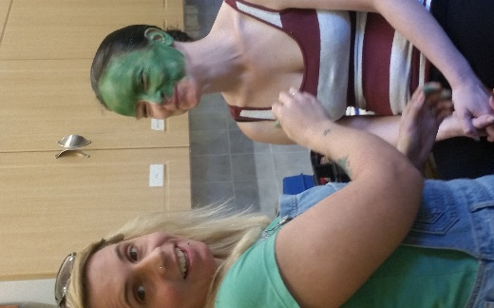

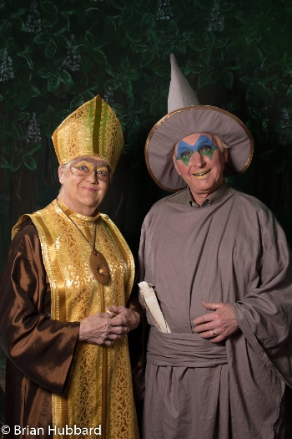
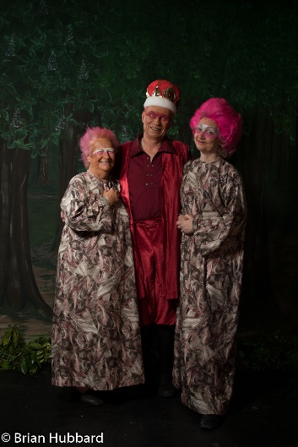
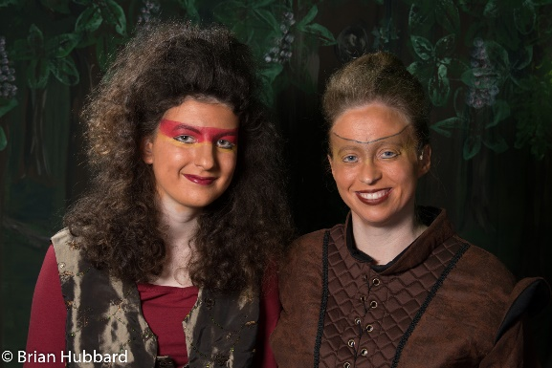

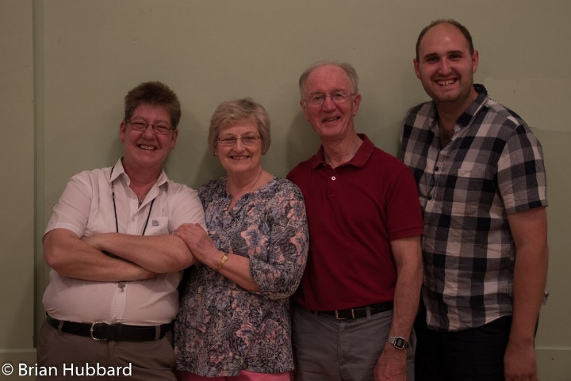
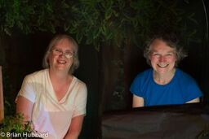
Preparations went well, apart from a slight mishap in the dress rehearsal where we inadvertently cut 10 minutes from the first half by singing at a pace that some would call a talent, but that Derry was less impressed by. But you can't have a good opening night without at least a couple of dress rehearsal dramas, and with a film crew attending, it was good to get the mistakes out the way. A group of ex-BBC cameramen very kindly gave up their time to help create a DVD of the production. We cannot wait to see it! All three shows went fantastically well, with the whole cast giving their all. The singing, dancing, and fighting had so much energy in them, it's no wonder we were all exhausted by the end of it!

Trolls was a fantastic way to end our 50th anniversary season. It was lovely to have so many Players on stage and to be so well supported by all those who came along. To all those who saw the show, or any of our productions this season, thank you so much for your support, and we really hope you enjoyed yourselves. We certainly did!
