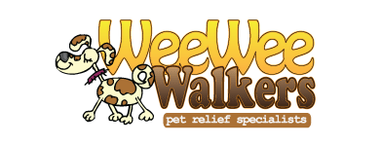

Bark and Play Social

I understand that my puppy/dog(s) will be in an environment
with other puppy/dog(s) to run, play and socialize together.

It is my understanding that if my puppy/dog(s) injures another
person/animal while at Wee Wee Walkers I will be held
responsible for any reasonable expenses occurred.

I will be held responsible for the conduct of my pet at all
times during the puppy/dog(s) play social time and free
run that my dog participates in.

If any unfortunate incidents pertaining to myself or my dog occur, it is understood that Wee Wee Walkers will not be found liable.

In acknowledgement of my signature I agree to all the previous
terms.

Signed _____________________ Date _______________

