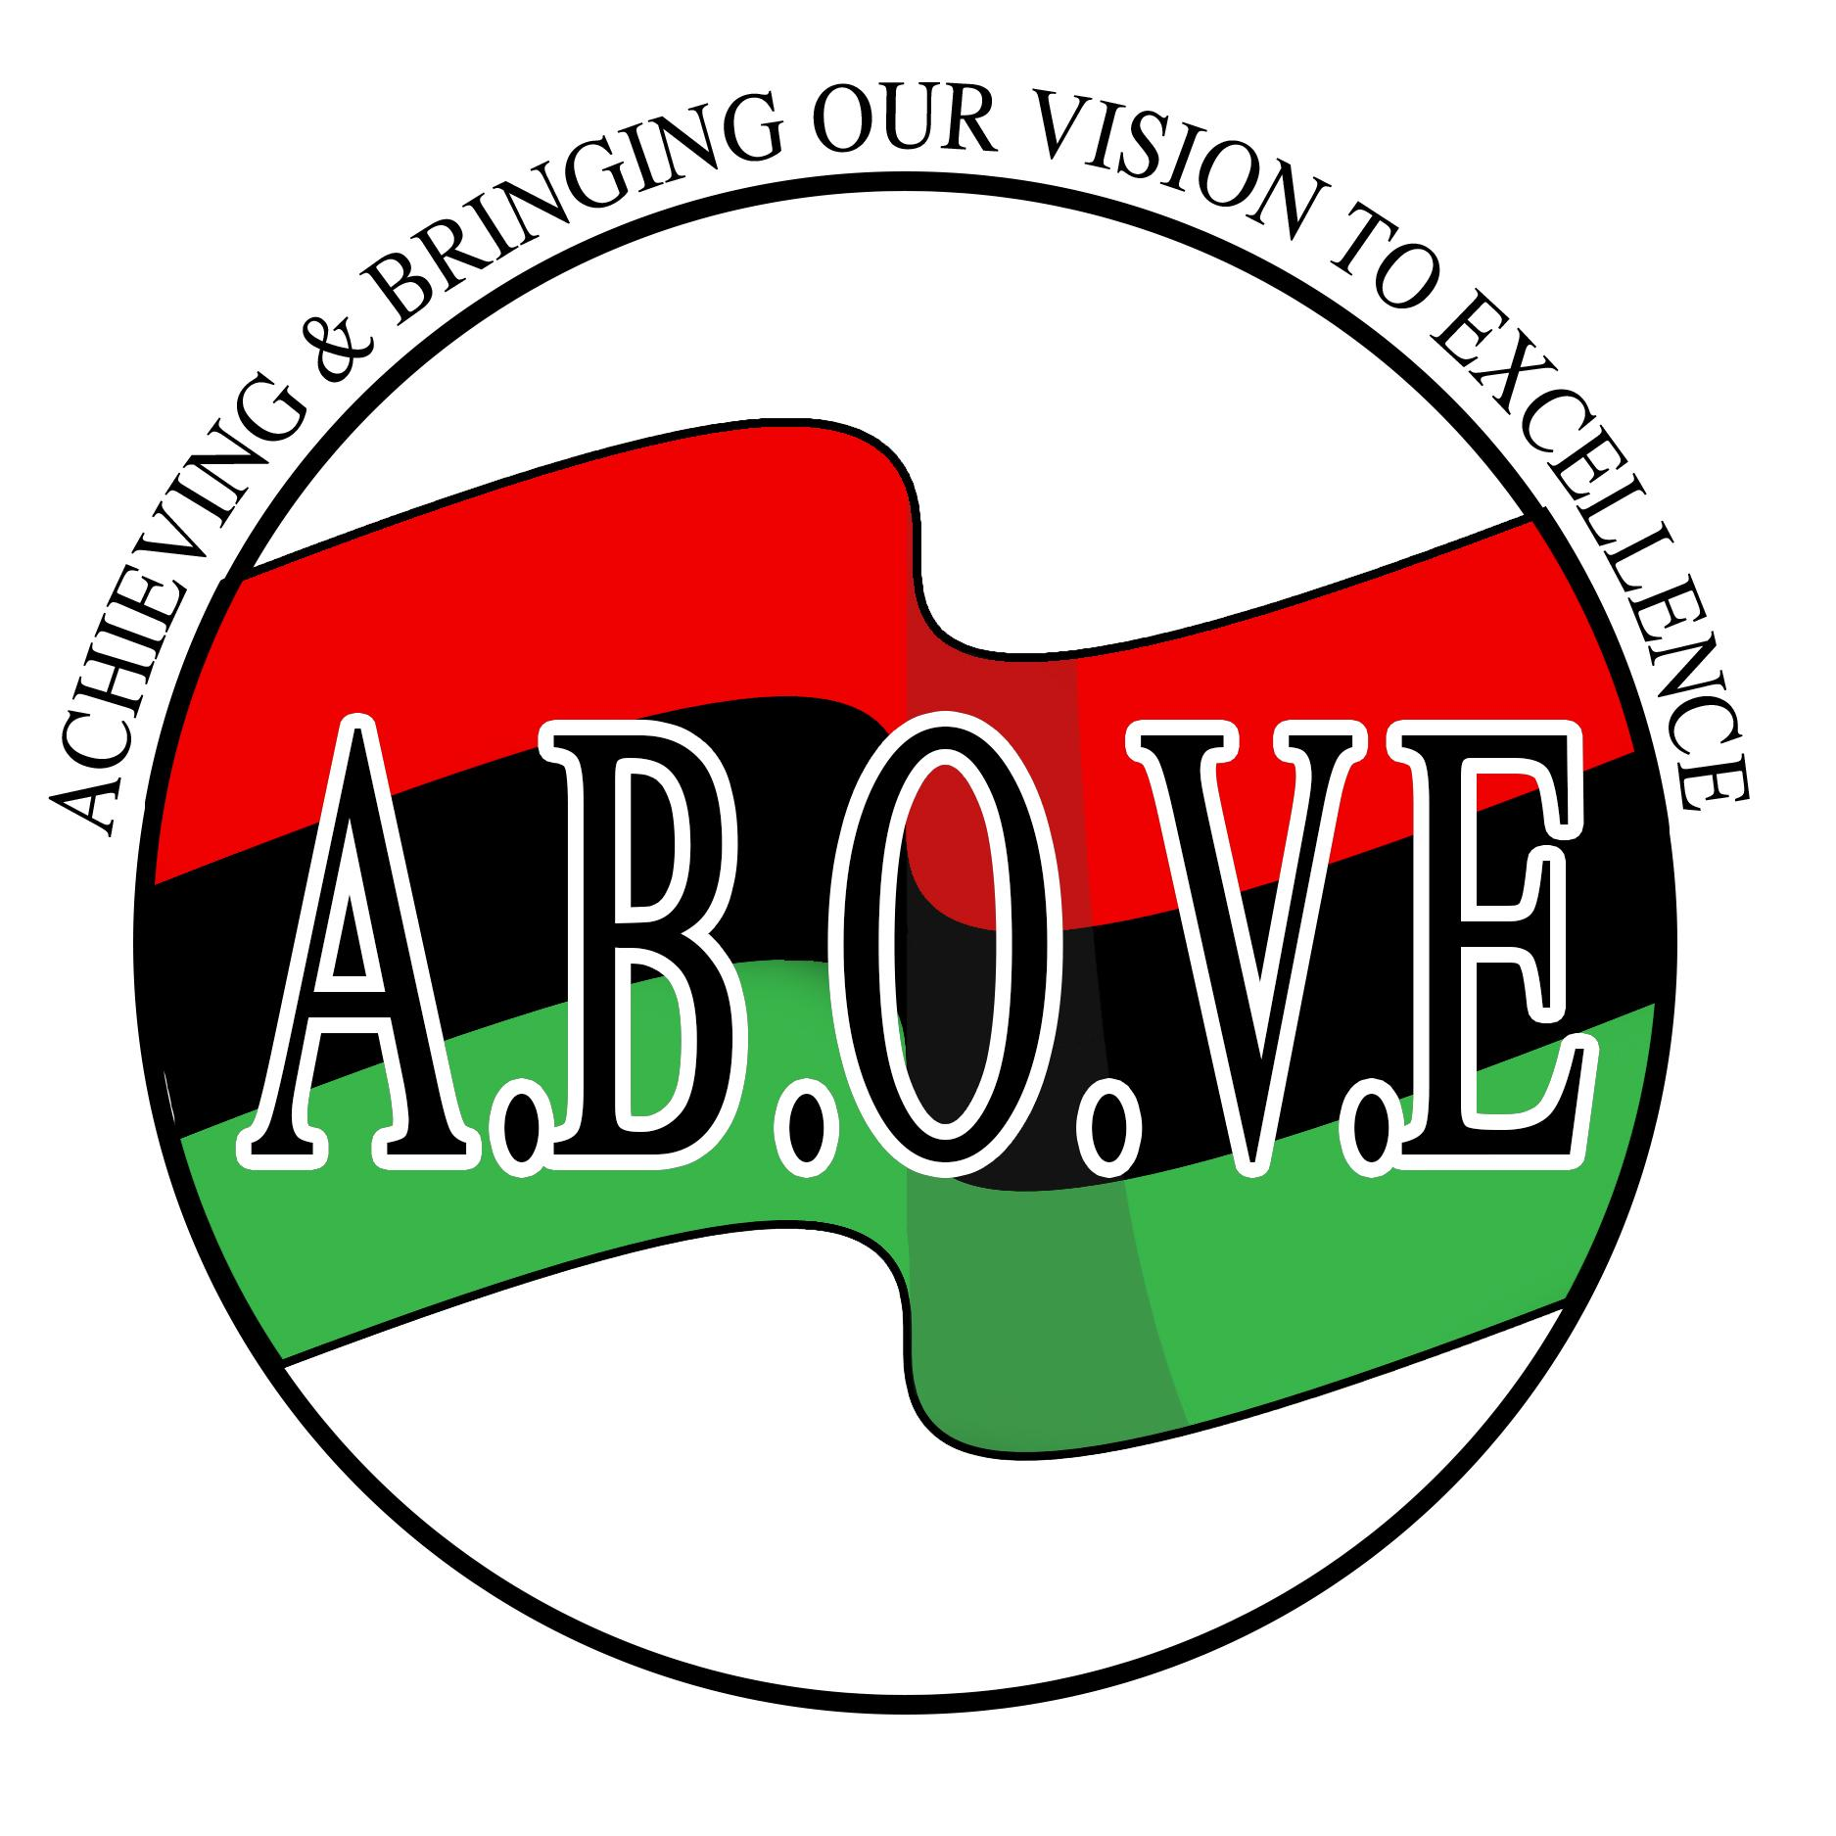
A.B.O.V.E
(Acheiving & Bringing Our Vision to Excellence)

A.B.O.V.E. (Acheiving & Bringing Our Vision to Excellence) is pleased to present its eleventh annual Afrikan American Cultural Festival, Saturday, August 3, 2019 at Highland Bowl Park in Rochester, New York from 12pm to 9pm.

The purpose of this special day is to celebrate Afrikan American heritage and culture through music, dance, art, literature, education and spoken word. In addition, the festival will build unity, pride, and self-esteem in an effort to improve the quality of life in our community. There will be an area for children that will include face painting, pony rides, carnival games, and story telling from 12-4pm.

The event is open to the public and attendance is encouraged among people of all ethnic and cultural backgrounds. It is our belief that knowledge of culture generates understanding among all people. It is for this reason that we encourage everyoneto come and join us in the festivities.

We are seeking your support by purchasing an ad to display your company’s logo/name on our festival website and stage banner to proceed with the planning of this event. The website logo/ad will be placed on our website at https://afamfestival.org/ and in addition to that, the banner will be displayed accross the stage and viewed by all participants/attendees of the festival! The price is as follows:

Stage Banner Logo recognition – $50.00 (banner price is the same for both color or black and white ads)

Stage Patron (Name) recognition – $25.00

Website Logo/Name recognition - $25.00

*Please send 6” x 4” Jpeg to info@afamfestival.com

A.B.O.V.E
(Acheiving & Bringing Our Vision to Excellence)

Company/Individual Name _________________________________________________

Contact Information:

Name __________________________________ Title ___________________________

Address ________________________________________________________________

City _________________________________ State _____________ Zip _____________

Phone ________________________________ Fax ___________________________

E-mail __________________________________________________________________

Signature_________________________________________ Date___________________

My Signature indicates authorization to make this commitment on behalf of my company

YES! We want to support A.B.O.V.E. Afrikan American Festival on Saturday, August 3, 2019. Please note that the deadline is June 1, 2019.

Stage Banner logo ad - $50.00 _____________

Stage Banner Patron ad - $25.00 _____________

Website logo/Patron ad - $25.00 _____________

Please make payments online @ https://afamfestival.org/ or mail this form and make checks payable to and mail this form to:

A.B.O.V.E.
PO Box 14131
Rochester, NY 14614

Thank you for your contribution !
This contribution qualifies for a charitable tax deduction.

