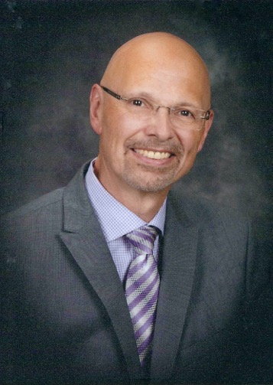
Robert de Frece is Professor Emeritus of Music and Music Education at the University of Alberta in Edmonton. Since his retirement in 2008, Dr. de Frece has continued his association with the university as director of the U of A Mixed Chorus and the U of A Faculty of Education Handbell Ringers.

He founded Edmonton’s Greenwood Singers in 1980 and continues as their Artistic Director. Dr.de Frece served for two years on the National Board of Directors of the Association of Canadian Choral Conductors and is a past president of the Alberta Choral Federation. He was Alberta’s Assistant Provincial Carillonneur from 1971 to 1979 and Provincial Carillonneur from 1979 to 1996.

In 1993, Dr. de Frece was awarded the Faculty of Education's Undergraduate Teaching Award and the University of Alberta's A. C. Rutherford Award for Excellence in Undergraduate Teaching. In 1998, he was awarded the Alberta Choral Federation’s Con Spirito Award in recognition of dedication and commitment to choral music. In 2002, he received the University of Alberta Alumni Association’s Alumni Honour Award in recognition of his work with the University of Alberta Mixed Chorus and, in 2004, he was named to the Edmonton Cultural Hall of Fame and also received the Alberta Choral Federation’s Richard S. Eaton Award of Distinction for exemplary service to choral music in the Province of Alberta. In 2005, he was awarded the Alberta Centennial Medal.

As the author of a number of textbooks, Dr. de Frece has presented music education workshops throughout Canada and the United States and in the People’s Republic of China, and has established a wide reputation as an adjudicator and guest conductor.

Actively involved in community leadership, Pamela Giesbrecht (A.R.C.T., A. Mus. First Class Honours Piano Performance), has a passion for bringing people and ideas together.
Over the past twenty years, she has worked with those in Albertan communities achieve their musical potential. With over twenty years of experience as an educator in the music community, Pamela is sought as an adjudicator for provincial music festivals.

Desiring to share the joy of music with others, she formed Bella Vita Music in 2010. Offering music-based educational workshops and delivering customized musical performances for private and corporate functions, Pamela strives for excellence in musical education and performance.

Actively leading in the music community, presidential leadership roles have included the Leduc and Area Music Teachers Association (LAMTA) 2009-2011, and the Alberta Piano Teachers Association (APTA) 2010-2012. As ongoing learning is an important part of her life, this winter, she will achieve her Bachelor of Human Resources and Labour Relations.
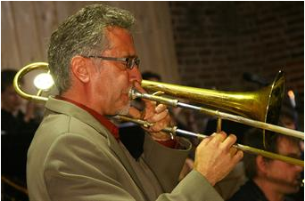
Allen Jacobson is a Trombonist, Vocalist, Composer, Arranger, and Educator who has performed throughout Canada and internationally for many years. During the course of his career he has established a reputation as an outstanding performer and educator.
He has performed with the Edmonton Symphony Orchestra, the Baden Baden Philharmonic (Conductor & Soloist), the European Philharmonie (Conductor, Soloist) the Citadel THEATRE, Tommy Banks Band, The Joan Rivers, Rich Little and Red Skelton Shows, European productions of Cats, Chicago and Cabaret, West Side Story (among numerous others), The EdJE (the JUNO nominated Edmonton Jazz Ensemble), film scores, jingles, modern dance collaborations and numerous commercial recordings.

Mr. Jacobson has performed in a wide variety of musical contexts including Theatrical, Symphonic, Mainstream Jazz, Contemporary Pop, Afro-Cuban, Latin Jazz, Blues, Big Band, Modern Dance, Avant Garde/Free Improvisation and numerous others and has performed at Jazz and World Music Festivals throughout Canada and in Europe, Scandinavia and Asia.

As an Educator, Mr. Jacobson has many years of experience as an adjudicator, providing workshops/seminars and in private teaching. He has provided workshops/seminars to schools, Colleges and Universities throughout Western Canada and Germany, and was a faculty member of the Performing Arts Universities of Frankfurt, Mannheim and Mainz.

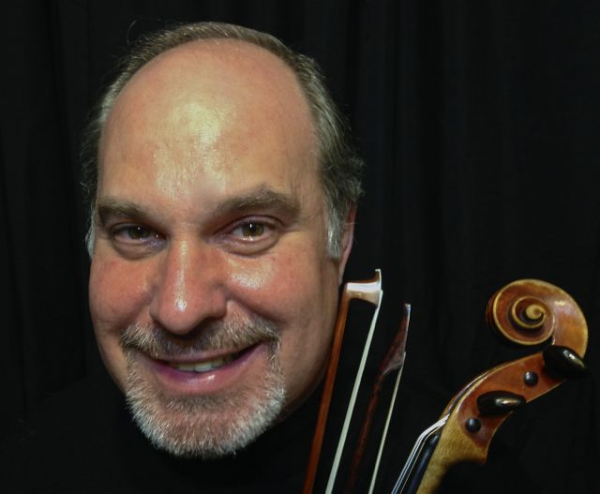
Thomas Schoen was born in Dawson Creek, B.C., has a Bachelor of Music degree in violin performance from the University of British Columbia, has studied at the Banff School of Fine Arts, the Royal Conservatory of Music in Toronto and Suzuki Institutes in Calgary and Edmonton, Alberta, Steven's Point Wisconsin (on scholarship as a Suzuki Teacher Training Scholar), and Seattle Washington. Thomas has completed and registered all 10 violin units of short term teacher training, the violin practicum, as well as an overview of viola books 1-3 with the Suzuki Association of the Americas. He has been the recipient of many scholarships, won first prize in the Vancouver Friends of Chamber Music Competition and has received awards in many other festivals and competitions.

Thomas currently resides in Edmonton and enjoys a busy and varied performing career as a recitalist, chamber, and orchestral musician, performing on both modern and baroque violins. He subs regularly with the Edmonton Symphony, has played with the CBC Vancouver Chamber Orchestra, the Saskatoon Symphony Orchestra, the Okanagan Symphony, the Royal Conservatory Orchestra, the Oshawa Symphony, where he played as principal second violin, and the Vancouver Early Music Festival Orchestra among others. He performs regularly throughout Canada with the Schoen Duo who are well known for their concerts and educational programs and have been recorded by the CBC and broadcast in Alberta on the program Our Music.

Mr. Schoen has extensive experience teaching and adjudicating in both British Columbia and Alberta. He is currently violin instructor at the Augustana Faculty of the University of Alberta, as well as teaching for the Society for Talent Education in Edmonton. He also conducts string ensembles for the Society for Talent Education, has coached string sectionals for numerous youth orchestra and gives frequent workshops in the schools. In addition to his teaching duties, Thomas is also director of the Alberta Summer Suzuki Institute held in Edmonton in July, and Music Program Co-ordinator for the Society for Talent Education.

Carmen So is known for her passion, creativity, and innovation in the music learning process. Her two decades of experience in music education includes private piano and voice instruction, vocal coaching for musical theatre, and conducting the All-City Junior Children's Choir and the Braille Tone Choir, a choir for individuals with exceptionalities.
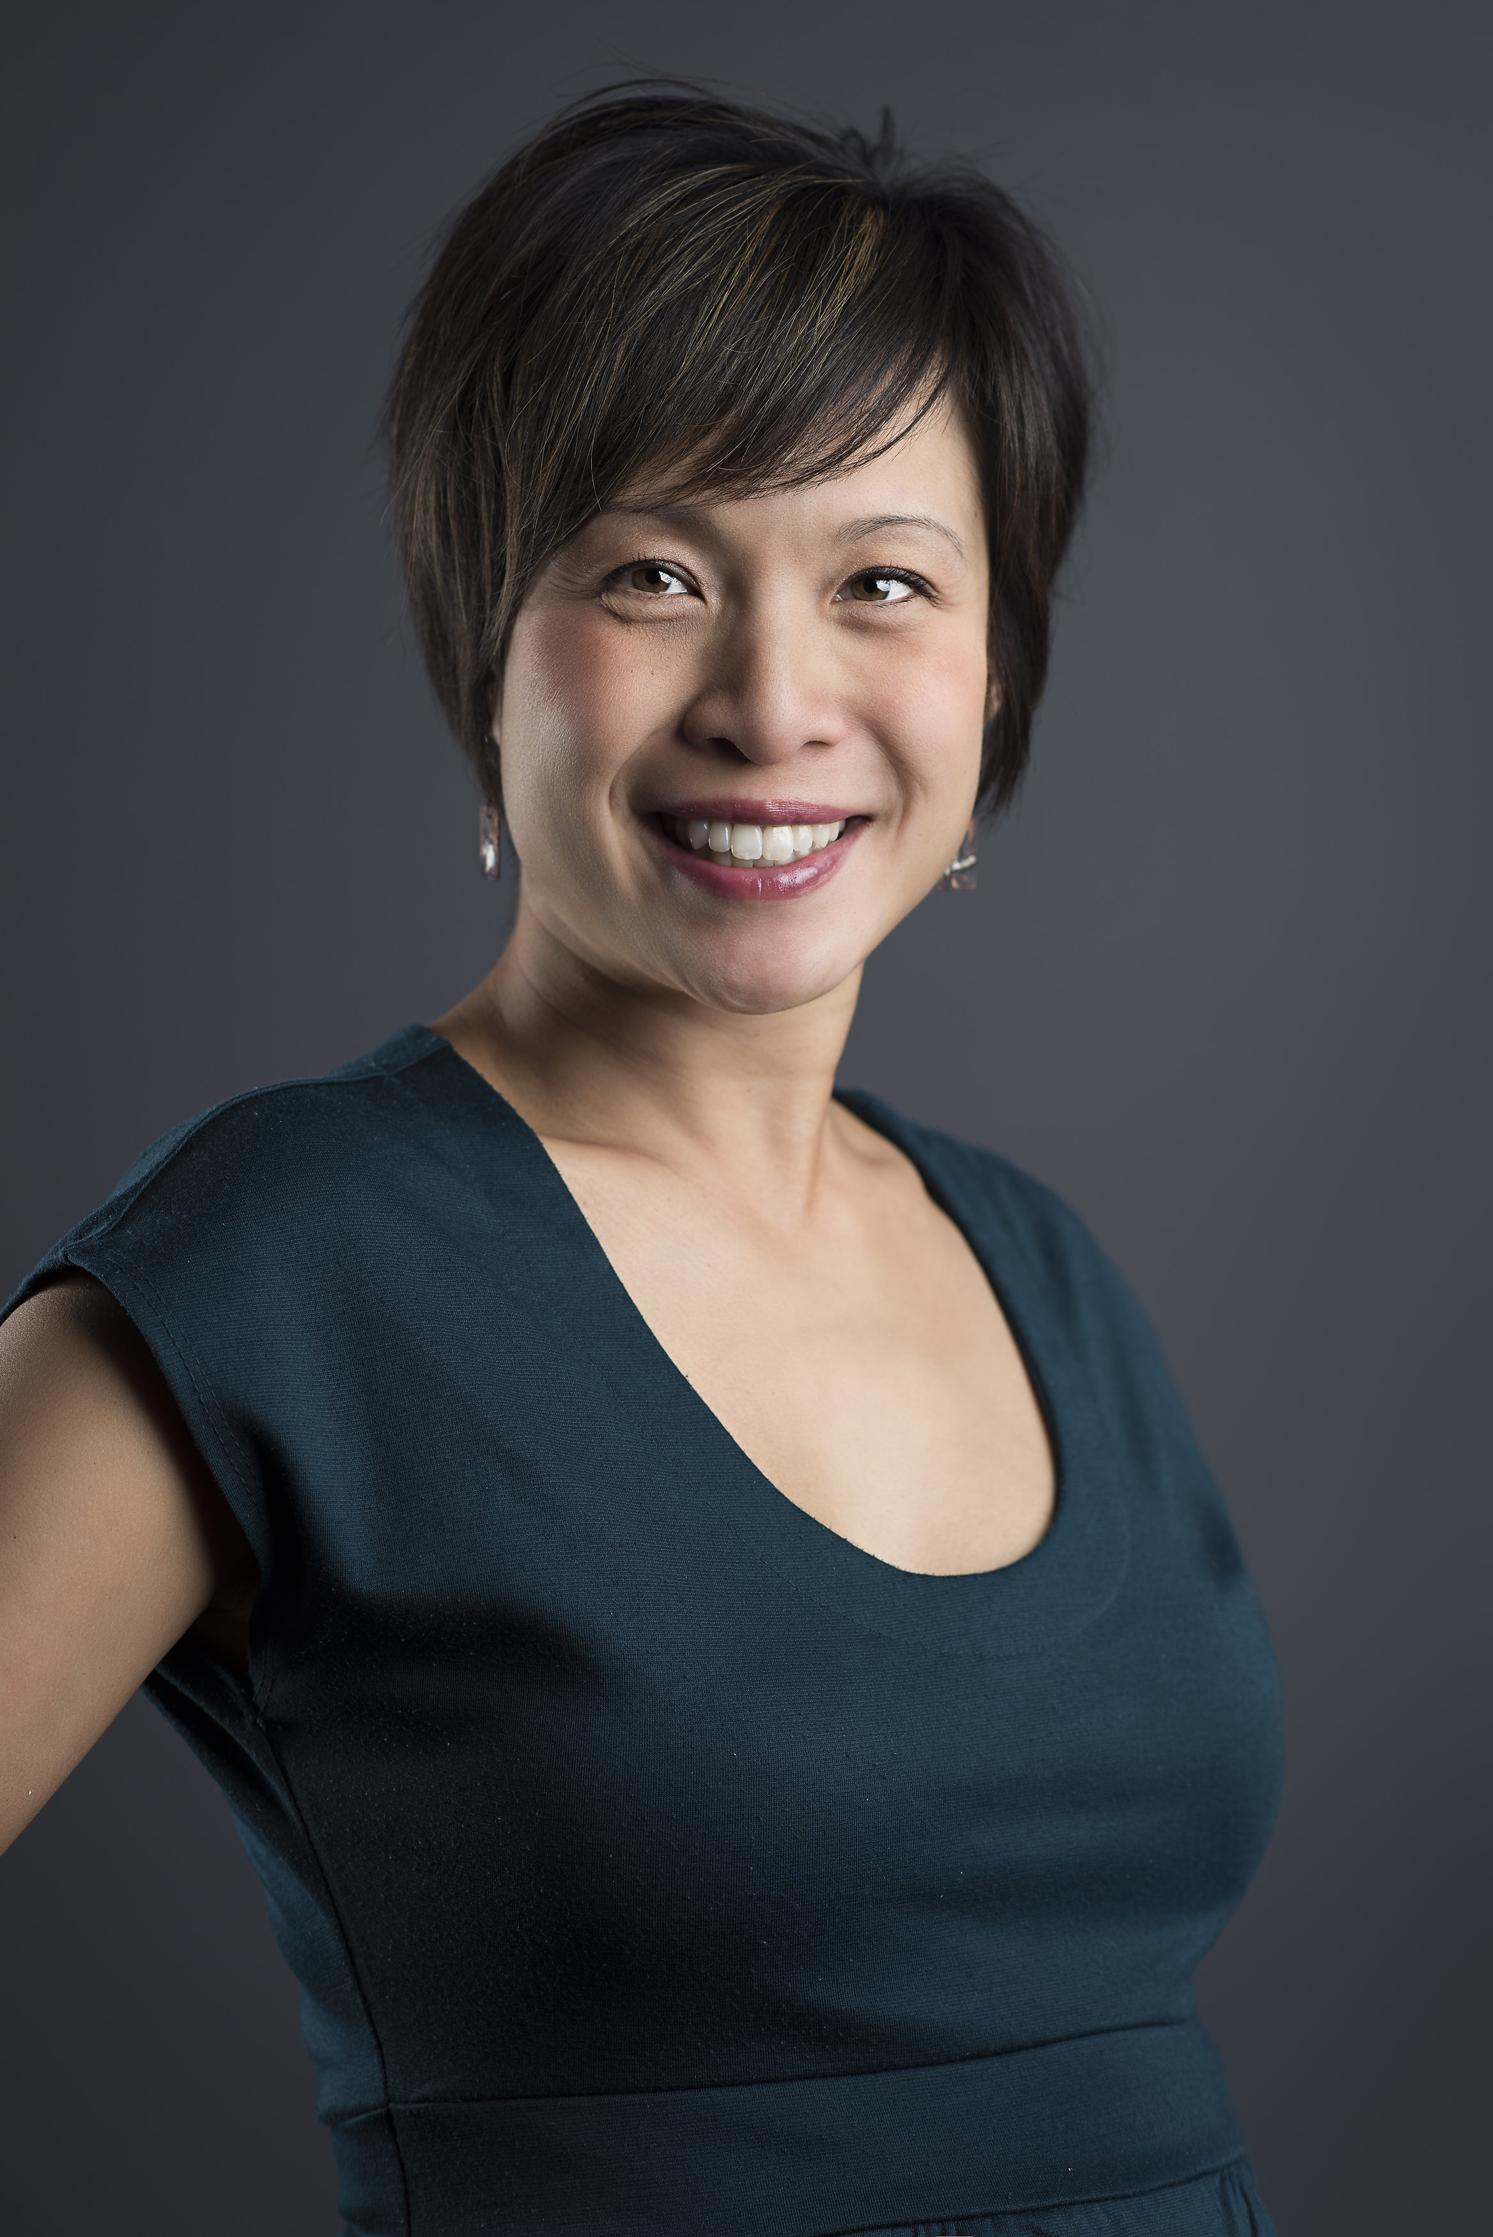
Ms. So is the founding director of Kokopelli's children's choir, Kikimasu, which was featured in a spotlight concert at the national PODIUM Conference in 2016. As a veteran teacher with the Edmonton Public School Board, she is currently the music specialist at Rutherford School.

She attained both her Bachelor of Music/Bachelor of Education combined degrees (2004) and a Master of Education degree specializing in Elementary Music (2015) from the University of Alberta. Ms. So holds a Level III certification in Orff Schulwerk and has completed the first two levels of Kodály training. As a lifelong learner, she is always searching for opportunities to learn and adores all things involving creative pedagogical practices. She is inspired by working with musicians from all walks of life and feels blessed to have such a wonderful career as a music educator.

