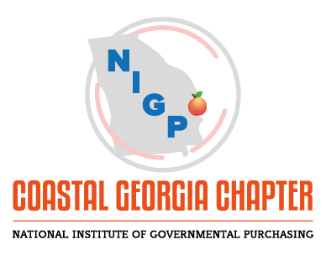

COASTAL GEORGIA CHAPTER OF NIGP MEMBERSHIP APPLICATION/INVOICE

2019 DUES $80.00 (DUE BY February 15, 2019)

Please complete the following information and return this form with your payment.

NAME:

TITLE/AGENCY:

ADDRESS:

PHONE:

EMAIL:

T-SHIRT SIZE: ____________ LONG SLEEVE OR SHORT SLEEVE? (SPECIFY ONE): _____________

TYPE OF MEMBERSHIP:
___________NEW ______RENEWAL

TYPE OF CERTIFICATION HELD: CPPB CPPO CMP

OTHER

ARE YOU A MEMBER OF NIPG (NATIONAL)? YES NO

___

___

Please make check payable to: Coastal Georgia Chapter of NIGP

Mail checks to: Coastal Georgia Chapter of NIGP Coastal Georgia Chapter of NIGP
C/O Lisa Lansford, CPPB
Georgia Ports Authority Purchasing Department
P.O. Box 2406
Savannah, GA 31402

