The Impact of Filariasis in India
Lalitha Guruju
George Mason University

Author Note
This paper was prepared for GCH 360 Section 002, taught by Professor Snyder
Introduction
There are many types of waterborne diseases that impact the population in India. Waterborne diseases are caused by having parasites in many contaminated water bodies within a certain population. For example, if people live near unsanitary waters such as sewages, they are more likely to get infected with the disease. One of the diseases that has been a major waterborne health problem in India is Filariasis. Of course, the main source of getting infected is drinking the water or using the bathroom. Having said that, this disease is also spread by mosquitoes, but how? When the mosquitoes swarm around and breed on stagnant waters, they travel to other unsanitary waters around the area, and people eventually get infected with the parasite. The main host is known as the filarial nematode worm, it effects humans and slowly causes encephalitis.
Filariasis is on the charts for one of the neglected tropical diseases. There are three main types of filariasis disease that are existing in many parts of the world. The first type is lymphatic filariasis, it is also known as elephantitis. This is transmitted from mosquitoes to humans. The disease is acquired during childhood and causes severe damage to the lymphatic system (p.1). According to the WHO, this type of filariasis is caused by infection with roundworms from the parasitic family Filariodidea. Within this parasite, there are three different types of filarial worms. Wuchereria bancrofti is the most common and causes more than 90% of cases. Brugia malayi causes the remainder of the cases, and Brugia timori causes the disease. These worms are known to be the most serious public health threats (Marty, 2015). It disturbs the lymphatic system and the lymph nodes of the body. The second type is Subcutaneous Filariasis. This type causes skin damage in the fatty skin layer and is caused by the parasites; these include Loa loa, also known as eye worm, Mansonella streptocroca, which causes streptocerciasis disease and Onchocerca volvulus, which causes river blindness (Mandal, 2016). The last type is called Serous cavity filariasis. This is cause by parasitic worms such as Mansonella perstans and Mansonella ozzardi. Both of which cause infection in the serous cavity of the abdomen (Mandal, 2016).
Background of Lymphatic Filariasis
The type of filariasis that is most common in India is Lymphatic Filariasis, or elephantitis. This is because the climate is extremely hot and there are many mosquitoes which invade the Indian region. According to the CDC, people of this sub-continent are at risk for developing LF because they suffer from having repeated mosquito bites over and over again every month. Also, people who live in tropical such as India are at greater risk on infection (p. 2). The main type of parasite which is found in this region is B. malayi. As stated before, LF can disrupt the lymphatic system functions. If a person is infected, there will be an abnormal enlargement of different body parts. It generally affects the legs, but also affects other body parts such as the arms, breasts for both men and women, and genitalia. This is because there is thickening of the skin and tissue in these areas since the excess amount of fluid is build up inside. It causes much pain and disability for someone to function normally. Since it is common for having enlarged legs, people will have difficulty walking regularly. And of course the social stigma arises as well, people will question whether they fit into society or not. Outsiders will look at them as though they are an outsource (Zazula, 2015).
The Center for Disease Control gives us a basis of how Lymphatic Filariasis is spread. After a mosquito bites a person who is already infected with LF, there are microscopic worms which circulate in the person’s infected blood. It will infect the mosquito as well and carry the microscopic worm (host) to other people it bites. The worms pass through the mosquito to the skin and eventually goes into the lymph vessels. The worms remain in the lymph vessels for five to seven years and grow into adult worms. When the adult worms mate, they release microscopic worms, also known as microfilariae into the blood. This illustration gives us a better 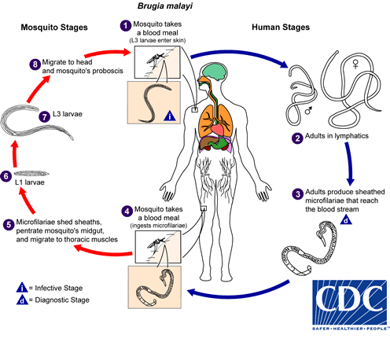understanding of how the life cycle of Lymphatic Filariasis is spread (p. 2).
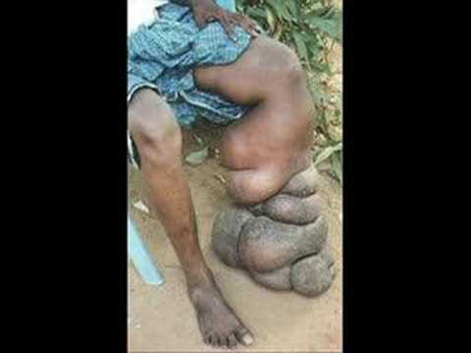
Fig. 2 Image of Elephatitis on leg

Fig. 1 Life Cycle of Filariasis
Prevention and Methodology
There are many ways to prevent Filariasis in the population of India. According to the Center of Disease Control (2013), the most helpful method used is by identifying the microfilariae through microscopic examination. In many parts of the world such as India, microfilariae are nocturnal, meaning that they only circulate blood at night time. Moreover, blood collection has to be done at night so that the microfilariae are easier to spot. As far as prevention goes, avoiding mosquito bites especially at night time is essential. Other prevention strategies such as sleeping under a mosquito net, wearing long sleeves and trousers, and using mosquito repellent on skin between dusk and dawn (p. 3). People who have already been infected with the worms can take a yearly dose of medication called diethylcarbamazine (DEC). The CDC quotes that this medication, “kills the microscopic worms circulating in the blood. While this drug does not kill all of the adult worms, it does prevent infected people from giving the disease to someone else”. There are three basic principles that the CDC encourages with people infected with LF. First, washing the swollen area with soap and water everyday. Second, elevate and exercise the swollen area to move the fluid around and improve the lymph flow. Lastly, disinfect any wounds by using antibacterial cream if necessary (p. 4).
According to the Indian Journal of Dermatology, Venereology, and Leprology (2004), there have been recent advancements in diagnosing Lymphatic Filariasis. The first diagnosis is the membrane filtration method for microfilaria detection. This is when blood is drawn at night and filtered through what’s known as milleporiae membrane filters. It allows easy detection of microfilariae and quantifies the load of infection. Within this filtration method, there is the quantitative blood count method. This is used to identify the microfilariae and their morphology is studied in the blood drawn at night time. Lyphoscintigraphy is mainly used for patients suffering from or showing symptoms of elephantitis. This test helps normalize the structure and function of the lymphatics involved with a limb. Radiolabeled albumin or dextran is injected in the web space of toes. A gamma camera is used to identify the structural changes of the limb. There is dermal back flow and obstruction which occur on the limbs in this method. If the patient comes in at the asymptomatic stage of the disease, it will be easier to cure it by using this method. The last type of method that is discussed is the DNA probes using Polymerase Chain Reaction, also known as PCR. These tests are able to detect the parasitic DNA found in infected humans and vectors found in brugian filariais. Although this method simple and easy to perform, it requires many types of equipment for the test (Anitha & Sheony, 2001).
First Supporting Case and Example
The first case study talks about how lymphatic filariasis is a problem in India and how it should be evaluated because of the amount of people affected. It talks about how strengthening the mass drug administration is a strategy to eliminate lymphatic filariasis. This study was researched to see how a single dose of diethylcarbamazine (DEC) would function (p. 1). The people who were experiments of this study were located in the three districts of Madhya Pradesh. The three districts were; District A: Chhatarpur, District B: Datia, and District C: Tikamgarh. Faculty members from Gajra Raja Medical College visited these districts and had interviews, desk review, and site observations of the people who were administered by the drug. Lahariya & Mishra (2008) quote, "the study was conducted as per the standard guidelines prepared by the National Vector Borne Disease Control Programme. In every district, four clusters (three ruraland one urban) of 30 house- holds each were selected. It was ensured that at least 600 people are covered in a single district for MDA evaluation. For selection of rural sites, on the basis of reported MDA coverage in the last round, all Primary Health Centers (PHCs) in a district were stratified into three groups: (i) PHC with coverage <50%; (ii) PHC with coverage between 50 and 80%; and (iii) PHC with coverage >80%” (p. 314). Researchers implied that there should definitely be more organization when administering the drug because many patients from the three districts of Madhya Pradesh are economically struggling (Lahariya & Mishra, 2008). The filaria units that were being held in these districts were understaffed. Even though there was an enough amount of the drug, the recording of the data was poor. This study further argues that there is not enough attention of preventing lymphatic filariasis. It is a major concern for this developing country because the rate of this tropical disease is increasing and there has to be an organized conducted experiment of the drug so that it can be given to the public (p. 2). Researchers learned from the study and came up with having more staffing in these districts so that there is enough about of healthcare professionals and health educators to help with administering the drug to the patients. They also imply that the MDA (mass drug administration) program in India will achieve the goal of LF elimination with the proper care and attention given by healthcare professional to the patients in these districts (Lahariya & Mishra, 2008).
Table 1: Coverage and Compliance observed by the evaluation teams
District ~ Total Population surveyed ~DEC tablets~ Percent coverage in evaluation~ Percent coverage reported by district authorities~ Compliance*
District A 667 195 28.8 85.2 151 (171)
District B 780 476 61.0 NA 292 (61.3)
District C 716 486 67.9 77.5 361 (74.2)
Second Supporting Case and Example
The second case study I researched was about how socio-economic determinants in India’s population impacts the elimination of lymphatic filariasis. Health behavior can help behave in certain ways according to where the person lives and the society that they live in. This study further discusses the attitude that is shown in Pondicherry, India towards getting overall treatment for lymphatic filariasis. KAP, also known as knowledge, attitude, and practice are what were studied in the people of this population (p. 346). These aspects were measured using questionnaires which identified all the variables from data collection in both men and women of the population. According to the researchers Perumal and Subbiah (2007), they quote “knowledge on disease treatment, mode of transmission, prevention and income explain about 29% of variation that occurs in knowledge on mosquito breeding and control. Standard of living, knowledge on disease transmission and knowledge on mosquito breeding and control explain 23% of variation in practice measures against mosquito biting. Knowledge gained on disease treatment, prevention, diagnosis and knowledge on mosquito breeding and control is greatly improving the prevention practices against mosquito breeding and control” (p. 346).
Analysis and Conclusion
This paper talks about the research discussed about Filariasis in India. The introduction talks about what Filariasis is, the types of filariasis there are and which type is most common in the Indian sub-continent. The background discusses Lymphatic Filariasis since in the most common type of Filariasis found in India. The prevention and methodology talks about what methods are given by the CDC and the what the Indian Journal of Dermatology, Venerology, and Leprology methods are used in India. There are two case studies which support Lymphatic Filariasis in India. The first case study demonstrates mass drug administration in India to eliminate Lymphatic filariasis. The second case study discusses about how health education plays a part of having knowledge of the disease to see if the population will respond to getting treatment for Lymphatic Filariasis. Overall, I learned that the reason why India is having such a difficult time overcoming LF is because of a lack of health education for certain populations and the lack of having poor organization skills when the drug diethylcarbamazine (DEC) is administered to the patients because of less healthcare workers being brought to a certain region in India.

References
Shriram, A. N. Diurnally subperiodic filariasis in India—prospects of elimination: precept to action. Parasitology research (1987). (07/2011), 109 (1), p. 1 - 8.
Elimination of lymphatic filariasis - second meeting of the Global Alliance to Eliminate Lymphatic Filariasis, India. Canada communicable disease report. (08/01/2002) , 28 (15), p.n a
Babu, B. V. Coverage of, and compliance with, mass drug administration under the programme to eliminate lymphatic filariasis in India: a systematic review. Transactions of the Royal Society of Tropical Medicine and Hygiene. (09/2014) , 108 (9), p. 538 – 549).
Lahariya, Chandrakant Strengthening of mass drug administration implementation is required to eliminate lymphatic filariasis from India: an evaluation study. Journal of vector borne diseases. (11/01/2008) , 45 (4), p. 313 - 320.
Perumal, Vanamail A quantitative analysis of the socio-economic determinants of health seeking behaviour related to bancroftian filariasis and its impact on elimination: a case-control study in Pondicherry, India. Journal of Public Health. (10/2008), 16 (5), p. 339 - 346.

