OUR LADY OF LOURDES, ROTTINGDEAN and ST. PATRICK’S, WOODINGDEAN

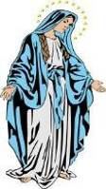
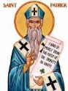
Eastfield, Steyning Road, Rottingdean BN2 7GA Website: www.ololandstp.org
Office email: ololandstp@outlook.com Office tel: 01273 302903
Priest: Mgr. Benny O’Shea 07802 791394 Deacon: Rev. Neil Mercer 07801 706167
Also resident: Canon Oliver Heaney and Canon Daithi Foley
COVID-19 - Guidance from the Government and The Bishops’ Conference is now allowing Places of Worship to reopen for the celebration of Mass. While this is very good news we still need to follow the strict guidelines from the Govt . Live Streaming of Masses from OLOL –
Link: https://www.youtube.com/channel/UCc4VXBr3EOa43nCxxzB-Edw
** OPENING TIME OF CHURCH FOR PRIVATE PRAYER THIS WEEK ***** TUESDAY & FRIDAY MORNING AFTER MASS
PLEASE NOTE MASS TIMES THIS WEEK *********** Monday, Tuesday, Thursday & Friday - 9.30am
PLEASE CHECK THE PARISH WEBSITE REGULARLY FOR ANY UPDATES
The Parish is part of the Diocese of Arundel & Brighton Diocesan Trust Registered Charity No.252878
Services and Intentions THE WORD WHO IS LIFE
Sunday 9 August | 6.30pm(Sat) OLOL  9.00am - St. Patrick’s  10.30am OLOL | **Weekend Masses with Congregation  **Vigil Mass  **OUTDOOR MASS -Church Garden  **19th Sunday in Ordinary Time | Welfare of Barbara Ann Bryant  People of the Parish  Victoria Schofield R.I.P. (R)
Monday 10 August | 8.30-9.25am  **9.30am | Adoration  Mass St. Lawrence***with Congregation | Michael Buni R.I.P.
Tuesday 11 August | 8.30-9.25am  **9.30am  10.00am – 11.00am | Adoration  Mass St. Clare***with Congregation  Time of Adoration/Private Prayer | Fr. John McSheehy R.I.P.
Wednesday 12 August | ---------------- | ------------------------------------- | -----------------------------------
Thursday 13 August | 8.30-9.25am  **9.30am | Adoration  Mass ***** with Congregation  Ss Pontian &Hippolytus | Welfare of James McGilligan
Friday 14 August | 8.30-9.25am  **9.30am  10.00am – 10.30am | Adoration  Mass St. Maximilian Kolbe ****with Congregation  Divine Mercy Prayer Time | Tessa Carrington, Deceased Relatives & Friends R.I.P.
Sunday 16 August  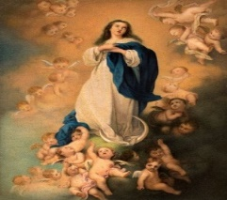 | 6.30pm (Sat)  9.00am - St. Patrick’s  10.30am | **Weekend masses with Congregation  **Vigil Mass  **OUTDOOR MASS-Church Garden  **ASSUMPTION OF THE BLESSED  VIRGIN MARY | People of the Parish  Fr. Edmund Geoghegan R.I.P.  Janet Robson R.I.P.

OFFERTORIES Thank you for the following cash and envelope collections for Our Lady of Lourdes:
Sunday 26 July £302.39, Sunday 2 August £189.50 and also for 2nd Collection for CAFOD: £118.12.
THANKS also to those who have Standing Orders.
Please pray for the repose of the soul of Diana Coutts who died during the week. Her Funeral Mass will take place at Our Lady of Lourdes Church, Rottingdean on Tuesday 18th August at 10am. May she rest in peace.
JESUS WALKING ON THE WATER – PETER SINKING!
What can we take from this account in Matthew’s Gospel today? The Evangelist, when writing, would have known the whole story of the Life, Death, Resurrection and Ascension of Jesus.
The BOAT – representing the CHURCH.
The DISCIPLES- beaten by the winds and the waves of PERSECUTION.
JESUS – once again comes to help them in their HOUR of NEED.
PETER sinking and being saved by Jesus – probably a reference to Peter’s FAILURE during the Passion, and his RESTORATION after the Resurrection.
Peter represents the typical disciple, caught between FAITH and DOUBT.
Jesus’ rebuke to Peter – ‘Man of Little Faith! Why did you DOUBT?’ is directed at us, who often start out courageously only to lose heart when faced with a crisis. ‘LORD, INCREASE OUR FAITH’

Please remember all those recently deceased members of our parish and others known to us. Please pray for their families also at this time.

Visits to the Sick/Hospital/Housebound: If you know of anybody who is sick please contact the Parish Office with details.
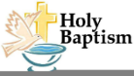
BAPTISM marks the beginning of the Christian’s life of Faith and preparation can now begin.
Ring the parish office or e-mail to start the process.

PLEASE PRAY for all our sick parishioners who are in nursing homes or housebound, listed in our chapels, but especially for Alison Stainthorpe, Sami Ghazal, Sophie Reilly, Ann Chapman, John Heal, Sandra Waugh, Eileen Cross, Carole Goudy, Victor Hopkin, Eileen Noakes, Una McLaughlin, Veronica Westbury, Sr. Agnes, Colin Allen and Fr. Tony Collins. Please let Fr. Benny know if you would like a name added.
Our Lady of Lourdes & St. Patrick’s – MASSES - LIVE STREAMING
Link: https://www.youtube.com/channel/UCc4VXBr3EOa43nCxxzB-Edw

SEE PARISH WEBSITE -www.ololandstp.org FOR ALL UPDATES

PLEASE BE AWARE

It is essential to be at the church 15 minutes before mass starts, so that a steward can show you where to sit.

Please enter the church in the normal way and exit through the double doors at the rear of the church.

Important: Please sanitise your hands on entry into the church. Refrain from touching anything in the porch.

There will be no missals or hymn books and therefore no congregational singing during mass.

There will be no sign of peace.

Kneelers in the pews should not be used.

Receiving Communion: Please remain seated until directed by a steward to proceed. Communion can only be taken in the hand with your arms outstretched to the full so that there is the required distance between you and the priest.

Important: At Communion after the response: ‘Lord I am not worthy....’ the priest will hold up the Host to the congregation and say “THE BODY OF CHRIST” to which the people respond “AMEN”. In the same way the people say “AMEN” after he has elevated the Chalice. This enables the people’s Communion to be distributed in silence with no dialogue, as they have already acclaimed the presence of the Lord.

There will be collection baskets for Offertory Collection at the entrance and exit from the church.

Please disperse as quickly as possible after mass.

Those attending Mass/ Services in Churches should limit their interactions with anyone they are not attending church with, i.e. if they are attending corporate worship with one other household, wherever possible they should maintain social distancing with anyone outside of this group.
FACE MASKS are now compulsory in churches and places of worship.
Face coverings are to be worn in enclosed public spaces at all times.
They are also currently mandatory on public transport and shops and in supermarkets.

Thank you for your co-operation.

Magnificat: The last available parish delivery is September – anyone needing copies after that date needs to set up their own subscription service. Currently there is a special offer available - 4 months subscription for £14.00 This is available by phone on 0207 448 3618 or email subscriptions@catholicherald.co.uk

Catholic Universe Date of last publication we will receive (to be confirmed). You can register for a personal subscription, either digital or paper copies at https://thecatholicuniverse.com/

OLOL School will continue to support the Whitehawk Food Bank Project Information about future food collections will be posted on the School Website www.ourladyoflourdesprimaryschool.co.uk and in our parish newsletter.

Planning your MARRIAGE – It is probably very difficult at present to make definite plans, please remember that our diocesan guidance is that couples should give at least 12 months’ notice of intention to marry in order to allow time for discernment, preparation, prayer and reflection. If you are engaged and wish to discuss preparation Courses etc. please contact Fr. Benny or Deacon Neil.
MASS ON THE PHONE - If you are unable to access Live Streamed Mass you can listen to the celebration each SUNDAY at 12 Noon by ringing St. Mary’s Cathedral, Middlesborough on 01642 130120.

Many Thanks to Ian Watson who has made it possible for us to have mass on line at Our Lady of Lourdes. The link for live-streaming is https://www.youtube.com/channel/UCc4VXBr3EOa43nCxxzB-Edw

THE TABLET In these difficult times if you can't find your usual copy of The Tablet at the back of the Church or in your newsagent, you can subscribe here: https://www.thetablet.co.uk/subscribe You'll find we have quarterly, six monthly or annual subscription options on offer - so don't miss out and subscribe now and you'll guarantee yourself a copy every week. Or email Ian Farrar The Tablet's Marketing Manager for more information here ifarrar@thetablet.co.uk

The website, www.ChurchPaper.co.uk, contains the latest editions of the newspapers: A&B News, UCM s (Union of Catholic Mothers) Reach - Catholic Schools Paper

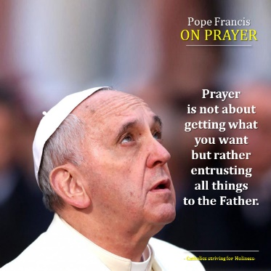
SVP Help Line During this period many people need our support and help. If you know of anyone who needs help, the SVP are on hand to look after the needs of our neighbours, be it shopping or giving support and advice when necessary. Contact Ann Knox on 01273 301252, john273knoxx@gmail.com

MEAL DELIVERY SERVICE St. Margaret’s and Our Lady of Lourdes have been involved in organising a distribution service of hot lunches (£6 per head) on Tuesdays, Wednesdays and Thursdays. If anyone is interested, please ring Ann (301252) or Eve (303126). The meals will be delivered to your door by a volunteer group.

The Holy Father’s Prayer Intention for August
The Maritime World

We pray for all those who work and live from the sea,
among them sailors, fishermen and their families.

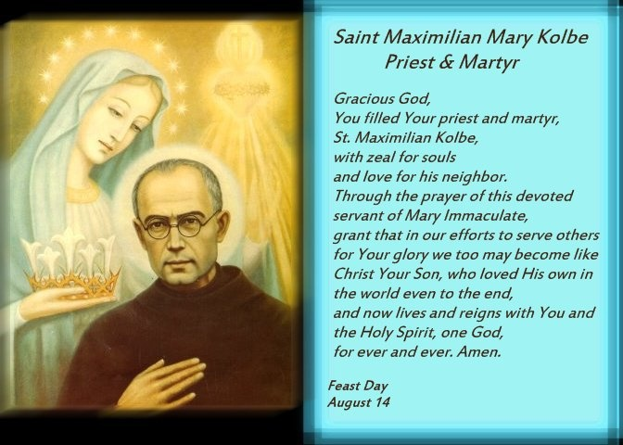

Father Maximilian Kolbe is a Saint! – Such was the proclamation by Pope Saint John Paul II on October 10, 1982, followed by the tolling of the bells of St. Peter’s Basilica in exultation of the martyr of Auschwitz! Met by the thunderous applause of thousands in attendance, including some of the surviving prisoners of the Nazi concentration camp – whose minds and hearts are forever branded with the memory of his saintly and heroic self-donation – their former cellmate had now been raised to the Altars of the Church! Once again, Christ reigns! Once again the enemy has been defeated!
Tracing back, however, to the inhumanity of World War II, where a shattering sense of hopelessness pervaded the death camps as the Nazis took over Poland, this place of infamy became the Calvary of the modern times. Anger and hatred filled the heart of every prisoner until one stepped forward from the prisoners of Block 14, among whom ten had been singled out in retribution for one escapee. Not initially selected, this obscure man – Father Maximilian Kolbe, a Catholic priest – voluntarily took the place of one of the ten, the father of a family, who, along with the others prisoners, had been sentenced to death by starvation.
Following the canonization Mass, the Holy Father emerged from St. Peter’s Basilica with his concelebrants, all garbed in red vestments, publicly proclaiming the Servant of God a martyr: a martyr of faith animated by love: “Greater love has no man than this that a man lay down his life for his friends” (Jn 15:12). That love, which is so very dear to the Franciscan life, was the summary of the life of St. Francis, the Poverello of Assisi. For this very reason, Pope Paul VI had called Blessed Maximilian the “St. Francis of our times” during his beatification ceremony some years earlier, on October 19, 1971.

