TBI, Pornography and Sexual Addiction: Is there a connection?
Angela K. Waggoner
Doctoral Student of Liberty University

Author Note
Angela K. Waggoner, P.O. Box 2476, Pearland, TX 77581 akwaggoner@liberty.edu
Angela K. Waggoner, a student within the Department of Counseling Education and Supervision, Liberty University, Lynchburg, Virginia

Abstract
About 69 million people have sustained a TBI each year (Dewan et al., 2018). TBIs have been linked to addictions and impulsive behaviors (Moore et al., 2019). This meta-analysis explores how TBIs link to pornography and sexual addiction.

TBI, Pornography and Sexual Addiction: Is there a connection?

Traumatic Brain Injury (TBI) is a physical assault to the brain, comprised of a direct hit to the head and it disrupts the typical function of the brain (Greco et al., 2019). According to the statistics, TBIs are the underlying cause for up to 30% of all injury deaths (Aldossary, Kotb, & Kamal, 2019, Dewan et al., 2018). TBIs have not only an impact on the individual but also the family and community (Pinto, Newman & Hirsh, 2018). Image 1 (https://vitamindwiki.com/VitaminDWiki) provides an example of how the brain images usually, with a concussion, or with a severe TBI,
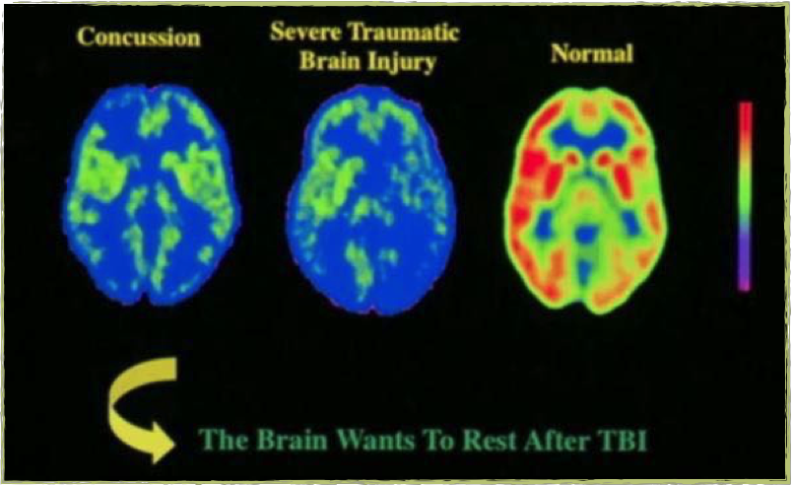
while the second image (https://www.researchgate.net/figure/Healthy-vs-Classic-PTSD-vs-TBI-vs-Both_fig2_275584043) provides a different imaging perspective of the brain showing a healthy brain versus PTSD versus TBI versus both.
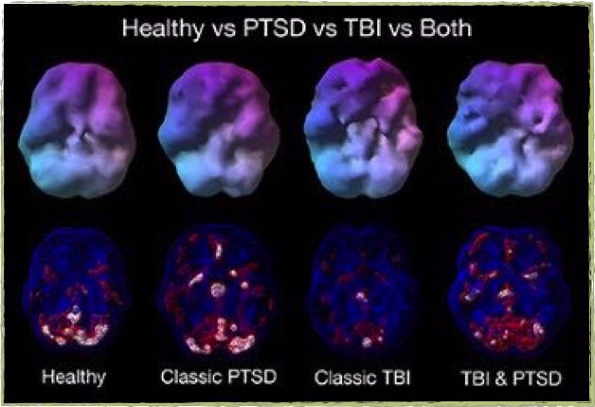
Sexual addiction is a more difficult process to define. The term sexual addiction, introduced in 1983 by Patrick Carnes, was based on behavioral parameters (Carnes, 1983) and since others have determined a need for a behavioral model for sexual addiction (Hilton, 2013). A sex addict is one who is looking on an on-going basis for an exciting situation or a no-ties sexual encounter; this person has multiple partners and engages in compulsivity to masturbate (Pinna et al., 2015). The current DSM-5 attempted to reclassify the disorder. However, the diagnosis rejected (American Psychiatric Association, 2013).
The World Health Organization (2018) has renamed sexual addiction to compulsive sexual behavior and defined it as a disorder based on an inability to refrain intense, consistent sexual desires leading to ongoing sexual behavior. Hagerdorn (2009) evaluates the literature from the years 2000-2001 to find that 17 to 37 million Americans are sexually addicted; however, the DSM and American Psychiatric Association does not support this with a diagnosis. At this time, there is little research on human sexual addiction as compared to other addictions (Hilton, 2013). He goes on to discuss the lack of clinicians trained to work with this population (2009) adequately.
Pornography is currently a debated topic when discussed as a sexual addiction even more so when debated if a person can be addicted to pornography, or could have harmful effects from the use of pornography (Hilton, 2013). At this time sexual addiction affects millions of Americans, and with the growth of Internet pornography, this number grows in secret. Nikolaas Timbergen (1951) coined the term ‘supranormal stimulus’ to explain the addictive effect Internet pornography has by its novelty. Pornography, for the first time, is taking the place of real naked women and having a real woman is now considered a form of poor pornography (Wolf, 2003). Below is an image by Cambridge University that depicts a brain shows the same reaction to compulsive pornography use as it would for an alcohol or drug addict.
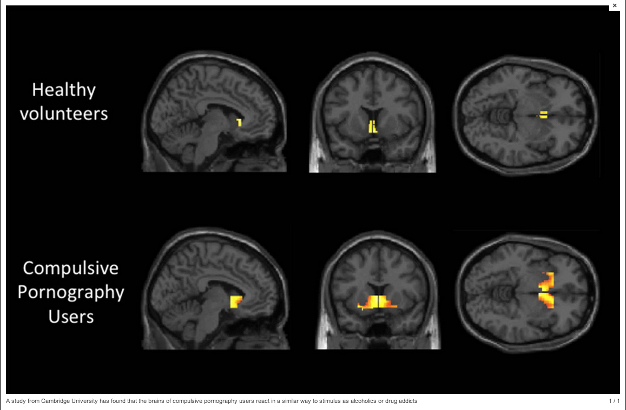

DSM-5 Criteria for Addiction
The APA (2018) defines addiction as a condition that manifests itself in the brain requiring compulsive substance use despite the detriment it may cause. The addiction can be a complex addiction (2018). The APA further explains the addiction does have the potential to take over one's life (2018). An addiction can impair one's control over the substance, cause issues with those around them, lead to high-risk environments, and tolerance levels may increase (APA, 2018). The table below shows how a substance use disorder diagnosed according to the DSM-5 (APA, 2013).
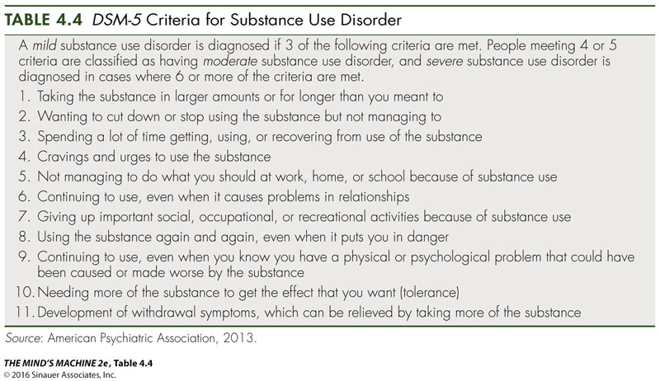
The DSM-5 lists (see chart below) 10 substance use disorder categories (1) alcohol, (2) caffeine, (3) cannabis, (4) hallucinogens, (5) inhalants, (6) opioids, (7) sedatives, hypnotics or anxiolytics, (8) stimulants, (9) tobacco, and (10) other (APA, 2013). Addictions many times are also present with a mental health disorder, leading to co-morbidity according to the DSM-5 (APA, 2013). Some of the co-morbidity diagnoses that can show with addiction are anxiety, depression, bipolar, attention-deficit hyperactive disorder (ADHD), psychosis, and other personality disorders (APA, 2013).
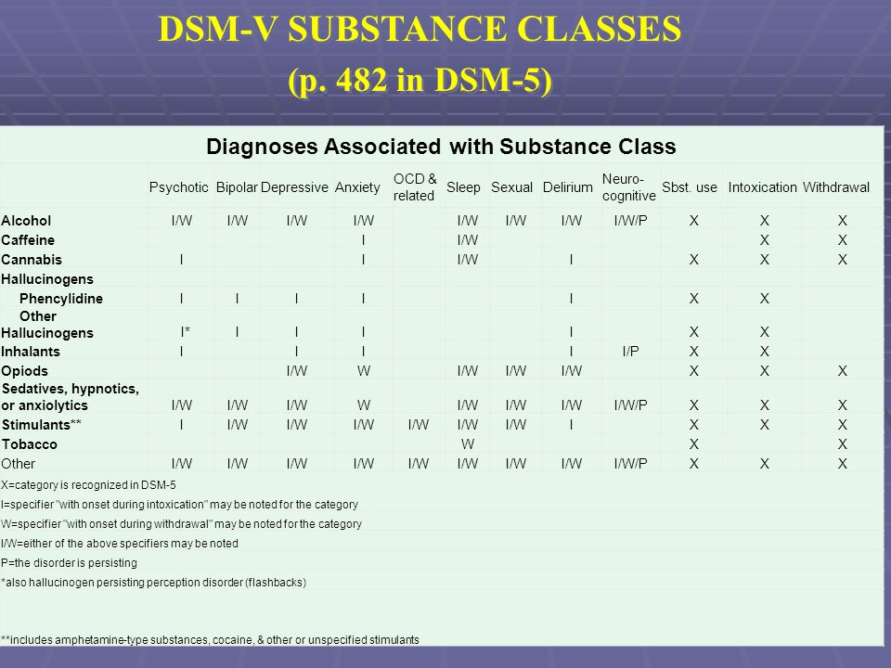

The rationale for the Meta-Analysis
According to the literature, there is little understanding of how pornography, TBI, and sexual addictions can affect the brain chemistry and in turn affect our mental health (Hilton, 2013), there is a gap within the literature in this area. In addition to this gap, as clinicians, training is considered ‘specialized' since sexual addiction is not considered a diagnosable disorder according to the American Psychiatric Association (Hagedorn et al., 2005). Finally, the literature currently does not suggest a strong effect, clinically proven treatment for those who struggle with sexual addiction (Hagerdorn et al., 2005). This meta-analysis will evaluate and explore each of these areas.

TBI, the Brain, and Mental Health
There are two types of TBIs, closed brain injury and open brain injury. A closed brain injury is one that did not break the skull, and the brain was not exposed. An example could be a car crash where the head jerked forward and backward, which led to the brain to slam against the inner bone. The open brain injury is one where the brain is exposed, or the skull has a break. This injury can be isolated to a particular area, leading the patient to be still communicative, or the injury can be widespread (Gerstenbrand et al., 2001).
Traumatic brain injuries are known to cause a level of psychological disorders, including depression and anxiety. Studies have shown that damage to the front-limbic region has an increased potential for psychological disorders (Maller et al., 2010). According to one study, if a client has a trigger allowing the client to compare pre-injury to post-injury function, then this client is at risk for employing maladaptive coping skills and has a higher risk of psychological distress (Ownsworth et al., 2011).
A person with severe TBI damage to their prefrontal and limbic areas, the ability to complete self-reflective capacity and emotional regulation is impaired (Ownsworth et al., 2017). Since the prefrontal cortex is known to be logical and cognitively consider situations, an injury to this area can affect the ability to control impulses (Ham et al., 2013).

Sexual Addiction, the Brain, and Mental Health
A neurobiologist who studies addiction support the existence of our bodies having a real addiction at the functional and cellular level to accumulate, which means addictions is not just a behavioral issue (Hilton, 2013). Human sexuality stems from the cerebral cortex and involves a high level of human functioning (Georgiadis, 2012). Research does not yet address the exact effects of how pornography and other sexual addictions affect the brain compared to other research (Hilton, 2013). The exact effects of "sexual neuroscience" viewed as a ‘riddle' or a mystery that may take years to uncover (Hilton, 2013).
Although sexual neuroscience is struggling to understand the exact effects, some research has concluded similar effects between those addicted to chemicals, such as drugs and alcohol, and those addicted to process, such as sexual addiction and gambling (Ledgerwood & Downey, 2002). Many times clients can present with both types of addictions; correcting one to begin the other and then correcting the second to move back to the other; this can be a vicious cycle for many clients (Hagerdorn, 2009).
According to Hagerdorn (2009), as one becomes addicted to sex, a breakdown of the brain chemistry at the emotional level begins to occur. The client may present as depressed or anxious, paranoia, obsessive-compulsive disorder or suicidal ideations (2009). Unfortunately, few clinicians are certified to treat such clients or to recognize the signs of sexual addiction (Hagerdorn, 2009).

Pornography, the Brain, and Mental Health
Research is currently showing since Internet pornography has developed, 66% of men and 41% of women view monthly (Kuhn et al., 2014; Dias, 2018). Many studies regarding pornography and its effects on the brain are contradictory. For example, a study completed in 2014 by Cambridge found 60% of the subjects struggled to be aroused by real-life sex partners while a study completed in 2015 found pornography heightened the sexual experience with real-life sex partners (Dias, 2018). Grubbs et al. believe one cannot self-identify as addicted to pornography if one has not dysregulated use (2018).
Pornography viewing can have adverse effects on mental health. According to Laemmle-Ruff et al. (2019), body image, objectification theory, affects as many as 37.4% of women and 13.1% of men in Australia. As an individual view's pornography there is an internalization of how a woman or man should look versus the reality (Laemmle-Ruff et al., 2019). A study was completed by Laemmle-Ruff to determine the effects of pornography and body image where 65% stated there was a minimal influence, one of the participants further explained age and internalization of norms might affect this percentage (2019). While in that same study one participant noted the pornography viewing negatively affected their relationship (2019). With conflicting results, Laemmle-Ruff admits that more research is required (2019).
A consideration some researchers are evaluating involves how morality affects one's view of pornography. For this reason, if a client has extreme values against pornography and then participates in pornography use, then the client may believe their mental health issue stems from their pornography use (Brand, 2019, Grubbs et al., 2018). It is a possibility, rather moral or actual; pornography addiction can lead to emotional, psychological, and relational issues (Brand, 2019, Grubbs et al., 2018). According to a previous study by Grubbs et al. the CPUI-9 showed a relationship between pornography and psychological distress; therefore those who would view themselves as addicted to pornography will also be more likely to have signs of psychological distress (2015).

TBI, Pornography and Sexual Addiction Connection
The questions remain if there is a connection between TBI, pornography and sexual addiction. Based on the literature thus far, a person with an injury to their prefrontal cortex could have issues with impulse control. Also based on the literature presented, those with a sexual addiction struggle with impulse control issues that also begins in the brain. Finally as viewed with regards to pornography, the debate is still occurring.
Hypersexual disorder is a label proposed for the DSM-5 to encompass repetitive and intense sexual behaviors, such as sexual addiction and pornography (IsHak, 2017). These behaviors have attributed to neurological conditions, like TBIs, as well as connected to psychological disorders (IsHak, 2017). Some researchers have defined hypersexual behavior as having as many as seven or more orgasms per week (Kinsey et al., 1948) while Kafka believed the diagnosis should base on the number of daily orgasms over six months (1997).
Davis (2012) provides case studies where TBI, pornography, and sexual addiction came together to affect the mental health of seemingly typical citizens. The first involves a 40-year-old school teacher, brain scans below, who began having sexual interests in children. The teacher began to view child pornography on the Internet. Once arrested, the individual stated he had headaches several days before acting out, an MRI completed and growth was discovered on an area of his brain connected with social norms and behaviors (2012).
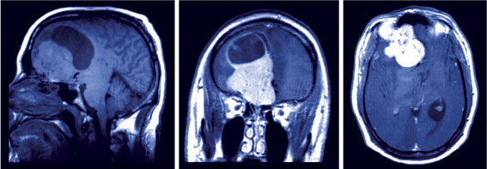
Dr. Russell Swerdlow, the doctor who treated this teacher, explained the teacher's pathways were damaged and broken that link the orbital frontal lobe to the amygdala. This part of the brain affects emotional response and decision-making, which can ultimately lead to impulsive behaviors (Davis, 2012).
Another case study provided by Davis (2012) is that of Herbert Weinstein who admitted to killing his wife. The defense his attorney used was a cyst on his temporal lobe affecting his self-control and ability to regulate emotion. While this defense proved unsuccessful in Weinstein’s case, there is evidence it has assisted in lessening the sentences in other criminal cases.
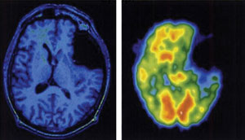
With the literature that is available regarding pornography and sexual addiction and TBI individually and their effects along with the case studies and images, one could propose a connection is present. However, a qualitative and quantitative study looking at the three pieces of the puzzle combined would provide a better basis.

Current Training for Clinicians
The current training to specialize in sexual addictions, which would include pornography use, is limited. There are also a limited amount of therapists with this particular training (Hagedorn, 2009). Some have received training through a seminar or continuing education training, a formal certification program, on the job training, and self-study (Hagedorn, 2009).
To obtain certification in this particular field, the clinician will need to complete CSAT training. CSAT stands for Certified Sex Addiction Therapist. With this particular training, clinicians will receive the most up to date information regarding sex addictions, as well as being a clinician referred to regarding court cases similar to Weinstein.
The two leading organizations to work with for CSAT training are IITAP and AASAT. IITAP stands for the International Institute for Trauma and Addiction Professionals. This organization began in the early 1980s by Dr. Patrick Carnes. They believe sex addiction is real and recovery is achievable. They believe addicts and families should receive the best care from compassionate individuals. They also do not believe in reparative therapy, and thus sexual addiction can cross all boundaries, it does not discriminate. Dr. Carnes goal is to provide a high level of care to clients with sexual addictions by providing excellence in training. The organization provides several types of certification in addition to the CSAT, including certification for pastors. This program does not require a lengthy time of supervision; however, the modules are face-to-face.
The other organization is AASAT, The American Association for Sex Addiction Therapists. This program is a training course the clinician can work through at his or her own pace at home, along with six months of supervision. This training would provide certification in Sexual Recovery Therapy, working with partners, and intimacy anorexia. Dr. Douglas Weiss has had over thirty years of experience working with sexual addiction and coined the term “intimacy anorexia.”
Another option for training includes providing a course at the graduate level for every student to complete that has a desire to work with trauma and or sexual abuse (Hagedorn, 2009). As Hagedorn (2009) explains many clinicians receive their training through continuing education, sometimes these are scratching the surface of the broader issues of our clients.
Current Effective Treatment Options
If the clinician chooses not to become a certified sex addiction therapists, it is still essential to understand and know effective treatment options for clients that may enter the office with a sexual addiction or pornography addiction. Alternatively, the clients may enter with one of these addictions co-morbidities, and it takes a few sessions to discover the source is in pornography and or sexual addictions. At this point, rapport has already developed, and the clinician will muddle through the process unless the clinician has some previous knowledge of working treatments. Also during these sessions the brain injury, TBI, may present in a casual conversation, now knowing a link is present, a referral may be necessary to a neurologist.
Beyond the issue of training, clinicians are the issue of effective treatment options (Hagedorn, 2009). Hagedorn provides several treatment options that have proven effective with sexually addicted clients, and they are, insight-oriented theory, solution-focused, motivational interviewing, reality therapy and choice, REBT, behavioral approaches, wellness-based, family systems, and CBT (Carnes, 1994)
Coleman et al. wrote about their model, integrative biopsychosocial and sex-positive model (2018). This model, first developed in the 1980s has modified as time has progressed. The model proposes that biological and environmental influences cause psychological influences. For example, Coleman et al. would argue that some have an innate need for affective dysregulation and impulse control, which results from attachment insecurity (2018).
Another form of treatment under evaluation is hypnotic psychotherapy (Moseley et al., 2005). This treatment was used with juvenile offenders with the hope of eliminating juvenile sex offenders (Moseley et al., 2005). The purpose of hypnotic psychotherapy is for the offender to access his or own memories, emotions, senses, past experiences and learning (Moseley et al., 2005). This treatment approach combined with cognitive behavioral therapy has shown promise according to Moseley et al. (2005).

Case Study
A 15-year old young man enters the office because his parents are making him attend therapy. The young man reluctantly sits downs on the couch as he listens to his parents to explain his story. The young man, as told by the parents, was suspended from school because he sexually acted out with a female student at the school that is about two years younger than him. The young man was talked to by police, arrested, and now within the juvenile court system. As the clinician listens to this story, she looks at the young man to see him looking down and refusing to make eye contact. Typically the clinician is aware this is disrespect, but in this case, this young man indeed seems embarrassed. The clinician asks the 15-year-old to tell his story.
The 15-year old is from a divorced family, where his dad was never around. His mother dated a lot, and some of the men were not very nice to him. He explains he is active and plays sports, has had some head injuries, mild concussions. He does claim to be a Christian and admits he made a mistake. However, he said the girl had been coming on to him and flirting with him. He explained she asked him to meet her behind the stairs at school. He does have a history of watching pornography but as a new Christian, is trying not to watch.
This 15-year old understands that he now has a case in the juvenile system as a sex offender. He understands it was one bad choice as he was running on impulse and hormones. The juvenile system sent this 15-year old to a certified sex therapist for in-depth counseling. For this student, he and his family traveled to the other side of the city to find someone certified.
Unfortunately, this student is not a rare case but a norm in today’s school. Many students his age or younger are beginning to watch pornography due to its accessibility, then as the research has shown, are more likely to engage in sexual activities at a younger age. Below is a brain scan showing how sexual addictions affect the adolescent brain (doi:10.1371/journal.pone.0102419.g002)
.
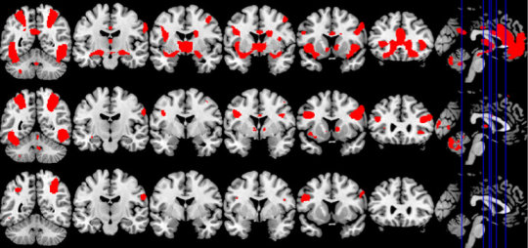
Conclusion
The case study just presented, along with the literature review should lead researchers to examine in more detail the need for at the minimum a hypersexual disorder diagnosis (IsHak, 2017). IsHak provided and proposed criteria for hypersexual disorder for the DSM-5; however, it was not accepted (2017). Provided the information from MRIs and PET scans it would be an excellent addition to the next revision by the APA. Below is IsHak's criteria.
DSM-5 Proposed Criteria for Hypersexual Disorder
A. Over a period of at least 6 months, recurrent and intense sexual fantasies, sexual urges, and sexual behavior in association with four or more of the following five criteria:
1. Excessive time is consumed by sexual fantasies and urges and by planning for and engaging in sexual behavior
2. Repetitively engaging in these sexual fantasies, urges, and behavior in response to dysphoric mood states (e.g., anxiety, depression, boredom, and irritability)
3. Repetitively engaging in sexual fantasies, urges, and behavior in response to stressful life events
4. Repetitive but unsuccessful efforts to control or significantly reduce these sexual fantasies, urges, and behavior
5. Repetitively engaging in sexual behavior while disregarding the risk for physical or emotional harm to self or others
B. There is clinically significant personal distress or impairment in social, occupational, or other important areas of functioning associated with the frequency and intensity of these sexual fantasies, urges, and behavior
C. These sexual fantasies, urges, and behavior are not due to direct physiological effects of exogenous substances (e.g., drugs of abuse or medications), a co-occurring general medical condition, or to manic episodes
D. The person is at least 18 years of age
Specify if masturbation, pornography, sexual behavior with consenting adults, cybersex, telephone sex, and strip clubs
[Reprinted from Reid RC, Carpenter BN, Hook JN, Garos S, Manning JC, Gilliland R, Cooper EB, McKittrick H, Davtian M, Fong T. Report of findings in a DSM-5 field trial for hypersexual disorder. J Sex Med. 2012;9(11):2868–77. with permission from Elsevier]

Since research is lacking data more recent than 2009 – 2012, this is an area that is still in huge debate. Pornography is a regularly debated topic regarding its level of addiction and its ultimate cause to those who use pornography as well as those around. Sexual addiction is also just as debated as a norm and not an addiction that could alter brain chemistry. TBIs when in conjunction with pornography and sexual addiction crimes is questioned in the courtroom. Progress is occurring to understand these three phenomena and their connection. However, the research, both qualitative and quantitative, is causing some contradictions that should address.

References
American Psychiatric Association (2013). Diagnostic and statistical manual of mental disorders
(5th ed.). Arlington, VA: American Psychiatric Publishing.

Aldossary, N. M., Kotb, M. A., & Kamal, A. M. (2019). Predictive value of early MRI findings
on neurocognitive and psychiatric outcomes in patients with severe traumatic brain injury. Journal of affective disorders, 243, 1-7. https://doi.org/10.1016/j.jad.2018.09.001

Brand, M., Antons, S., Wegmann, E., & Potenza, M. N. (2019). Theoretical Assumptions on
Pornography Problems Due to Moral Incongruence and Mechanisms of Addictive or Compulsive Use of Pornography: Are the Two “Conditions” as Theoretically Distinct as Suggested?. Archives of sexual behavior, 48(2), 417-423. https://doi.org/10.1007/s10508-018-1248-x.

Carnes, P. J. (1994). Contrary to love: Helping the sexual addict. Center City, MN: Hazelden.

Carnes, P. (1983). Out of the shadows. Center City, MN: Hazelden.

Coleman E., Dickenson, J.A., Girard, A., Rider, G.N., Candelario-Pérez, L.E., Becker-Warner,
R., Kovic, A.G., & Munns, R., (2018) An Integrative Biopsychosocial and Sex Positive Model of Understanding and Treatment of Impulsive/Compulsive Sexual Behavior, Sexual Addiction & Compulsivity, 25:2-3, 125-152, DOI:10.1080/10720162.2018.1515050

Davis, K. (2012). Brain trials: neuroscience is taking a stand in the courtroom. ABAJ, 98, 37.
https://heinonline.org/HOL/P?h=hein.journals/abaj98&i=799.

Dewan, M. C., Rattani, A., Gupta, S., Baticulon, R. E., Hung, Y. C., Punchak, M., ... &
Rosenfeld, J. V. (2018). Estimating the global incidence of traumatic brain injury. Journal of Neurosurgery, 1(aop), 1-18. https://doi.org/10.3171/2017.10.JNS17352

Gerstenbrand, F., & Stepan, C. A. (2001). Mild traumatic brain injury. Brain Injury, 15(2), 95-
  - 97. https://doi.org/10.1080/026990501458326

Georgiadis, J. R. (2012). Doing it . . . Wild? On the role of the cerebral cortex in human sexual
activity. Socioaffective Neuroscience and Psychology, 2, 17337.

Greco, T., Ferguson, L., Giza, C., & Prins, M. L. (2019). Mechanisms underlying vulnerabilities
after repeat mild traumatic brain injuries. Experimental Neurology. https://doi.org/10.1016/j.expneurol.2019.01.012

Grubbs, J. B., Perry, S. L., Wilt, J. A., & Reid, R. C. (2018). Pornography problems due to
moral incongruence: An integrative model with a systematic review and meta-analysis. Archives of Sexual Behavior. https://doi.org/10.1007/s10508-018-1248-x.

Grubbs, J.B., Volk, F., Exline, J.J. & Pargament, K.I. (2015) Internet Pornography Use:
Perceived Addiction, Psychological Distress, and the Validation of a Brief Measure,
Journal of Sex & Marital Therapy, 41:1, 83-106, DOI: 10.1080/0092623X.2013.842192

Hagedorn, W.B., (2009) Preparing Competent Clinicians: Curricular Applications Based on the
Sexual Addiction Counseling Competencies, Sexual Addiction & Compulsivity, 16:4, 341-360, DOI: 10.1080/10720160903399855

Ham, T., Bonnelle, V., Hellyer, P., Jilka, S., Robertson, I. H., Leech, R., & Sharp,
D. ( 2013). The neural basis of impaired self‐awareness after traumatic brain I njury. Brain, 137, 586– 597. https://doi.org/10.1093/brain/awt350

Hilton, D. L Jr. (2013) Pornography addiction – a supranormal stimulus considered in the
context of neuroplasticity, Socioaffective Neuroscience & Psychology, 3:1, 20767, DOI: 10.3402/snp.v3i0.20767

IsHak W.W. (2017) Evaluation and Treatment of Hypersexual and Other Sexual
Dysfunctions. In: IsHak W. (eds) The Textbook of Clinical Sexual Medicine. Springer, Cham https://doi.org/10.1007/978-3-319-52539-6_24

Kafka MP. Hypersexual desire in males: an operational definition and clinical implications for
males with paraphilias and paraphilia-related disorders. Arch Sex Behav. 1997;26:505–26.

Kinsey AC, Pomeroy WB, Martin CE. Sexual behavior in the human male. Philadelphia: W.B.
Saunders Company; 1948.

Kühn S, Gallinat J. Brain Structure and Functional Connectivity Associated With Pornography
Consumption: The Brain on Porn. JAMA Psychiatry. 2014;71(7):827–834.
doi:10.1001/jamapsychiatry.2014.93
Laemmle-Ruff, I. L., Raggatt, M., Wright, C. J., Carrotte, E. R., Davis, A., Jenkinson, R., & Lim,
M. S. (2019). Personal and reported partner pornography viewing by Australian women, and association with mental health and body image. Sexual health, 16(1), 75-79. https://doi.org/10.1071/SH18037

Ledgerwood, D. M., & Downey, K. K. (2002). Relationship between problem gambling and
substance use in a methadone maintenance population. Addictive Behaviors, 27, 483–491.

Maller, J. J., Thomson, R. H., Lewis, P. M., Rose, S. E., Pannek, K., & Fitzgerald, P.
B. ( 2010).Traumatic brain injury, major depression, and diffusion tensor imaging: Making connections. Brain Research Reviews, 64, 213– 240. https://doi.org/10.1016/j.brainresrev.2010.04.003

Moore, T. M., Gur, R. C., Thomas, M. L., Brown, G. G., Nock, M. K., Savitt, A. P., ... & Army
STARRS Collaborators*.(2019). Development, Administration, and Structural Validity of a Brief, Computerized Neurocognitive Battery: Results From the Army Study to Assess Risk and Resilience in Servicemembers. Assessment, 26(1), 125-143. doi:10.1177/1073191116689820

Moseley, S., Briggs, W.P., & Magnus, V. (2005). Hypnotic psychotherapy with sex offenders.
Journal of Addictions & Offender Counseling. 26, 38-51.

Ownsworth, T., & Gracey, F. ( 2017). Cognitive behavioural therapy for people with brain
injury. InB. Wilson, J. Winegardner, C. van Heugten & T. Ownsworth (Eds.), Neuropsychological rehabilitation: The international handbook (pp. 313– 326). Hove, UK: Routledge (Taylor & Francis).

Ownsworth, T., Fleming, J., Haines, T., Cornwell, P., Kendall, M., Nalder, E., & Gordon,
C. ( 2011). Development of depressive symptoms during early community reintegration after traumatic brain injury. Journal of the International Neuropsychological Society, 17, 112– 119. https://doi.org/10.1017/S1355617710001311

Pinna, F., Dell’Osso, B., Di Nicola, M., Janiri, L., Altamura, A. C., Carpiniello, B., & Hollander,
E. (2015). Behavioural addictions and the transition from DSM-IV-TR to DSM-5. J Psychopathol, 21(4), 380-9.

Pinto, S., Newman, M., & Hirsch, M. (2018). Perceived Barriers to Exercise in Adults with
Traumatic Brain Injury Vary by Age. Journal of Functional Morphology and
Kinesiology, 3(3), 47.https://doi.org/10.3390/jfmk3030047

Tinbergen, N. (1951). The study of instinct. Oxford: Clarendon Press.
W. Bryce Hagedorn (2009) Sexual Addiction Counseling Competencies: Empirically-Based
Tools for Preparing Clinicians to Recognize, Assess, and Treat Sexual Addiction, Sexual
Addiction & Compulsivity, 16:3, 190-209, DOI: 10.1080/10720160903202604

Wolf, N. (2003, October 20). The porn myth. New York Magazine. Retrieved from
http://nymag.com/nymetro/news/trends/n_9437

World Health Organization (2018). ICD-11 for mortality and morbidity statistics. Retrieved from
https://icd.who.int/browse11/lm/en#/http%3a%2f%2fid.who.int%2ficd%2fentity%2f1630268048

Appendix 3: Grading Rubric for Practical Article Submission I and II
 | CAREFULLY FOLLOW THE GENRE AND STYLE YOU FIND IN THE ARTICLES YOU DOWNLOAD FROM THE JOURNAL YOU SELECT | Comments
1 | Proper APA (6th Edition) Style: Title page through references and everything in between.
2 | Paper Organization: Includes a clear, succinct abstract, introduction and conclusion that summarize paper’s contents, and clearly articulated transitions between the primary sections of the paper.
3 | Professional, Scholarly, Publishable Quality: Correct grammar, spelling, syntax, use of verbiage, tense, etc. | .
4 | ALL points and facts presented in the paper are supported by proper use of citations and references to current empirical and theoretical literature.
5 | Content:  Title —It is specific and has a clear focus. It appropriately sets the readers’ expectations for what they will learn.  Abstract —Should express the central idea of the manuscript in nontechnical language. It should be on page 2 and is limited to 40 words (Journal of Addiction and Offender Counselor).  Introduction —The introduction builds interest and strides confidently into the topic and focus.  Pronouncement paragraph —The manuscript includes a pronouncement paragraph and what is previewed there matches the main headings of the article.  Main headings —The headings are specific to the focus of the article and are consistent in format (e.g., all stated as questions, each begins with a verb; they effectively guide the reader through major shifts in the argument).  Body of the manuscript —There are no more than 3–5 main headings that are evenly balanced in terms of length.  Literature review —The evidence base is current and authoritative with just a few classic sources? It uses original sources rather than textbooks. The review of the literature is thorough, current, persuasive, and synthesized.  Transitions —reading through the article, the transitions are smooth.  Examples —The examples provided resonate with the experience of counseling professionals. There were not too few, too many and they were not too long.  Visual material—Figures, tables, charts, graphs, and/or other visual material are helpful and worthy of publication? They original and focused very specifically on the topic of the article.  Length and clarity —The manuscript is not too wordy in places (i.e., in need of condensing) nor is there places where the material requires further development (i.e., where not enough explanation is given).  Conclusion —The conclusion: (1) briefly “recaps” the main ideas (2) moves from specific to more general ideas? (3) Revisits the main thesis that was explained in the introduction (4) gives a genuine sense of wrapping everything up and sending readers on their way?
 | Reference page is in proper APA style and citations throughout are ample and are primary (not secondary) sources. INCLUDE DOIs
 | Assignment is double spaced, 12 point, Times New Roman
 | Follow the author guidelines or what you see in the articles you download from the journal regarding use of first person. Either way (first or third person) it must be appropriately professional and scholarly. DON’T USE PASSIVE VOICE!
 | Assignment is of proper length (18-22 pages) [not including title page, abstract, references and required appendices]) DO NOT EXCEED PAGE LIMIT.
 | Few, if any, quotations that are brief and are in proper APA format.
 | Includes a copy of the peer review of your article from a group member as an appendix item. Include a copy of the author guidelines for the article as an appendix item. Include a copy of the grading rubric filled out as a self-assessment as an appendix item (submission one only) | DO NOT HAVE TO INCLUDE BUT HAVE SOMEONE REVIEW USING RUBRIC!
 | Total Points (Points will vary based on quality of each section)- Submission I: 190 Submission II: 250

