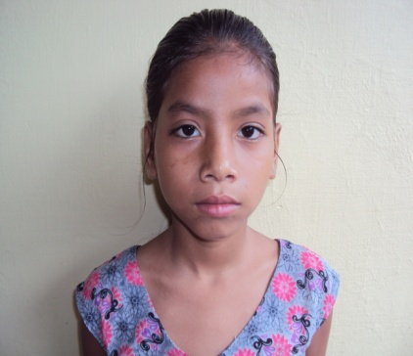
Name ANISHA 11 YEARS
CHILD’S ID No. : WPC-001
DOB: July 11, 2001
Anisha is from Hetauda, Nepal.
Anisha is a very responsible and polite girl. Anisha’s biological mother abandoned her when she was 3 years old, and they don’t have any contact with her. She is a step daughter of Sunita Shrestha who is a former survivor of human trafficking. After coming back to Nepal, Sunita struggles to send her three daughters to school.
Anisha struggles and gets confused about her situation and thinking about why her own mother abandoned her. Her father is abusive to towards his wife and children. She is dealing with lots of emotional issues and sometimes it can be difficult for her to concentrate on her education. Staff members continue to provide all the support she needs to be successful in her school and for her healing. She is in grade 4. She loves to learn English and one day she wants be an English teacher in Nepal. She has two other sisters.
Your support will give her an opportunity to come in to our Safe Home where she will have a safe and secure place to live and go to school as well.

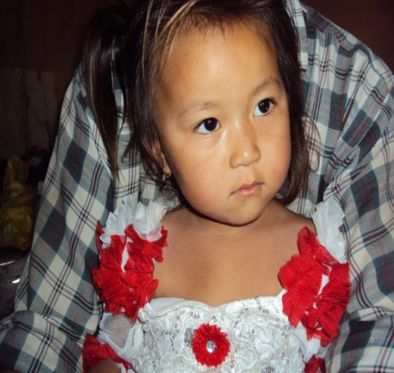
KHUSHBU 4 Years Old
CHILD’S ID NO : WPPC-0025
DOB : June 16, 2008

Khushbu is a sweet and cute child from Thanabharang, Makwanpuer District of Nepal. She lives in one of the slum areas. From her village everyday girls are trafficked to India, as young as 3 years old to the circus trade. When she was two (2) years old her mother died and her father was disabled. He is unable to care for her because he can’t work. Shushbu is lacking nutritious food and care. She is by herself, wandering alone and begging for food in the neighborhoods. Our staff identified her at risk of being trafficked and she needed a safe place to live and care. She is getting ready to go school but there is no one to take care of her.

