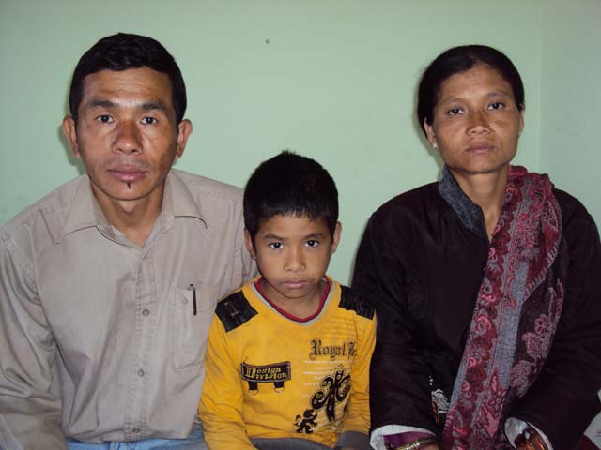
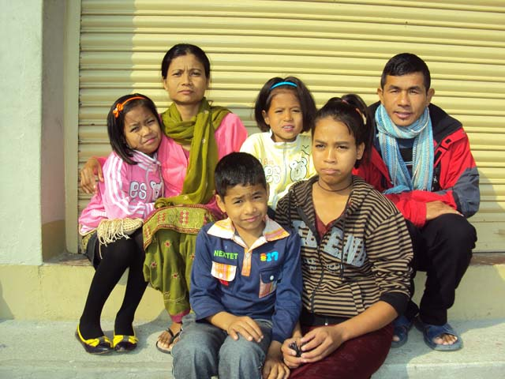

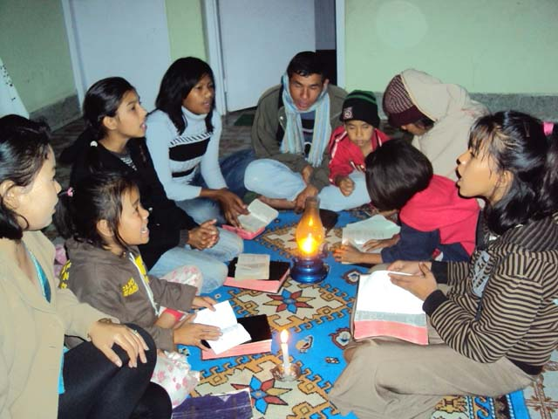
This Christian missionary family comes to the Safe House to teach Bible lessons to the children. They moved from their village to serve our children at our center in Hetauda.

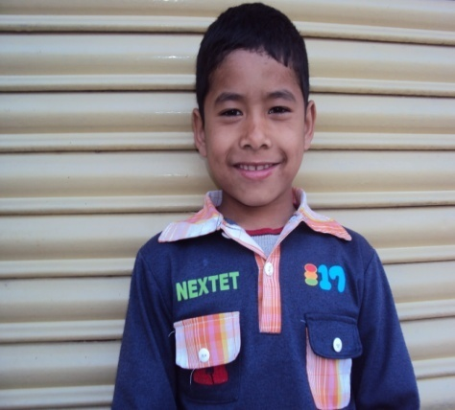
PRANTIYA 9 YEARS OLD
CHILD’S ID NO: WPPC-0026
DATE OF BIRTH: April 18. 2003
GRADE: 3
PRANTIA TAMANG is a very bright and intelligent boy. He hopes to become a teacher in his future. He shares his parents with other children in our safe home in Nepal without any complaint. He accepts all the children at our center like his own siblings. His parents have dedicated themselves to serve the children in our safe home in Nepal. It becomes our obligation to provide their basic needs. We have to help this family to raise support for them. If we have an educational sponsorship for each child it will be very helpful.

