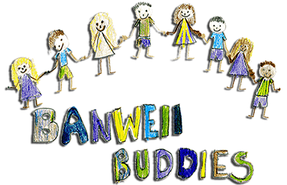 Tapestry Questionnaire. Feedback to parents. May 2018

Q.1. How often do you access your child’s online learning journal?

Daily: 43% Weekly: 29% When I receive a notification: 29%

Q.2 Do you have any issues accessing Tapestry?

No: 100%

Q.3 Do you feel able to ask for help/support regarding Tapestry and any issues you are having using the service?
Yes: 100%

Q.4. How do you feel about the observations the staff publish about your child? Any activities or learning that you’d like to see more of?
We had some really positive comments here:
‘There’s a great range of fun activities – thank you!”
“Great to see what *** gets up to. Always looks happy whatever activity *** is doing.”
“The observations are short but the checklist complements the comment nicely. I’m happy with it!”
“It’s always nice to get an insight into ***’s activities when he’s at Buddies.”
“Very informative. I like to see what my child has been learning and playing with at Buddies”
We also had some comments about there being less observations from outside. This is because it’s more difficult to take the iPads outside to do observations. They can’t be picked up and put down like they can inside, and we can’t have staff leaving the children to collect/return them inside. Staff do their best to record outside activities as much as possible, but please don’t assume that the children spend less time outside based on what you see on Tapestry!
As for frequency of posts, we try to strike a balance between record keeping (and keeping parents updated) and spending quality time with the children. A lot of the time we don’t have the iPads in our hands to capture the moment, and nor is it appropriate to do so. We’re aiming to have as much in the Tapestry journals as we had in our paper Learning Diaries.

Q.5 What would you change/improve about the service?
Thank you for your encouraging words!
“We love the tapestry service and really appreciate the time that is obviously spent by staff filling it in – thank you so much!”
We had some queries about home learning. Tapestry flags up any gaps in learning that the staff use to plan future sessions. At the parent consultations, your child’s key worker discusses with you the ways in which you can support and extend your child’s learning at home.
The Early Years Foundation Stage curriculum is all about learning through play and experience, so if you are spending time with your child, then you are helping them at home! Children at Buddies take it in turns to take the Storytelling Project books home which we hope they love telling you all about! It’s a lovely way for them to share their learning with you at home.
Please also remember to make use of our other Home Learning resources we have at Buddies, like the Story Sacks, and reading books. We also have some ideas that we’re sharing on FB and Pinterest. We always love to hear what our children get up to outside of Buddies so please continue to share those via Tapestry or on our ‘Good News’ sheets.

