Meredith Roberts
May 2, 2016
GCH 360-002
Naegleria Fowleri

Introduction
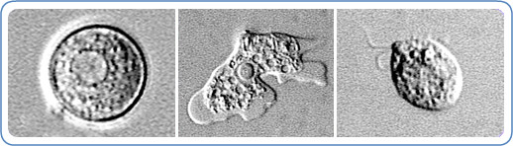 Be careful how you play in water because it can kill you. There’s a child playing in a lake with his sister. The sister throws him but the child comes up out of the water coughing saying water got up his nose. There is nothing wrong with that right? Children swallow water all the time. About a week later, the child complains about headaches and starts getting sick. His parents rush him to the emergency room when his fever spikes 102. After multiple tests, the doctors confirm the infection and inform the parents that the child has PAM (Primary Amebic Meningoencephalitis), which is caused by the brain-eating amoeba called Naegleria Fowleri. Unfortunately, the antibiotics and anti-fungal medications did not work to bring down the swelling and there is permanent, fatal damage to the brain tissue. The boy dies from simply getting lake water up his nose on a family vacation. Most cases involving this infection are similar to this one. They are pure accidents. The amoeba is in almost all warm water but typically not harmful unless it gets in the nose so is often over looked. Naegleria Fowleri is rare, but there have been two interesting cases of one child surviving and another’s fatal death from ingesting tap water.

Background
Naegleria Fowleri is an infection that causes primary amebic meningoencephalitis, which is 97 percent fatal (“Primary Amebic Meningoencephalitis (PAM) | Naegleria fowleri | CDC,” n.d.). Miltefosine is known to kill free-living amebae, but for most this does not work. It can infect people when the water enters the body through the nose which than goes to the brain to destroy brain tissue (“Primary Amebic Meningoencephalitis (PAM) | Naegleria fowleri | CDC,” n.d.). The infection cannot occur if only swallowed. More cases have been found in the southern countries near lakes, rivers, hot springs, and poorly maintained swimming pools (“Primary Amebic Meningoencephalitis (PAM) | Naegleria fowleri | CDC,” 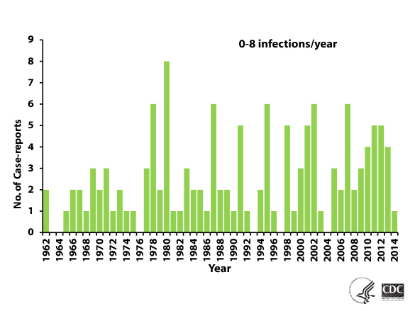n.d.). Naegleria Fowleri is not a common infection. The first infection in the United States was in 1962 in Florida and since than to 2014 there have been 133 infections reported (“Primary Amebic Meningoencephalitis (PAM) | Naegleria fowleri | CDC,” n.d.). There are signs to look out for if worrisome about infection. Symptoms are noticeable and include headache, fever, nausea, vomiting, stiff neck, confusion, lack of attention, loss of balance, seizures, and hallucinations (“Primary Amebic Meningoencephalitis (PAM) | Naegleria fowleri | CDC,” n.d.). Anyone can be infected, but male children around the age of 11 have been infected the most (“Primary Amebic Meningoencephalitis (PAM) | Naegleria fowleri | CDC,” n.d.). Most warm bodies of water have the amoeba in it but getting the infection is rare.

Case Study One
Kali Hardig is one of three people that have survived the infection Naegleria Fowleri. It started with swimming in a muddy pond in Arkansas in July. Thirteen-year-old Kali was immediately brought to the Arkansas Children’s Hospital after becoming unresponsive and having difficulty breathing. The symptoms started with a fever, nausea, and a severe headache but progressively got worse (News, 2014). At her arrival to the hospital, doctors evaluated her spinal fluid and examined the white blood cells (AM, 2015). The cells are what gave the infection away and told the doctors what needed to be done. Immediately, Kali was given a breathing tube and doctors prescribed her anti-fungal medication and an anti-amoeba medication, miltefosine, 24 hours after admission into the hospital (AM, 2015). She was also given antibiotics 6 hours after getting into the hospital (AM, 2015). To preserve any brain tissue that might not be damaged, the doctors lowered her body temperature to 93 degrees (Correspondent, n.d.). This was about a seven-week process for Kali and even after she was blessed with walking out of the hospital there were health consequences from the infection. Kali had rehab, physical therapy, and speech therapy to go to even after receiving hospital treatment to reach full recovery (Correspondent, n.d.). Doctors said the luck to her survival was the fact that she was treated for the infection as soon as possible with the correct diagnosis and aggressive treatment (AM, 2015).

Case Study Two
In July, a five year old boy was infected was Naegleria Fowleri from tap water in St. Bernard parish, Louisiana. It was contracted from simply playing outside on a slip and slide on a warm, summer day. Nine days after the fun, the boy started showing health problems including nausea, headaches, prolonged starring, and high fevers up to 104(“Brain-eating amoeba in tap water kills four-year-old boy,” 2015). The parents decided to take him to the New Orleans Hospital. Doctors believed it to be meningitis but tests such as CT scans and spinal taps failed to support this (“Brain-eating amoeba in tap water kills four-year-old boy,” 2015). Because the causes of the infections were unknown, the doctors did not prescribe any antibiotics. The child was in the hospital being undiagnosed and untreated for five days (“Brain-eating amoeba in tap water kills four-year-old boy,” 2015). The boy started to suffer from seizures and was later declared brain dead from the swelling in the brain (“Brain-eating amoeba in tap water kills four-year-old boy,” 2015). After the parents took the child off of life support, doctors tested samples of the brain and discovered that Naegleria Fowleri was the cause of death (“Brain-eating amoeba in tap water kills four-year-old boy,” 2015). Water samples were collected from the home of the family to find if traces of the amoeba were in the water supply and the results showed that Naegleria Fowleri was indeed in the water (News, n.d.). The town immediately put chlorine in water supply to kill pathogens so this incident would not occur again (News, n.d.).

Analysis
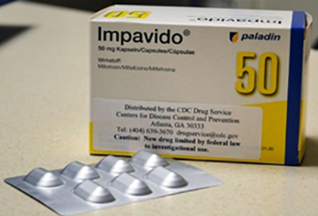 Naegleria Fowleri infected Kari and the young boy so the children experienced similar things. Both children experienced headaches and nausea before going to the hospital and reported recently playing in some sort of water. Both incidences also occurred in the summer during the month of July. The only medication available right now for the infection is miltefosine, trade name Impavido. This medication was given to both patients but was only effective on the girl. This could be because age, gender, severity of infection, and other treatment methods.
These children might have had the same infection but their stories ended differently. Kali got infected from the muddy pond and was immediately diagnosed. The doctors at the hospital recognized the amoeba in her blood and knew treatments to bring down the symptoms. She was being treated for the correct diagnosis while the little boy was never diagnosed until after his death. The boy was infected by regular tap water, which was never heard of before his case. His parents waited a couple days before bringing him to the hospital, which lets the amoeba infect the body for a longer period of time. When the child was brought to the hospital, he was given the wrong diagnoses so the treatments were not working. All the people working on this case waited too long so the child died which gave the doctors the ability to check his brain and see what the real cause was. The girl lived because of the correct diagnoses and treatment while the boy died because of lack of knowledge and treatment.

Conclusion
Naegleria Fowleri infects a small amount of people but when a person contracts the infection, it is almost always fatal. These two cases show different situations where the infection has killed and where it has not. It also demonstrated how the amoeba can be in any waters, muddy or tap, if not treated corrected. In any case, parents should be aware of the amoebas in waters especially for children. If a child is feeling ill out of ordinary, immediately go to the doctor in case the symptoms worsen like the case story earlier. No small headache should lead to a death because of lack of treatment. Since Naegleria Fowleri is everywhere, it is impossible to avoid but one can be aware that it exists.
References

AM, D. M. O. 2/22/15 at 10:28. (2015, February 22). How a 12-Year-Old Survived a Brain-Eating Amoeba Infection. Retrieved May 2, 2016, from http://www.newsweek.com/how-12-year-old-survived-brain-eating-amoeba-infection-308427

Brain-eating amoeba in tap water kills four-year-old boy. (2015, January 29). Retrieved May 2, 2016, from http://www.dailymail.co.uk/sciencetech/article-2931319/Boy-killed-brain-eating-amoeba-tap-water-confirmed-case-death-N-fowleri-organism-treated-water-US.html

Correspondent, B. E. C. Senior Medical. (n.d.). Kali Hardig, brain-eating amoeba survivor, to begin school next week - CNN.com. Retrieved May 2, 2016, from http://www.cnn.com/2013/09/12/health/arkansas-amoeba-survivor/index.html

News, A. B. C. (n.d.). Brain-Eating Amoeba Kills 4-Year-Old Boy. Retrieved May 2, 2016, from http://abcnews.go.com/blogs/health/2013/09/13/brain-eating-amoeba-kills-4-year-old-boy/

News, A. B. C. (2014, August 11). Brain-Eating Amoeba Survivor Swims Again. Retrieved May 2, 2016, from http://abcnews.go.com/Health/girl-survived-brain-eating-amoeba-swims/story?id=24887364

Primary Amebic Meningoencephalitis (PAM) | Naegleria fowleri | CDC. (n.d.). Retrieved May 2, 2016, from http://www.cdc.gov/parasites/naegleria/index.html

