Chicken Enchiladas with Chopped Cabbage
Preparation Time: 10 minutes
Cooking Time: 10 minutes
Servings: 4
1 pound chicken breast without skin  1 cup red enchilada sauce  4 - 5 each 6" corn tortillas, cut into 2" x 2" squares | 1/2 - 3/4 cup Mozzarella cheese shredded  4 cups cabbage, green and purple, shredded
Procedure
    - Cut chicken into 1" x 1" pieces. Place in rice cooker pot with enchilada sauce, cheese and corn tortilla pieces. Place lid on rice cooker. Press to "cook." Stir mixture occasionally. Transfer mixture into a serving bowl as soon as all chicken is cooked through.
    - Shred green and purple cabbage. Serve with enchilada mixture on top or on the side with your favorite low calorie salad dressing. Add avocado slices to enchilada mixture if desired.
Nutrition Facts
Serving size: 1/4 of a recipe (10.9 ounces). | 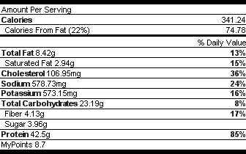
Source
Copyright: Copyright@FoodRx

