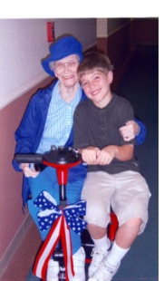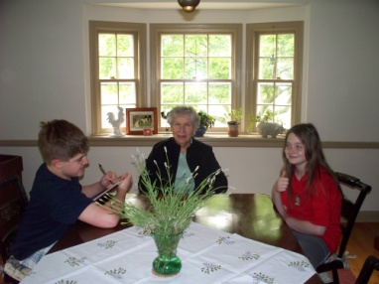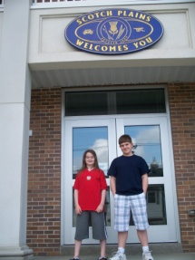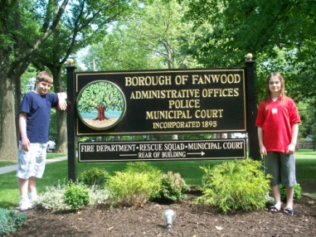

Spectacular Senior Services for Scotch Plains & Fanwood Residents (55 and above.)

By Michael Szanto & Matthew Furino

Presidents of Senior Clubs:

Fanwood Senior Club~Joe Bruno (908)889-7262x 148
joebruno2099@comcast.net
Scotch Plain’s Golden Age Club~Jean Detore (908)889-4121
jeandt4@hotmail.com
Meridian Club~Laura Swidersky (908)889-2084

Director of Senior Services:

Fanwood~Paulette Drogon (908)322-5244
Scotch Plain’s~Recreation Department~Steve Dahl (908)322-6700

Senior Hotline (800)792-9745

Senior Advisory Committee~Chairperson; Laura Swindersky

Listing of available services

Transportion:

**Fanwood & Scotch Plains residents have free bus service to various local shopping centers on Monday, Wednesdays and Fridays. The bus will pick up residents starting at 9:00 and drop off at 1:45.

**Medical transportation is available in Scotch Plains 322-5151

Dial a Ride~(908)322-5151

p-2

SpectacularSenior Services. continued

Meal Services:

Meals on Wheels~(908) 233-6146 approximately $30.00 delivery for a 5 days a week. This includes one hot dinner, $2.50 additional per day for an additional lunch.

Crisis Intervention Hotline:

This volunteer hotline is available 24 hours a day to provide consultations to anyone who is need. (908)232-2880 or (800)273-talk

Home Repair Services:

**Handyman for Fanwood~ 322-5244

**Utility Assistance~(800)792-9745

Medical assistance:

**Blood Pressure Screenings
Free blood pressure screenings are offered the 2nd Monday of every month (except July and August) at Forest Road Park, 10:00 AM to 11:00 AM.

**Prescription Drug Assistance
The following prescription and health services for seniors age 65 and above are available through the NJ Department of Health and Senior Services to singles with incomes below $24,432 or married couples with incomes below $29,956:
- Pharmaceutical Assistance to Aged and Disabled (PAAD)
- Hearing Aid Assistance for Aged and Disabled (HAAAD)

page 3

Spectacular Senior Services. continued

Frequently called numbers:

Adult protective services (908)497-3902

American Association of Retired Persons (866)542-8165`

Consumers Affairs of Union County (908)654-9840

Disabled, office of Union County (908)527-4807

Elizabeth office of aging (908)820-4044

Hispanic Services (908)497-3950

Home Energy Assistance Program (908)351-7727

Homeless Emergency Services/ Domestic Violence (908)355-1500

Medicaid (732)777-6977

Medicare (800)633-4227

NJ Nursing Home Information (safe) (908)497-3950

Elderly Abuse Hotline (877)582-6995

Psychiatric Hotline (908)668-2599

Social Security/Medicare (800)772-1213

Union County Division on Aging: Day Care, Home Care, Education,
Employment, Counseling, Financial Assistance, Housing,
Legal Assistance, Prescription Help. (888)280-8226

