40 Hour Director Training Application
Name: __________________________________________ Date: _____________
Address: ________________________________________________________________
City State Zip
Email Address: ___________________________________________________________
Cell #: ________________________________ Work #: __________________________
Training Start Date: ___________________ Projected End Date: ___________________
Materials Needed:
- Access to the internet
- Email Address
- Bright from the Start licensing manual
- Handbook for Early Childhood Administrators text book (purchased by you)
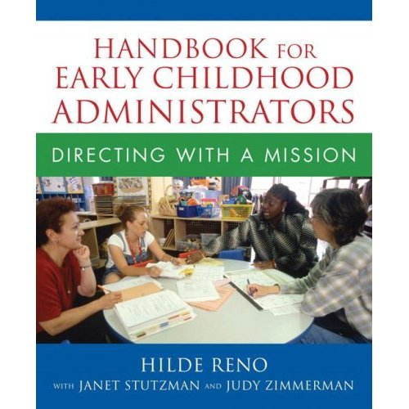

- All homework should be emailed to creatingconnections@yahoo.com or faxed to 770-693-3627
Directions:
- Complete the 40 hour director training application
- Submit payment of $350 for the course. Payment can be made by check, credit card or money order.
- Order your text book. We recommend that you order it from www.amazon.com
- Once your fee has been paid you will receive your workbook.
- Request the first of 4 conference sessions to review the course, assignments and set the remaining conference sessions. Conferences will be conducted through Join.Me.com. The instructor will email the participant a link to sign in for each conference/video call.
- Participants must complete the course within 4 weeks from the start date.
- After the final homework assignment has been completed, the participant will be scanned their 40 hour director certificate. The original certificate will be placed in the mail.
- Once the program has started we have a “no refund” policy
This is 40 hour distance learning course. Each participant has 4 checkpoints during the process. Participants will check in through https://join.me which is an online video meeting system. These checkpoints allow the participant to discuss information and ask questions. Through Join.Me, participants will be sent an invitation by the presenter to join the meeting. Join.Me allows the participant to be able to see the presenter’s computer screen during the discussion.

