**WWW.Strategic-Social-Marketing.Org**

**Cost value matrix, the de CIDES Framework**

**and**

**Intervention Matrix tool.**

**The Exchange Matrix Tool**

The Exchange Matrix is a conceptual device or ‘Proto Tool’ that can be used to represent four different ‘Forms’ of social exchange that can be designed to promote change in individuals and groups.

The assumption is that whilst ‘Nudges’ can be effective in promoting some behaviours in some situations they do not represent a full toolbox. As well as ‘Nudges’, governments and other organisations can also use, Shoves, Hugs and Smacks. Social interventions may well use a combination of all four.



It should also be noted that the four ‘Forms’ are not absolutely distinct categories rather they represent more of a continuum of options. The matrix is constructed using two axes, the first: active and passive choosing, and the second: positive and negative rewarding or penalising.

The selection of which ‘Form’ of exchange or combination of them should always be

driven by evidence of effectiveness and target audience insight. Whichever combination is selected there will be an on-going need to evaluate the impact they

are having in terms of behaviour change and how they are perceived by the intended

target audiences if the impact is to be sustained.

The Exchange Matrix is ideologically neutral, it depends on input from experts and target audiences to define the nature of rewards or penalties. These in most countries will be developed through existing legal and representative systems of public engagement, for example the level of fines that might be applied to penalise driving too fast will be informed by due legal and economic considerations.

The Matrix indicates the importance of ‘Mindful Choosing’ as well as ‘Mindless Choosing’ as being an important option for tackling some behavioural challenges and as a mechanism for many long-term social attitudinal and behavioural change programmes.

The Exchange Matrix can be used to map a variety of ‘Forms’ of intervention, it can also be used as a device to communicate the range of interventions deployed in a project or programme as a model to help review the comprehensiveness of social programmes. Whilst the Exchange Matrix can help to describe the variety of ‘Forms’ of exchange that can be used as part of public health behavioural and communication programmes or other kinds of social intervention it is not intended to represent the full range of ‘Types’ [1] of intervention that can be employed by organisations wishing to bring about social good.

**The de-CIDEDS Framework Tool**

A key principle of effective health promotion is to apply tailored evidence and insight informed mix of intervention to bring about the desired behavioural goal. In most cases a single intervention is less likely to be effective than multi-component interventions. For example just ‘informing’ someone of something may have some limited effect, but if this is combined with practical support and a chance to critically consider it with guidance (Education) it may well be more effective. A key task then, is to establish the right mix of interventions given the available resources and time.

The de-CIDEDS framework tool, French and Blair-Stevens (2010) sets out five ‘Types’ of intervention that can be used to encourage and foster social good.

**The de-CIDEDS Framework Tool**

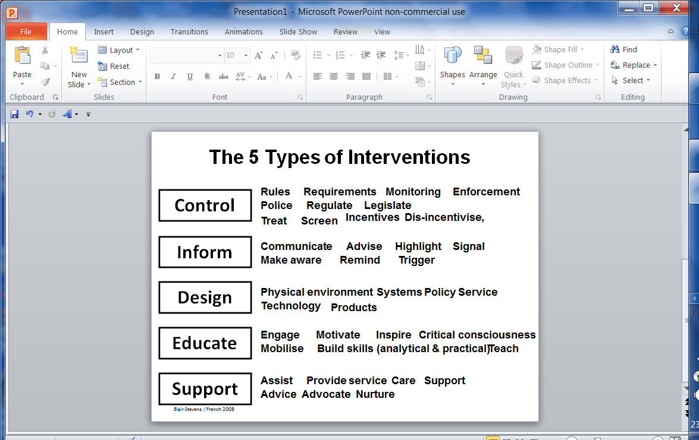

1. The word ‘Type’ of intervention is used in this context to mean different approaches that governments and

   public sector institutions can use to bringing about social change or maintaining social benefits. The five Types

   of intervention open to these organisations are considered to be: Education, Support services provision,

   Design interventions, Information provision, and Control systems including the law.