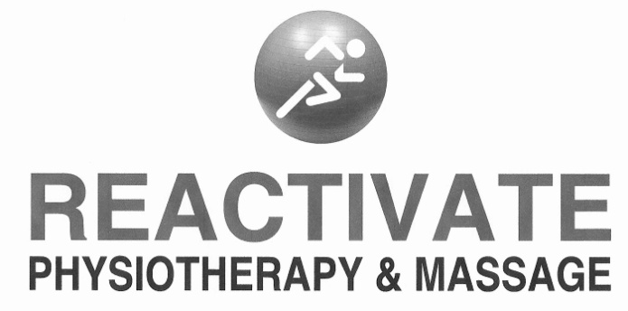
81 Middlecote Drive. Ajax, Ontario. L1T 0K3
P: (905) 231-1418 F: (905) 448-2538
www.reactivatephysiotherapy.com
reactivatephysio@hotmail.com

COVID-19 Liability Waiver

Patient Name:

I understand the novel coronavirus causes the disease known as COVID-19. I understand the novel coronavirus has a long incubation period during which carriers of the virus may not show symptoms and still be contagious.

I understand that physiotherapy and massage therapy services may require hands on contact which is one way the novel coronavirus can spread. (Initial)

I understand that being out in the community and attending visits at Reactivate Physiotherapy & Massage puts me at an elevated risk of contracting the novel coronavirus when compared to at home isolation. (Initial)

I confirm that I am not presenting with any of the following symptoms of COVID-19 as defined by the Ministry of Health of Ontario:
- Fever >38° (Initial)
- Cough (Initial)
- Sore Throat (Initial)
- Shortness of Breath (Initial)
- Difficulty Breathing (Initial)
- Flu-Like Symptoms (Initial)
- Runny Nose (initial)

I confirm that I am not currently positive for the novel coronavirus. (Initial)

I confirm that I have not been in contact with someone who has tested positive for coronavirus. Initial)

I confirm that I am not waiting for the results of a laboratory test for the novel coronavirus. Initial)

I understand that it is not possible to receive in person physiotherapy and massage therapy services while maintaining the 6 feet social distancing as per the recommendations of the Ministry of Health of Ontario. Initial)

I verify the information I have provided is truthful and accurate. I knowingly consent to in-person treatment during the COVID-19 pandemic.

Patient Signature: Date: Click here to enter a date.

