4.85 Evaluation of hearing impairment.
(a) An examination for hearing impairment for VA purposes must be conducted by a state-licensed audiologist and must include a controlled speech discrimination test (Maryland CNC) and a puretone audiometry test. Examinations will be conducted without the use of hearing aids.
(b) Table VI, “Numeric Designation of Hearing Impairment Based on Puretone Threshold Average and Speech Discrimination,” is used to determine a Roman numeral designation (I through XI) for hearing impairment based on a combination of the percent of speech discrimination (horizontal rows) and the puretone threshold average (vertical columns). The Roman numeral designation is located at the point where the percentage of speech discrimination and puretone threshold average intersect.
(c) Table VIa, “Numeric Designation of Hearing Impairment Based Only on Puretone Threshold Average,” is used to determine a Roman numeral designation (I through XI) for hearing impairment based only on the puretone threshold average. Table VIa will be used when the examiner certifies that use of the speech discrimination test is not appropriate because of language difficulties, inconsistent speech discrimination scores, etc., or when indicated under the provisions of §4.86.
(d) “Puretone threshold average,” as used in Tables VI and VIa, is the sum of the puretone thresholds at 1000, 2000, 3000 and 4000 Hertz, divided by four. This average is used in all cases (including those in §4.86) to determine the Roman numeral designation for hearing impairment from Table VI or VIa.
(e) Table VII, “Percentage Evaluations for Hearing Impairment,” is used to determine the percentage evaluation by combining the Roman numeral designations for hearing impairment of each ear. The horizontal rows represent the ear having the better hearing and the vertical columns the ear having the poorer hearing. The percentage evaluation is located at the point where the row and column intersect.
(f) If impaired hearing is service-connected in only one ear, in order to determine the percentage evaluation from Table VII, the non-service-connected ear will be assigned a Roman Numeral designation for hearing impairment of I, subject to the provisions of §3.383 of this chapter.
(g) When evaluating any claim for impaired hearing, refer to §3.350 of this chapter to determine whether the veteran may be entitled to special monthly compensation due either to deafness, or to deafness in combination with other specified disabilities.
(h) Numeric tables VI, VIA*, and VII.
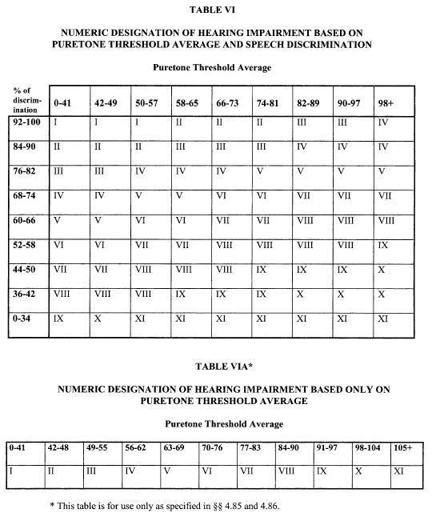
View or download PDF
