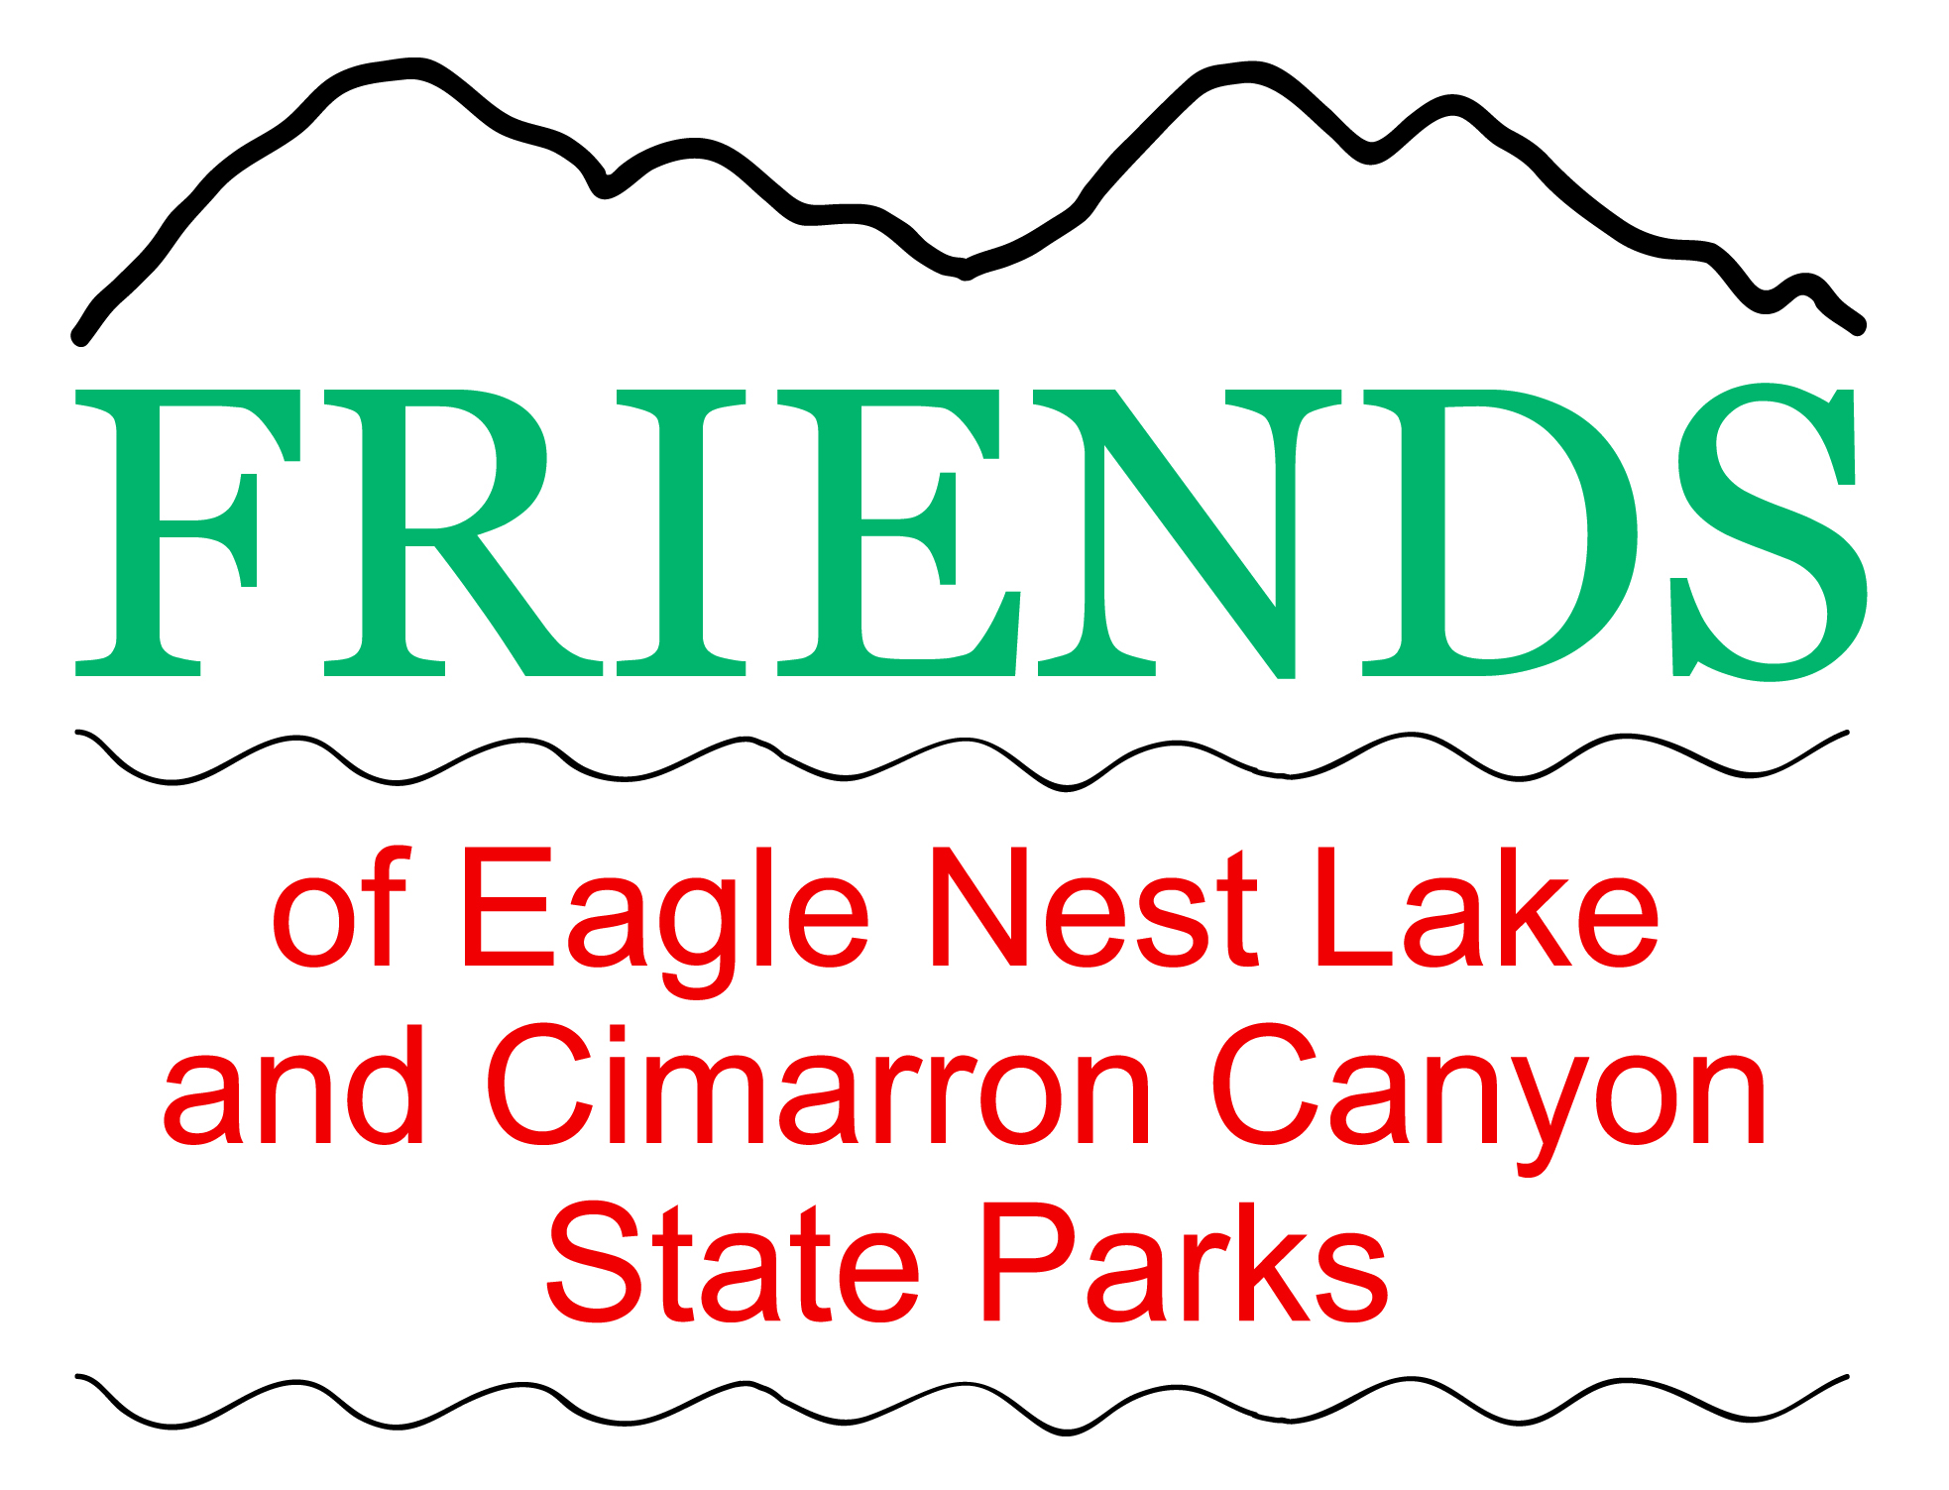 | Annual Friends of  Eagle Nest Lake Eagle Nest Lake  Ice Fishing Tournament  Last Saturday in January  Sponsored by  Friends of Eagle Nest Lake and Cimarron Canyon State Parks  In cooperation with  NM Department of Game and Fish and  New Mexico State Parks
Save time at registration – print this Registration form, complete & bring to registration.
Waiver, Release & Registration
All New Mexico Game and Fish and State Park
Rules & Regulations will be enforced!
I understand that activities associated with ice fishing involve risks to both body and equipment, and I agree that I am participating in this Ice Fishing Tournament after having given due consideration to such risks, and I WAIVE AND RELEASE all demands, damages, actions, causes of actions, suits and claims of any nature whatsoever, and costs, that I or my heirs, next of kin, executors, administrators, estate, agents and assigns, and representatives of any nature might otherwise have against any person, organization, agency, sponsor, or entity involved in sponsoring, promoting, organizing, or otherwise involved with ice fishing and this Ice Fishing Tournament. |  | I hereby give permission to Friends of Eagle Nest Lake and Cimarron Canyon State Parks and New Mexico Dept of Game and Fish and New Mexico State Parks and their agents to use my name and photographic/ videographic likeness in all forms and media for electronic and print news, advertising, trade, and any other lawful purposes.  By entering this Ice Fishing Tournament, I agree to follow all New Mexico Game and Fish and State Park Rules & Regulations and the rules of said Tournament, and I am hereby entering the following categories of said Tournament. (Note: Entry of categories must be done at time of original registration by participant.)  Circle categories entered.
1. Trout/Salmon $10 | 2. Perch $10 | 3. Pike $10 | 4. *Fishing Creel Total $10* | Total cash to be paid:
*Must enter Species Category for Species to count in Fishing Creel Total*
Fish submitted for judging must be caught by participant submitting said fish for judging.
Misrepresentation by participant in any category disqualifies participant in all categories.
PLEASE PRINT
Name:__________________________________________________________________________________
(First) (Middle) (Last)
Mailing Address: ________________________________________________________________________ City __________________________________________________ State ___________ Zip ____________ Home Phone: (______) __________________ Cell Phone: (______) _______________________________ Email: _________________________________________________________________________________
Signature: ______________________________________________________________________________
Signature of Participant or Parent/Guardian if under 18 years of Age
<<<<<<<<<<<<<<<<<<<<<<<< Following section to be completed by Tournament personnel >>>>>>>>>>>>>>>>>>>>>
Registration accepted on January _____, 202__ at __________ (time), Pmt Amt $_________cash rec’d by ___________(Tournament Registrar)
Score Sheet Participant MUST select one fish to be measured for prize in entered categories 1, 2 & 3.
1. Largest Trout/Salmon |  | 2. Largest Perch |  | 3. Largest Pike |  | 4. Fishing Creel Total
Length | Girth | Length | Girth | Length | Girth | Species | Points per fish caught | No. this Species caught | Total Points this Species
 |  |  |  |  |  | 1. Trout/Salmon | 3 | x | =
Raffle Winners must be present to claim prize.  (rev 1-03-19) |  |  |  |  |  | 2. Perch | 1 | x | =
 |  |  |  |  |  | 3. Pike | 5 | x | =
 |  |  |  |  |  | Fishing Creel Total Points

