Hello to you all. I hope that everyone is keeping well. As we enter the Summer period it is important to enjoy the good weather and enjoy as much outside time as possible. Activities that I have previously posted such as, P.E. and the mini beast hunt are great outdoor activities. I have included more activities below and please feel free to send any pictures of the children partaking in them to the school face book page. If you wish to contact me please email the school website on stmarysspecialschooldrumcar@gmail.com.
Mark it FAO Declan McCoy and I will get it. If you wish to send your phone number to arrange a call, I am more than happy to oblige. Hopefully we continue our recovery and are back in September.
We have a student in our class leaving this month and unfortunately the usual graduation ceremony cannot proceed. We will miss you Kassy and I will be in touch soon to see how you are.
Stay safe and hopefully we are over the worst of it.
Declan.

Communication
Revise the signs that the children have done throughout the year. These are in the first home document and I will also insert below.

The class have been using Lámh for communication each day. The following link will give you free access to the online material.
www.lamhsigns.org
Simply follow below instructions:
- Click ‘apply for membership’
- Enter the code ‘lovelamh’
- Follow the simple registration instructions.

The children have been using the following signs in class:
- Greetings
- Hello
- Goodbye

- Food
- Eat
- Drink
- Dinner
- Hot
- Cold
- Apple
- Banana
- Sweet
- Biscuit
- Burger
- Cheese

- Feelings
- Help
- Happy
- Good

- Hygiene
- Brush hair
- Brush teeth
- Toilet
- Clothes
- Daily use
- Mummy
- Bus
- Finished
- Boy
- Girl
- House
- Music
- bed
Sentences
Hello Mummy
Goodbye mummy
Thank you mummy
Good boy
Good girl
Eat dinner

Note: when doing the sign face your child and both do and say the sign. Praise any attempt, it doesn’t have to be perfect just a reasonable effort.
We also sing a daily Lámh song to the tune of ‘this is the way we…’
The child looks at a picture (please see below) and uses the associated sign whilst singing, for example, ‘this is the way we brush our teeth, brush our teeth, brush our teeth, this is the way we brush our teeth on a cold and frosty morning’.

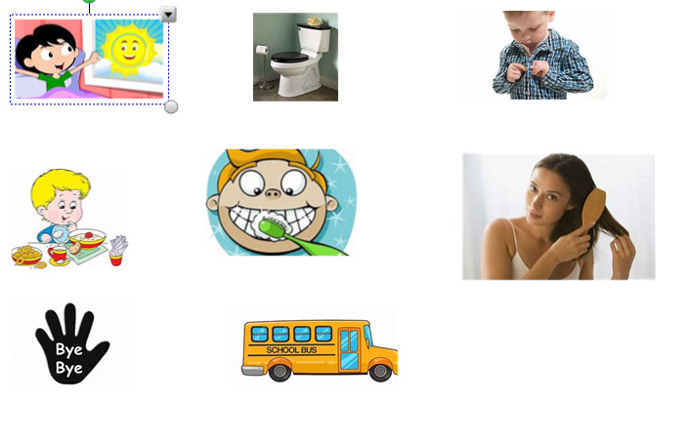
Do above with your child using the signs and signing the song.
- This is the way we get out of bed song
- This is the way we use the toilet song
- This is the way we put on our clothes
- This is the eat the food song
- This is the way we brush our teeth song
- This is the way we brush our hair song
- This is the way we say bye bye
- This is the way we drive the bus
Other useful websites for enhancing communication skills:
https://www.starfall.com/h/
http://www.speechtx.com/language/language_fun.htm
https://www.do2learn.com/

Add in

The sign for hot involves brushing the back of your hand on your forehead from left to right and saying hot. This can be used in the last week to explain it is hot as it is Summer and that we are on our Summer Holidays.
- Weather Song

- https://www.youtube.com/watch?v=KUSbazn3STo

Writing
Depending on the individual child there are a number of techniques
1, Mark making: the child can experience making marks with paint, shaving foam or using their finger in sand.
2. The child can trace letter and numbers with hand over hand support
3. The child can draw lines horizontally and vertically between objects
4. The child can attempt to write their name and copy numbers and letters independently.

Writing resources can be obtained at www.twinkl.com
There is currently a free sign up.

Mathematics
We use www.topmarks.co.uk
This is a free service. Simply select the tab ‘Learning Games’.
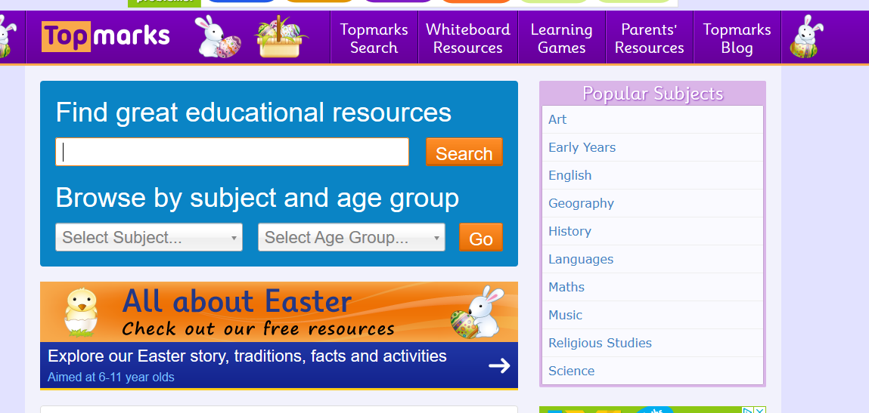

- Then select any of the following three games.

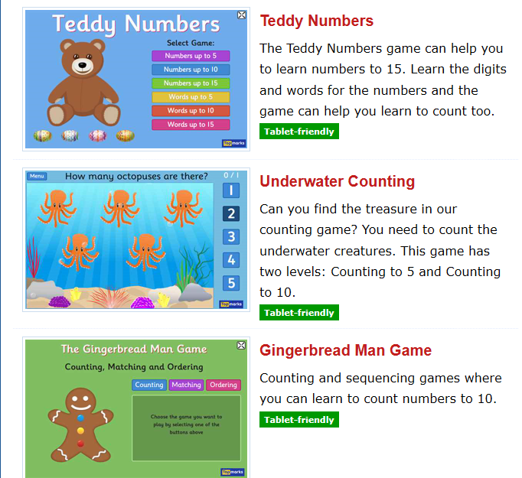

- Depending on abilities you can select numbers to 5 or numbers to 10.

Other activities include your child counting out loud to ten, counting objects to 10 and ordering objects big or small.
Number song web links:
http://www.youtube.com/watch?v=F2OpkQuOjig

ART
Check out the free resources for Early Years on www.scholastic.co.uk and free resources on www.twinkl.com

TACPAC
The children in our class love tacpac and currently you can receive free sessions online.
To obtain 5 free TACPAC sessions:
Click on the following link
http://tacpac.co.uk/product/set_5
At the checkout enter code 8Q7A3TXS
Once this is done go to http://www.facebook.com/TacpacLtd to watch the short videos on how to do TACPAC.

Music/Drama

Caterpillar Music – Facebook page Caterpillar Music are offering live music sessions using puppets, musical fun and action songs. They are colourful and the songs are catchy and encourage the children to join in.

Rhythm and Rhyme These are sessions with rhymes and action songs that the children will know.
https://www.youtube.com/watch?v=kXQQB8lzMmQ

All about me
This is an enjoyable project that incorporates history.
- Begin by cutting out a picture of your child and they label it me
- Next cut out a picture of family members (including extended family) and label each with their name
- Extend this to pets
- The next step involves a picture of your child when they were little.
- The next step involves making a profile for your child based on their picture.
I have ____ eyes
I have _____ hair
I am ____ years old
I like ______
Finally cut out a picture your child as a baby and talk with them about things that have changed and things that remain the same. For example, I was small and had no hair, but my eyes were still blue.
This information can be transferred to a scrap book, so the child now has their own personal book.

Sensory Stories
The link below contains several sensory stories that your child may enjoy

http://www.greenside.herts.sch.uk/Creative/SensoryStories/SensoryStories.html?fbclid=IwAR1EaTS k2mu633RKq_wmwPCR9tJ6birjNkm6q7r4RIB9EsVTyQfdmJNMWCA

