Here’s the final set of instructions showing how the blocks are to be put together! Completed quilt top is due at the March 2020 PPQG Quilt meeting. Remember, you only need to have the top completed, it doesn’t have to be quilted and binded.
I want to thank everyone that has hung in there and made it this point. Congratulations, I hope you enjoy your quilt as much as I will enjoy mine.

8. Arrange the blocks in 6 rows as shown. Sew the blocks into rows. Sew the rows together.
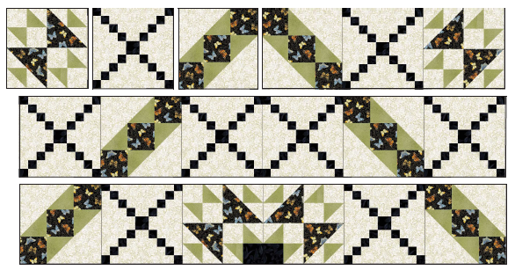
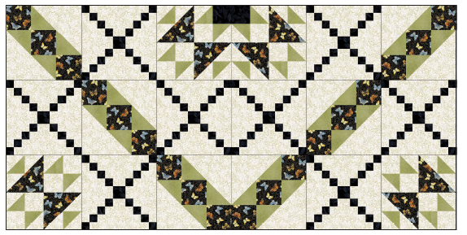

9. Layer and baste the backing, batting and quilt top.

10. Quilt as desired. Bind the quilt with the 2½” focus fabric strips.

