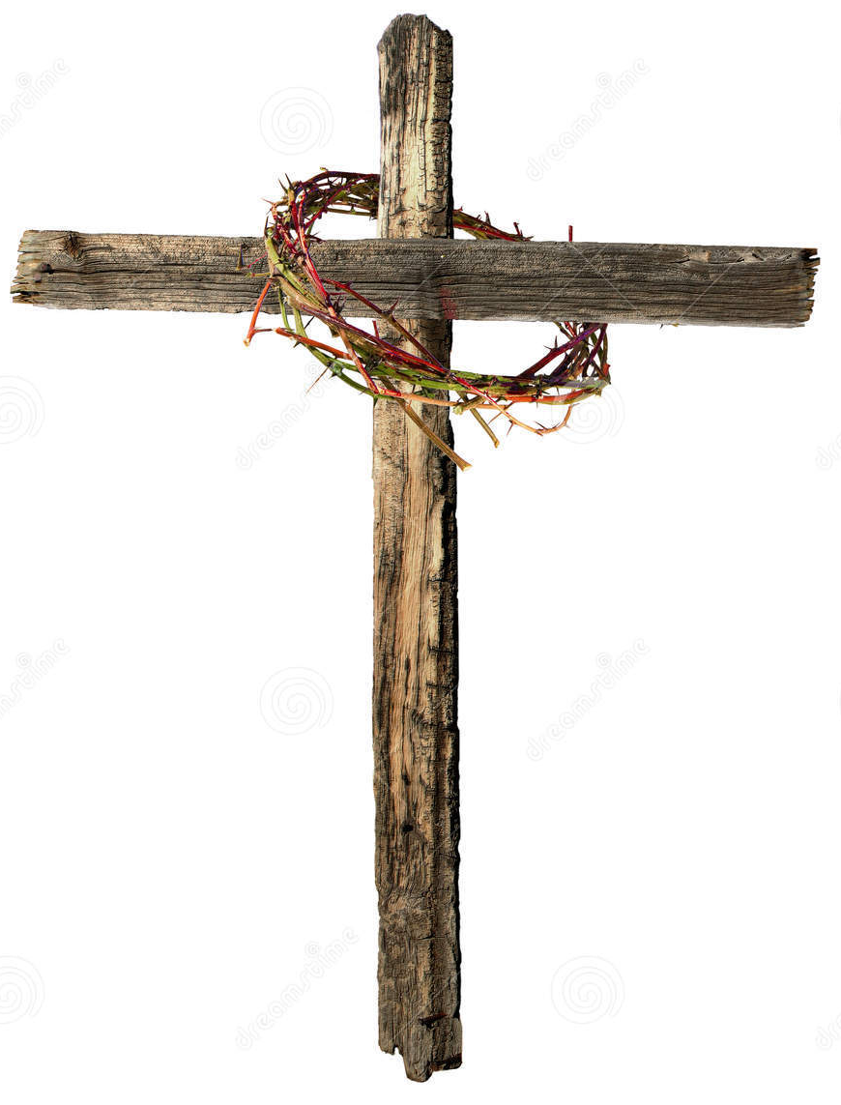
Countryside
Church of Christ
July 5, 2020
Opportunities
Prayer Time
Hymn 486 “My Country ‘Tis of Thee”
Hymn 485 “America the Beautiful”
Hymn 74 “Mine Eyes Have Seen the Glory”
Communion
Children’s Time
Children’s Church begins
Message from God’s Word
“The Star-Spangled Banner”
Closing Prayer
Offering
(baskets in back)

Church Facilities: 8063 Loop Road, Hesperia, Michigan 49421
Pastor Dick Cotton: pastor@countrysidechurch.net, 616-560-6843
Facebook: www.facebook.com/CountrysideChurchHesperia
Website: www.countrysidechurch.net
“Our Dual Citizenship”
1. Citizens of the ___________ of _________
Genesis 1ff

2. “Citizens” (___________) of ____________
Exodus 1ff

3. Citizens of ________________
Exodus 20ff

4. “Citizens” (_________________) of Assyria, _________________, and Medo-Persia
Daniel 3 & Daniel 6

5. “Citizens” (______________) of _________
Matthew 22:17-21
Romans 13:1-7
1 Peter 2:13-14

6. Citizens of __________ ________________
Ephesians 2:19-21
Philippians 3:17-21
Hebrews 11:13-16

7. Our _____________ Citizenship
Revelation 5:8-10
Matthew 6:33
Acts 5:27-29
This Week’s Bible Readings
Sunday, July 5 1 Corinthians 6:14-17
Paul teaches that believers are united with Christ. Therefore, we died with Christ. And God raises us from the dead (spiritually & physically) with the same power that He raised Christ from the dead. Since the believer is united with Christ, what happens when a believer sins?
Monday, July 6 1 Corinthians 6:18-20
Paul circles back to the believer being the temple of God (cf. 3:16-17). Now he applies this truth to sexual matters. Why should the believer run away from sexual immorality? In practical terms, how can a believer proactively avoid sexual immorality today?
Tuesday, July 7 1 Corinthians 7:1-7
Apparently the Corinthian believers had written to Paul asking him if Christians ought to get married or not. In this chapter, Paul gives both God’s commands and some of his own advice. What were the reasons Paul gave for and against marriage in these verses?
Wednesday, July 8 1 Corinthians 7:8-9
Paul seems to favor remaining unmarried if possible. Under what circumstances does Paul say it is better to marry?
Thursday, July 9 1 Corinthians 7:10-11
Now Paul speaks to those who are already married. He makes it clear that this is God’s command, rather than his own opinion. What does the Lord command to married believers?
Friday, July 10 1 Corinthians 7:12-14
Paul’s gives his own advice on marriage when a believer is married to an unbeliever. What does he say to believers who are married to unbelievers? What benefits are there in following Paul’s advice?
Saturday, July 11 1 Corinthians 7:15-16
Paul continues to speak to believers who are married to unbelievers. In the previous verses (12-14), the unbelieving spouses were willing to remain with the Christian spouse. Now in these verses (15-16), the unbeliever wants to leave the marriage. What does Paul say to the Christian spouse in this situation? Why? What’s his main concern?
Opportunities
Sunday 10 am Bible Class: Study of 2 Peter (weekly)
Tuesday, July 7: Bible Study 1 pm (weekly)
Tuesday, July 7: Ministry Leadership Team 6 pm
Tuesday, July 7: Bible Study 7 pm (weekly) – What does the Bible say about the Role of Women in the Church? How does it apply to Countryside?
Tuesday, July 14: Elders & Deacons meet
Thursday, July 16: Women’s Fellowship 6 pm
Tuesday, July 21: Ministry Leadership Team 6 pm
Tuesday, July 28: Youth Pizza with Pastor 5:30 pm Meet at Fat Boys Pizza. For middle and high school students.
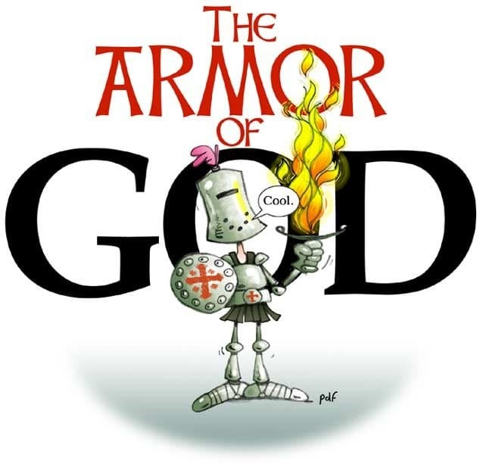
August 3-7: Five-Days Club for children and youth, Monday through Friday,
5-Days Club
10 am to Noon. Youth will be given opportunities to help leaders. Stay tuned for volunteers, snacks, & other needs. There will be a
Hot Dog Roast on Friday, August 7 at 6 pm for the whole church and all families of the kids.

