Weston on the Green  Neighbourhood Plan | 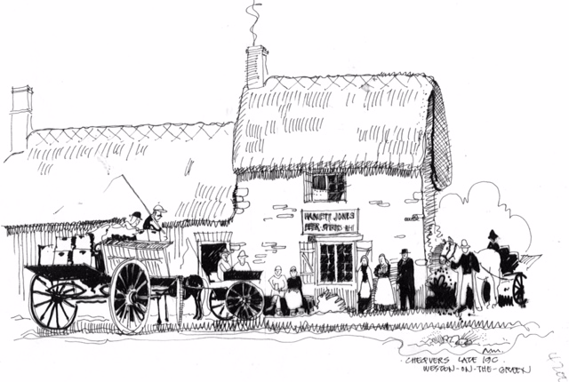
September 2016

On 20th September the Steering Group held a public meeting to consult with the village on the pre-final draft of the Neighbourhood Plan (NP). It was a well attended and lively meeting, with over 35 villagers turning out.

The evening was a chance for villagers to hear an explanation of the contents of the final Neighbourhood Plan – how the central planning process works and how a NP fits into this; a description of the proposals put forward at the original village consultation meetings and how they were chosen etc – and thus to discover what the Neighbourhood Plan means for the village. It was also an opportunity for any feedback to be given and questions to be asked. Diane Bohm, the Chair of the Steering Group (SG) led the presentation with support from Susan Daenke and Bob Hessian. Refreshments were kindly provided by Liz Machin and Paula Hessian.

For those who were unable to attend, the Executive Summary can be seen on our website at http://www.wotgneighbourhoodplan.co.uk/ or go to Facebook.com and search for Weston on the Green Neighbourhood Plan. Once we have finalised the Plan it will be available in full on the website. We welcome further feedback on the plan via our website.

Next Steps

- All feedback from this meeting will be considered based on the information in the Executive Summary.
- The final draft will be presented for approval to the Parish Council and then submitted to Cherwell District Council for review.
- After consideration of CDC’s comments, the Parish Council, which is the legal body for submitting the Neighbourhood Plan, will formally submit the Plan to CDC.
- It will go to the Planning body and will either be agreed and comments/suggestions made or will be rejected.
- If agreed with suggested amendments, the Steering Group will make changes as advised by the CDC.
- The NP will be formally published for consideration by statutory consultees for a six week period. This is known as the “Formal Consultation Period”.
- It will be submitted to the External Examiner for review and recommendations.
- If the External Examiner authorises the NP it will go to the village to seek approval via a referendum.
- If the village agree to accept the NP, it will formally be adopted as policy by the CDC.

Dates of the next Steering Group Meetings:

13th October
10th November
8th December

They are all held at 7.30 pm in the Village Hall and open to the public.
Alex Reid

