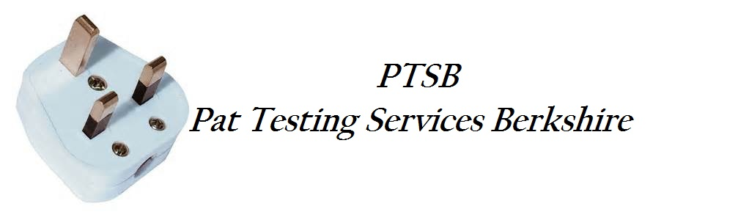

Concise Test History
Page 1
31st March 2016
Test Status: All,
Test Type: All
Person: Doug
Instrument: All

From: 31/3/2016 To: 31/3/2017

Client: Fosters Catering LTD
Site: CAFÉ Basingstoke
Location: CAFÉ XPRESS

Asset ID Description Result
FC001 40m extension lead PASS
FC002 30m Extension Lead PASS
FC003 25m Extension Lead PASS
FC004 Hog Roast Motor 1 PASS
FC005 Hog Roast Motor 2 PASS
FC006 Hog Roast Motor 3 PASS
FC007 Light set 1 PASS
FC008 Light Set 2 PASS
FC009 Light Set 3 PASS
FC010 Halogen Light 1 PASS
FC011 Halogen Light 2 PASS
FC0012 Pizza Roller PASS
FC013 Oven 1 PASS
FC014 Oven 2 PASS
FC015 Fryer 1 PASS
FC016 Fryer 2 PASS
FC017 20ltr water boiler PASS
FC018 10ltr water boiler PASS

