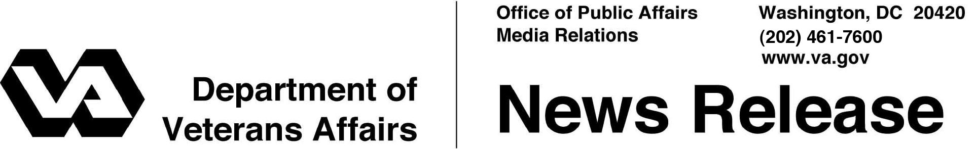

FOR IMMEDIATE RELEASE
January 5, 2011
President Signed Improvements to Post-9/11 GI Bill
Many Non-College Programs, State Service of Reserves and Guard Covered
WASHINGTON – To bring the educational benefits of the Post-9/11 GI Bill closer to more Veterans and Service Members, President Obama signed legislation Jan. 4 that streamlines the 18-month-old education program administered by the Department of Veterans Affairs (VA).
“Since the first GI Bill in 1944, this unique educational program has adapted to the needs of America’s Veterans, active-duty personnel, reservists and Guardsmen,” said Secretary of Veterans Affairs Eric K. Shinseki. “Like its forbearers, the Post-9/11 GI Bill is growing to ensure the men and women who serve this nation in uniform receive valuable education benefits from a grateful nation.
“On behalf of Veterans and the many who serve them at VA, we would like to thank the president for his support, as well as members of Congress and our Veterans service organization partners for helping make this bill a reality,” Shinseki added.
Among the provisions of the legislation are:
- Paying for on-the-job training, some flight training; apprenticeship training and correspondence courses;
- Allowing reservists and Guardsmen to have their time supporting emergencies called by their state governors credited to the time needed to qualify for educational benefits;
- Providing one half of the national average for the program’s housing allowance to students enrolled in distance learning;
- Pro-rating the housing allowance to exclude payments when students are not in class;
- Allowing students on active duty receive the stipend for books and supplies;
-More -
GI Bill 2/2/2/2

- Allowing people eligible for the Post-9/11 GI Bill, but participating in VA’s Vocational Rehabilitation and Employment (VR&E) benefits to choose between the GI Bill’s housing allowance or VR&E’s subsistence allowance;
- Permitting reimbursement for more than one “license and certification” test;
- Reimbursing fees to take national admission tests, such as SAT, ACT, GMAT and LSAT; and
- Establishing a national cap of $17,500 annually for tuition and fees in a private or a foreign school, not including contributions by educational institutions under the “Yellow Ribbon” program.
Information about the new provisions is available on the Internet at www.gibill.va.gov.
By the end of December 2010, VA issued nearly $7.2 billion in tuition, housing, and stipends for more than 425,000 Veterans or eligible family members pursuing higher education under the Post-9/11 GI Bill.

# # #

