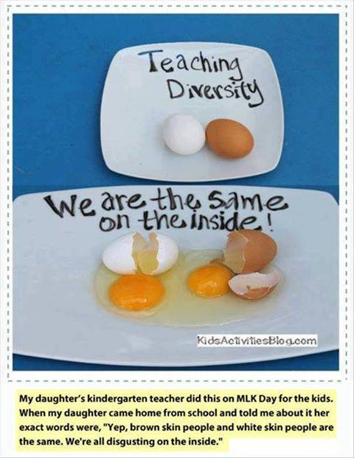
From “Being Liberal” Facebook Page
I disagree that we’re disgusting on the inside but it’s a great way to start the discussion about diversity with young children!

