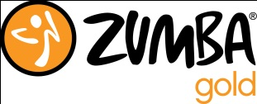
Zumba and Zumba Gold February 2020 farmingtonzumba.com
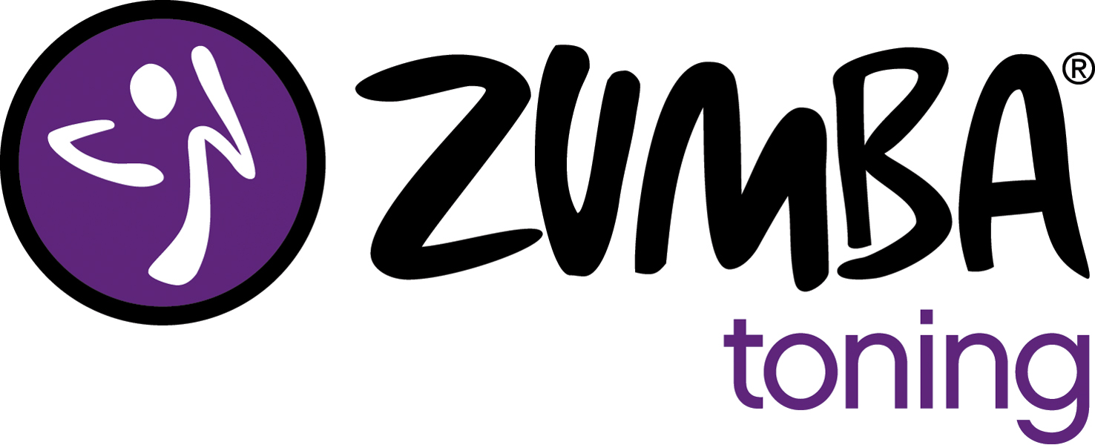
SUNDAY | MONDAY | TUESDAY | WEDNESDAY | THURSDAY | FRIDAY | SATURDAY
Fitness World is on East Pinon Hills Blvd (behind Dickey’s BBQ).  Rec Center is located at 1101 Fairground Rd  For pricing info see farmingtonzumba.com |  |  |  |  |  | 1 Zumba  Fitness World 9-10am  No Gold Class
2 | 3 Zumba Fitness World 6-7pm | 4Zumba  Fitness World 6-7pm  GOLD  RC 6:30-7:30pm | 5 Zumba  Fitness World 6-7pm | 6 Zumba  Fitness World 6-7pm | 7  Fitness World 6-7pm | 8 Zumba  Fitness World 9-10am  GOLD  Rec Center 10-11am
9 | 10 Zumba  Fitness World 6-7pm | 11 Zumba  Fitness World 6-7pm  GOLD  RC 6:30-7:30pm | 12 Zumba  Fitness World 6-7pm | 13 Zumba  Fitness World 6-7pm | 14  Fitness World 6-7pm | 15Zumba Fitness World 9-10am  GOLD  Rec Center 10-11am
16 | 17 Zumba  Fitness World 6-7pm | 18Zumba  Fitness World 6-7pm  GOLD  RC 6:30-7:30pm | 19 Zumba  Fitness World 6-7pm | 20 Zumba  Fitness World 6-7pm | 21  Fitness World 6-7pm | 22 Zumba  Fitness World 9-10am  GOLD  Rec Center 10-11am
23 | 24 Zumba  Fitness World 6-7pm | 25 Zumba  Fitness World 6-7pm  No Gold Class | 26 Zumba  Fitness World 6-7pm | 27 Zumba  Fitness World 6-7pm | 28 Zumba  Fitness World 6-7pm | 29 Zumba  Fitness World 9-10am  GOLD  Rec Center 10-11am
Zumba®, Zumba Gold®, Zumba® Toning, Zumba ® Gold-Toning and the Zumba Fitness logos are trademarks of Zumba Fitness, LLC, used under license.

