Complaints Process

Step 1 – Contact the relevant staff member informally via phone or email to discuss your concern

Step 2 – If unresolved, please put complaint in writing to the Coordinator or Community Engagement Officer

Step 3 – The Coordinator or Community Engagement Officer will acknowledge receipt of the complaint within 2 business days

Step 4 – The Coordinator or Community Engagement Officer will contact you within 10 business days with the proposed course of action

Step 5 – If still unresolved, the complainant may discuss the complaint with the General Manager

Step 6 – If the complaint is still unresolved, the complainant may request a review of the complaint by the Board of Management

(Please note: If the complaint is about the General Manager or Board of Management, the Board of Management will be involved)

You are welcome to have an external person supporting you at all stages
of the complaints process.
Please contact us at anytime.

Contact can be made in the following ways:

Phone:
(07) 3343 9833

Email:
intake@mgcci.org.au

In Person:
1693 & 1697 Logan Rd,
Mt Gravatt, 4122

In Writing:
PO Box 806,
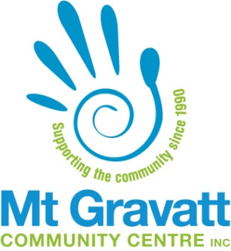
Mt Gravatt, 4122
Compliments and Complaints Information

Help Us Improve Our Service

Are we meeting your needs?

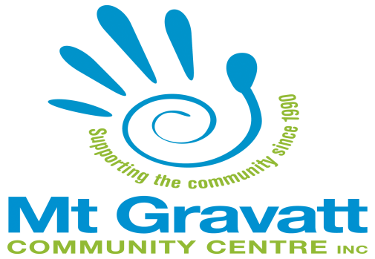
If you have a concern, chances are that you are not alone. Your feedback could make us aware of problems that we don’t know about. We want to hear from you about how we are doing.
Let’s talk
Please discuss any concerns or questions you have about the quality of care provided by our service.

We take all feedback seriously and want to understand how we can best deliver services to you.

You are welcome to speak to our staff if you have any issues you wish to raise.

We welcome feedback via email, telephone, in writing or in person.
What to expect
If you have a complaint, we will respond to it promptly and sensitively. We will treat your complaint in confidence and respect your privacy.

You can help us by providing as much relevant information as possible.
We aim to address your concerns as quickly as possible. Where appropriate, we will investigate your complaint to understand what happened and why, and to find ways to prevent it from happening again.

We will keep you informed about the progress of your complaint along the way.

We will work with you to assess how best to resolve your complaint. Please consider the outcome you would like and we will strive to provide it.

Improving our service
Mount Gravatt Community Centre Inc. (MGCCI) values feedback received from clients. It is useful in planning future supports and informs the organisation about ways to improve and strengthen the ways we work with people in the community.

External complaint mechanisms
If you do not feel your complaint is resolved or continue to be dissatisfied, assistance is available. We would encourage you to ask someone to assist you. You can seek assistance from either an informal person such as
a family member, friend, or neighbour;
or from a formal advocacy service such
as:
- Aged Care Advocacy - 1800 700 600.

- Aged Care Complaints Commissioner - 1800 550 552.

- Queensland Aged and Disability Advocacy Inc. (QADA) – 1800 818 338.

- Speaking Up For You (SUFY) - 3255 1244.

- Home Assist Secure: Department of Housing & Public Works – 137468

- Department of Communities, Disability Services and Seniors: 1800 080 464

