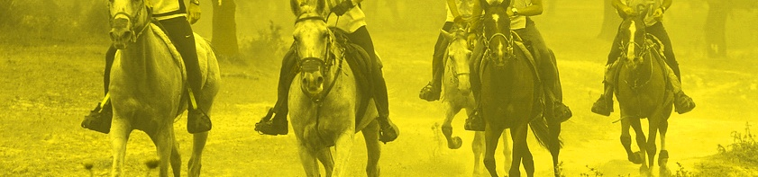
AUSTRALASIAN ENDURANCE FORUM
FEI Event Veterinarians, Officials & Competitors
Centr@l Bardon Conference Venue, 390 Simpsons Road, Bardon, Queensland, Australia.

FEI Course Directors : | Mrs Ruth Carlson (CAN)
 | Mr Ian Williams (GBR)
 | Dr Brian Sheahan (AUS)
 | Dr Jean-Louis Leclerc (FRA)
 | Dr Jim Bryant (UAE)
International Speakers : | Dr Peter Huntington (AUS)  Mr Jaume Punti Dachs (UAE)  Dr Warwick Vale (AUS)  Dr Steve Zedler (AUS)  Prof. Bashir Ahmad Fateh (MAS)  Dr Martha Misheff (UAE)  Dr Anne Barnes (AUS)  Dr Paula Williams (AUS)  Dr Cliff Pollard (AUS)  Mrs Meg Wade (AUS)  Mr Chris Gates (AUS)
Language: | English
Participation : | Open to all NFs  (this clinic is not suitable for any request of FEI promotion)
Applications must be sent to : | Mrs Ieva Peters
 | 96 Battersby Road
 | Anketell, 6167
 | Western Australia
 | Email : ieva.peters@bigpond.com
Deadline for applications : | 26th May 2011
Programme & Time table : | Will be sent to participants after receipt of their application, or visit the websites : www.thesquad.asn.au  www.aera.asn.au
Participation Fee : | AU $380 for three days.  AU $165 per day.
Participants will be responsible for their own transport, accommodation and some meal costs.
The Forum is a course for maintenance of star rating for 4* officials & vets.
The above information serves as an official invitation.

