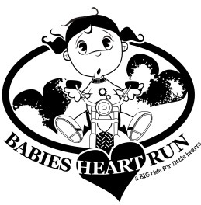

January 1, 2019

To Whom It May Concern,

The Babies Heart Run is a local Non-Profit organization. The money raised each year goes to local families who have babies in the Neonatal Intensive Care Unit or children in the Pediatric Intensive Care Unit. We are currently planning our 11th Annual event to be held on Sunday, August 18, 2019. This event is a local motorcycle ride that includes race cars, vendors, and activities for children. The police escorted ride starts at Fitch High School in Groton, travels over 25 miles through Mystic and Ledyard .
The success of our event is credited largely to our sponsors, who lend their name and financial support to the event. Last year we were able to raise $17,000.00! All of those funds are used to provide families with $1000 check, $500 in gift cards for gas, parking and food. In 2019 we expect to exceed these numbers. By participating as a sponsor, your business will benefit from extended exposure through media campaigns and promotional efforts directed toward the participants of The Babies Heart Run.
We have four levels of sponsorship, as detailed in the enclosed commitment form. All sponsorship and donations are tax deductible. You can be secure in the knowledge that your sponsorship will be used to make the Babies Heart Run event come to life.
We're counting on your support, and will be happy to answer any questions you may have. Please take a moment to view our website www.babiesheartrun.com to see information on the event, sponsors, and pictures of the families we have helped. The deadline is May 1st 2018. Thank you in advance for your willingness to support the efforts of The Babies Heart Run and make a difference in your community.

Sincerely,

Babies Heart Run, Inc. (501c3) 47-1011991
PO Box 315
Groton, CT. 06340
jayandnina@babiesheartrun.com

The Babies Heart Run Sponsor Commitment Form
There are four levels of sponsorship available:
Intersection Sponsor - $100 (renewal $25) – this option can be in memory of someone, a business name, a family name, etc. It is a lawn sign that will be posted at one of the intersections along the BHR route.
Silver Level - $150 - donation will ensure that your business is posted as Silver Sponsor on website, on an intersection sign and on a banner at the event.
Gold Level - $250 - donation will ensure that your business is posted as a Gold Sponsor on website, on an intersection sign, on a banner at the event, and your logo will be on our event t shirt.
Presenter Level - $750 - donation will ensure that your business logo is on all advertising (i.e. flyers, posters, banners, etc). The logo will be on the event t shirts in a larger size. The logo will be on our website, on an intersection sign, on a banner at the event at both locations.
Name of Business____________________________________________________________
Address____________________________________________________________________
Contact Person_____________________________________________________________
Phone Number_____________________________Email____________________________
Business Website____________________________________________________________
Check Sponsorship Level Choice:
Intersection $100 ______ Silver $150_______ Gold $250__________ Presenter $750________
*Please make checks payable to The Babies Heart Run. All sponsors attending with a motorcycle or as a walk in must still pay the registration fee at the event to participate in the ride.
BABIES HEART RUN TAX ID #: 47-1011991
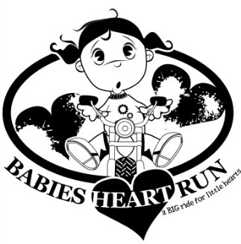
Mail checks and sponsorship form to: PO BOX 315 Groton, CT. 06340

