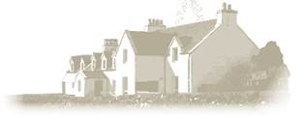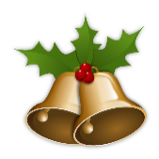

**The Inn @ Àird a Bhaisar**

**CHRISTMAS DAY MENU**

**TO BEGIN**

**AIRSON TOISEACH TÒISEACHAIDH**

**Celeriac & Apple Velouté**

Blue Cheese Croutons and Apple Crisps

**Scottish Hot Smoked Salmon Mousse**

Filo Pastry Parcel, Dressed Rocket, Lime & Dill Crème Fraiche

**Confit Duck & Pistachio Terrine**

Red Onion Relish and Homemade Melba Toast

**Mango Sorbet**

**dinner main course**

**Cùrsa prìomh dinnear**

**Roasted Turkey Crown**

Goose Fat Roasted Potatoes, Garlic & Tarragon Carrots, Bacon wrapped Chipolatas, Buttered Brussel Sprouts, Fig & Chestnut Stuffing, Cranberry & Red Currant Jus

**Pan Seared Cod Fillet**

Potato & Parmesan Croquettes, Roasted Walnuts, Lemon Scented Green Beans, Vine Cherry Tomatoes, Onion and Artichoke Cream Sauce.

**Daube of Venison Shoulder**

Trompette Mushrooms, Celeriac Puree, Chestnuts, Honey Glazed Quince, Port and Red wine Reduction

**Sweet Potato, Chestnut, Kale and Mushroom Wellington**

Roasted Potatoes, Garlic & Tarragon Carrots, Vegetarian Wrapped Sausage, Buttered Brussel Sprouts, Cranberry & Red Currant Vegetarian Gravy

A DELIGHTFUL ENDING!

DEIREADH NA SGEOIL!

**Traditional Christmas Pudding**

Butter Brandy Sauce

**Buche de Noel**

Chestnut Cream, Dark Chocolate Ganache, Meringue,

Christmas Pudding Ice Cream

**Selection of Scottish Cheeses**

Homemade Oatcakes, Celery, Dried Figs and Red Onion Chutney