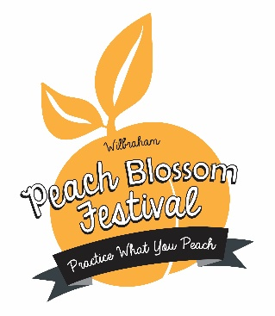
2019 Blue Ribbon Tent
Item Submission Form

Submitter Name:
Adult Category: ______ Children's Category (18 or Under): ____
Email Address:
Phone Number:
Number of Items Being Submitted:
Please list all items being submitted:
Item #1
Item #1 Description

Item #2
Item #2 Description

Item #3
Item #3 Description

**Your item must be picked up on Saturday June 15th from 6-7pm. Any person not picking up their item, without having made special arrangements beforehand will have been considered to have made it a donation to the Peach Blossom Festival.
For PBF use only
Item #: _____ Item Category: ________________ Returned ___________ gave it to _____________

