Serving the St. Louis Region  copyrights © 2001-2015 Living Independently home care, llc. |  | LIVING INDEPENDENT LY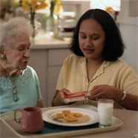  Gift Certificate
 |  | This certificate entitles the bearer
 |  | to 3 hours of home services customized to meet your needs.
 |  | Tel: (314) 733-0335  Fax: (573) 539-1091  www.live-independently.com | Expires:
 |  |  | Authorized by:
 |  | Not redeemable for cash. Redemption value not to exceed $1000.00, | 0000010

