Peninsula Piecemakers Quilt Guild 2019/2020 Mystery Quilt
(Finished Quilt size: 72” x 72”, Finished Block size: 12”)

5. a. Sew 2 4-patch squares to a light 3" x 7½” rectangle as shown below to form Section D. Make 32.

b. Sew 2 4-patch squares to a light 3" x 2½” rectangle as shown below to form Section E. Make 32.

c. Sew a light 3" x 2½” rectangle to a dark 2½” square as shown below to make Section F. Make 16.
d. Sew E sections to F sections as shown below to make Block 4. Make 16.
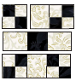

e. Sew 2 light 3" x 7½” rectangles to Block 4 as shown below to form Section G. Make 16.
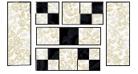

f. Sew D sections to G section as shown below to form Block 5. Make 16. Square up to 12½”.
