DRAGONFLY DESTINATION CHIOS
INCLUDING A CHECKLIST OF THE DRAGONFLIES OF CHIOS
Mike Taylor, Associate, World Museum Liverpool. (WML).

Introduction
Investigations into the bio-diversity of Chios in the last twenty years has proven the richness and variety of its wildlife and has encouraged increasing numbers of wildlife tourists to visit the island. Tourists to date having mainly been attracted by the wealth of wildflowers, particularly orchids, but also by the birds, butterflies, moths, grasshoppers and crickets.
In autumn 2012 I received a copy of Studien zur Libbelenfauna Griechenlands IV .LIBELLULA Supplement 10, Bremen, 15 July 2010. Julia Lopau. ISSN 0723-6514. This summarised all dragonfly records from Greece known to the author, recording 11 species from Chios.
In the last two years, 2013 and 2014, intensive investigations into the dragonfly fauna, redressing a lack of effort in an historically almost totally neglected group on Chios, by detailed studies ‘in the field’, have discovered several rare and much sought after species on the island. The total list now numbers 29 species.
Chios landscape and habitats
Chios is an island in the north-east Aegean Sea lying close to the Turkish coast, south of Lesbos and north of Samos. The island is the fifth largest in Greece, with a total area of 904km², a varied geology and a wide topographic range, capped by Mt. Pelinaeon (1297 m) in the north of the island. Its location close to the Turkish mainland, opposite the Izmir Peninsula, means that its fauna and flora consists of a mixture of European and Asian/Middle Eastern elements. Agricultural activity is non-intensive and patchy in nature and this has contributed to the retention of much of the natural landscape and to the preservation and protection of native plants and animals. Furthermore, Chios has not suffered from the excesses of environmentally damaging and inappropriate developments seen in many other Mediterranean areas. On the contrary many of the old properties in the villages are being gradually modernised with tasteful and sympathetic care to ensure the preservation of their character for the benefit of future generations of citizens and visitors. A majority of the 50,000 inhabitants are concentrated in the principal town, Chios Town, on the east coast and the human population of the remainder of the island is exceptionally low.
Chios has a wide range of habitats, including lowland phrygana ( the Greek name for garrigue, Mediterranean vegetation dominated by spiny under-shrubs ), montane phrygana, flower-rich grassland, pine forest, relict oak forest, freshwater marsh, rocky stream valleys and gorges. Coastal habitats include both stony and sandy beaches, reed beds, semi-saline spring fed pools and rocky cliffs.

Principal Dragonfly Locations on Chios
1. Armolia Reservoir.
The agricultural reservoir located on the northern fringe of the village is the most species rich site discovered on Chios with 18 species found there so far. Virtually all of them are believed to be breeding on the site. Many are also found in large numbers, the tracks around the reservoir affording ideal conditions for close observation and photography, as well as close elevated views over the reservoir surface. This site has been designated as a dragonfly sanctuary. It is also a great attraction for migrating birds. See Fig A.

Species of dragonflies recorded here, numbered as in the following checklist, are:-
5,6,7,8,9,10,12,13,14,17,19,21,22,24,25,26,28,29.

2. Marmaro Marsh.
The marsh located on the south eastern edge of the coastal village of Marmaro is the most extensive freshwater wetland remaining on Chios. Prior to the drainage of Kontari marsh and the building of the airport to the south of Chios Town, the Kontari site was probably as important as Marmaro Marsh is today. Marmaro marsh has been declared an area fully protected from development by a recent presidential decree. The site which is generally flooded after winter rains, with the ground acting like a giant sponge, has been sporadically cultivated over the centuries, resulting in several drainage channels and ditches which act as havens for wildlife including a rich dragonfly, damselfly and water beetle fauna. Viewing is easy from the cross marsh roads and footpaths. See Fig B.

The general naturalist is sure to find plenty of interest in the marsh, bird migration can result in large varied flocks of waders in the drainage ditches flowing alongside the cross marsh roads, terrapins, large fresh water crabs, tree frogs and snakes are also features of the marsh. The marsh also holds a number of rare Lepidoptera.

Species of dragonflies recorded here are:-
4,5,9,12,13,14,19,20,21,24,26,27.

3. River Malagiotis.
The River Malagiotis is the longest river on Chios, 15 Km in length. It starts high up on Mt. Pelinaeon to the northeast of Fyta on the western slope of the mountain fed by melt water, springs and seasonal rains. In early spring the upper reaches flowing in narrow v-shaped valleys form mountain torrents with numerous deep holding pools, many of which persist for most of the summer. This upper region of the torrent crosses the road between Fyta and Spartounta, about 1km from its source. This upper section of about 3Km in length has been well surveyed for dragonflies. See Figs C&D.

I have never visited the central 5Km section of the river in search of dragonflies, nor has it been visited for such purposes by anyone else to the best of my knowledge and belief.

The river finally discharges into the sea at Managros beach near Limnia, south of Volissos. The final 3Km section is much wider and in early spring is often too deep and swift flowing to enable easy crossing. During late spring and summer, flow rates reduce considerably, however even by the end of September the final hundred metres or so just behind the beach still has flowing fresh water in the terminal reed beds.

Species of dragonflies recorded here are:-
1,2,4,9,10,12,13,14,15,16,18,19,21,23,24,26,28.

4. Kampia Gorge and River.
The Kampia river is about 5Km in length, commencing in the upper reaches of the Kampia valley to the west of Kampia village. It descends rapidly in a northerly direction through the spectacular Kampia gorge, finally discharging into a permanent terminal freshwater lagoon at the back of Kampia beach. The river has formed a series of rapids and deep plunge pools, some of the latter retaining water throughout the year. Access is very easy as the path alongside the river is a great tourist attraction, made easy by several stout wooden bridges to allow dry crossing of seasonal torrents. See Fig E.

Species of dragonflies recorded here are:-
1,9,10,12,13,14,16,18,19,21,24,26.

5. Lagkada Marsh.
Lagkada marsh is a small but different type of marsh to Marmaro marsh, it is rather short in length and very compact. The river itself is only 1Km in length, being fed by a strong natural spring. There is only a small gradient during its journey to its discharge in the sea, it is of medium width and flows more or less at a constant rate throughout the spring and summer. See Fig F.

Species of dragonflies recorded are:-
1,12,13,14,20,21,24,26.

6. Ag Markella.
There is a large reed bed fringed fresh water lagoon behind the beach at Ag Markella at the termination of a south flowing sporadically flowing seasonal river which drains the hills to the north of Ag Markella beach.

Species of dragonflies recorded here are:-
9,12,13,14,21,24,26.

7. Keramia Pool.
Situated 9Km south of Chios Town on the east coast of the island, the large pool is within the area once used for producing large quantities of building bricks and roofing tiles, abandoned about seventy years ago. The pool which is fed by underground springs was originally developed to supply water to be combined with the extensive clay deposits on the site in brick manufacture. The dangerous state of the dilapidated factory buildings have required the area to be fenced off. There are also several brackish spring fed pools along the shore line at the southern end of the beach. This site has important populations of breeding water beetles as well as important species of Odonata.

Due to the importance of the pool which contains local insect populations found nowhere else on Chios, and its regular use by migrating birds, every effort should be made to preserve and protect the pool.

In particular, feasibility studies into the future development of the site including a casino and hotel complex, should include plans to retain and integrate the pool as an attractive feature, within the associated landscaping. The source and quality of the spring water supplying the pool and the established biodiversity of the pool ensures that mosquito populations will be minimal.

Note, access is strictly only by prior arrangement with the site agents. See Fig G.

Species of dragonflies recorded here are:-
9,12,13,14,21,22,26,28.

8. Kato Fana.
Kato Fana bay in the centre of the south coast of the island is one of the most bio-diverse sites in Chios. It is undeveloped and has a large gently sloping sandy beach very safe for bathing. At the back of the beach is a semi-saline lagoon, fed by a seasonal river. The relatively deep lagoon contains water throughout the year. Adjacent to the back of the lagoon are several more or less permanent semi-saline pools within a small salt marsh area, bounded on the eastern side by a semi-saline drainage ditch. See Fig H.

The access road to Kato Fana from Pyrgi has a number of springs feeding drinking troughs for domestic animals, which then overflow to feed a few semi-permanent reed fringed ditches.

Species of dragonflies recorded here are:-
3,9,12,13,14,18,21,24,26.

9. Lithi Saltmarsh.
There is an extensive saltmarsh behind the beach at Lithi in the centre of the west coast of Chios. Sporadic agriculture, mainly hay cropping, has been carried out for centuries. Attempts have been made to drain the area from time to time, with varying degrees of success, however the resulting water filled drainage ditches hold breeding populations of a number of dragonfly species.

Species of dragonflies recorded here are:-
3,5,9,12,13,14,21,26.

10. Komi Lagoon.
A seasonal river terminates in a semi-saline lagoon behind the beach at Komi. Permanent water remains in the lagoon all year and also within the reed fringed water course for about one hundred metres or so inland.

Species of dragonflies recorded here are:-
9,12,13,14,21,24,26.

11. Elinta Beach.
In the centre of the west coast, just north of Lithi, there is a sheltered bay at Elinta. A seasonal stream discharges into a reed bed at the back of the beach. As this stream is fed from a large mountain contained valley to the north, and the soil substrate is impervious heavy clay, there is a fresh water spring line along more or less the whole length of the beach. The reed bed is permanently standing in fresh water even at the end of summer.

Species of dragonflies recorded here are:-
9,12,13,14,21,24,26.

12. Mountain Torrents in North East Chios.
There are several melt water and spring fed seasonal torrents fed from the upper reaches of Mt. Pelinaeon. These have provided permanent domestic water supplies from springs and plunge pools resulting in the establishment of settlements in ancient times, at Nagos, Giosonas, Amahdes, Viki and Spartounta

No dragonfly survey work has been undertaken by the author on these torrents, we are not aware of any records by other workers.

13. Mountain Torrents in North West Chios.
Comments as for Para 12, above. Northwest villages include, Halandra, Nea Potamia, Afrodisia, Keramos, Agiasmata, Kourounia, Nenitoria, Ag Gala, Parpara and Pirama.

No dragonfly survey work has been undertaken by the author on these torrents, we are not aware of any records by other workers.

14. Small Seasonal and Permanent Water Bodies.
There are many other small water bodies of interest to dragonfly researchers. These are often found besides newly constructed roads when adjacent spring water is contained by the newly compacted road surfaces. In addition there are numbers of natural spring fed pools used as water sources by shepherds.

Species of dragonflies recorded here are:-
2,5,7,9,10,12,13,14,19,20,21,23,24,26,27,28,29.

15. Ornamental Ponds and Cisternas.
There are large numbers of ornamental garden ponds and cisternas, particularly in the fertile plain of Kampos situated to the south of Chios Town. These were originally established in the15th Century by rich Venetian and Genoese merchants, and many are retained to the present time. A typical example is at Perlais Mansion, whose cisterna contains ornamental plants and several species of breeding dragonflies.

Species of dragonfly recorded are:-
9,12,13,14,20,21,22,26,28.

16. Zifias Reservoir.
A preliminary survey of the Zifias Reservoir in October 2014 has shown great potential for its having substantial and varied resident dragonfly populations. A full survey is planned for spring and summer 2015.

The habitat at Zifias is significantly different from the Armolia Reservoir which has a mud base, little marginal vegetation and a large seasonal variation in water levels. In contrast Zifias has a sandy gravel base, significant marginal vegetation, floating large patches of the Large Yellow Waterlily, and minimal seasonal fluctuations in water levels.

The reservoir is about the same size as the Armolia Reservoir, has existed for many years now, it has easy access by a public track off the new Zifias bypass. This track allows access round the whole reservoir except for the retaining dam wall.

Dragonfly Material.

Voucher dragonfly specimens, supporting the checklist, which I have collected under the WML licences, issued by the Greek Ministry of Agriculture, Department of National Parks and Game Management, are all deposited in the WML collections.

Checklist of Odonata of Chios with Notes on Occurrence
ODONATA
ZYGOPTERA
CALOPTERYGIDAE

1. Beautiful Demoiselle Calopteryx virgo (Linnaeus, 1758)
Widespread and locally common on mountain streams and down to sea level. [First WML record, Nagos,3.VI.1994]
LESTIDAE
2. Migrant Spreadwing Lestes barbarus (Fabricius, 1798)
Recorded from two sites on Chios, local. [First WML record, Marmaro Marsh,17.VI.2002]
3. Dark Spreadwing Lestes macrostigma (Eversmann, 1836)
Recorded from two sites on Chios, locally common. [First WML record, Kato Fana,12.VI.1997]
4. Eastern Willow Spreadwing Lestes parvidens.Artobolevskii, 1929.
Recorded in autumn 2014 from two sites on Chios.[ First WML record, Managros, 6.9.2014]
5. Common Winter Damsel Sympecma fusca (Vander Linden, 1820
Widespread and locally common. [First WML record, Marmaro Marsh,30.IV.2013]
COENAGRIONIDAE
6. Azure Bluet Coenagrion puella (Linnaeus, 1758)
A few found only at the Armolia reservoir.[First WML record, Armolia reservoir,25.IV.2013]

7. Dainty Bluet Coenagrion scitulum ( Rambur, 1842)
Two sites only in small numbers. [First WML record, Olympi pool,1.V.2013]
8. Common Bluet Enallagma cyathigerum (Charpentier, 1840)
One site only, abundant at the Armolia reservoir. [First WML record, Armolia reservoir,11.V.2013]
9. Common Bluetail Ischnura elegans ( Vander Linden, 1820.
Widespread and locally common. [First WML record, Thimiana,15.VI.1993]
PLATYCNEMIDIDAE
10. Blue Featherleg Platycnemis pennipes (Pallas, 1771)
Widespread and locally common. [First WML record, Kipouries,10.VI.1992]
ANISOPTERA
AESCHNIDAE

11. Migrant Hawker Aeschna mixta Latreille, 1805.
A single specimen only. [First WML record, Vrondados, 7.X.2006]
12. Vagrant Emperor Anax ephippiger (Burmeister, 1838)
Widespread and common . [First WML record, Kampia beach,2.IX.1997]
13. Blue Emperor Anax imperator Leach, 1815.
Widespread and common. [First WML record, Diefcha,20.V.1995]
14. Lesser Emperor Anax parthenope Leach, 1815.
Widespread and common. [First WML record, Kipouries,20.V.1995]
15. Eastern Spectre Caliaeschna microstigma ( Schneider, 1883)
Local on mountain streams in north Chios. [First WML record, Fyta,8.VII.1997]
16. Small Pincertail Onycogomphus forcipatus albotibialis Schmidt, 1954.
Widespread and locally common on mountain and lowland streams. [First WML record. Fyta,8.VI.1997]
17. Bladetail Lindenia tetraphylla ( Vander Linden, 1825)
One site, max two males seen in territorial dispute.[ First WML record, Armolia Reservoir.5.6.2014]
CORDULIGASTRIDAE
18. Blue-eyed Goldenring Corduligaster insignis insignis Schneider, 1845.
Widespread but infrequent. [ First WML record, Kipouries,11.VI.1996]
LIBELLULIDAE
19. Broad Scarlet Crocothemis erythraea ( Brullé, 1832)
Widespread and locally frequent. [First WML record, Kipouries,10.VI.1992]
20. Broad-bodied Chaser Libellula depressa Linnaeus, 1758.
Widespread in low numbers. [First WML record, Kipouries,10.VI.1992]
21. Southern Skimmer Orthetrum brunneum ( Fonscolombe, 1837).
Widespread and locally common. [First WML record, Fyta,10.VI.1992]
22. Black-tailed Skimmer Orthetrum cancellatum ( Linnaeus, 1758).
Widespread, locally common, abundant at Armolia reservoir. [First WML record,Thimiana,3.VI.1993]
23. Epaulet Skimmer Orthetrum chrysostigma ( Burmeister, 1839)
Local. [First WML record, Spartounta,19.IX.1994]
24. Keeled Skimmer Orthetrum coerulescens anceps ( Fabricius, 1798).
Widespread and locally common. [First WML record, Spartounta,26.VII.1997]
25. Black Pennant Selysiothemis nigra ( Vander Linden, 1825).
Single fresh male, Armolia reservoir. [First WML record, Armolia reservoir,15.V.2013]
26. Red-veined Darter Sympetrum fonscolombei ( Selys, 1840).
Widespread and locally abundant. [First WML record, Kipouries,14.VI.1996]
27. Ruddy Darter Sympetrum sanguineum ( Müller, 1764).
Widespread but local. [First WML Record, Marmaro marsh,29.V.2013]
28. Common Darter Sympetrum striolatum ( Charpentier, 1840).
Widespread in small numbers. [First WML Record, Cape Pyrgos, 24.V.2013]
29. Violet Dropwing Trithemis annulata ( Palisot de Beauvois, 1807).
Locally common. [First WML Record, Armolia reservoir,11.V.2013]
Dragonfly species as yet unrecorded from Chios which could be expected to be discovered following further surveying.
A. Probable
1. Calopteryx splendens (Harris, 1782)
2. Epallage fatime Charpentier, 1840.
3. Erythromma lindenii (Selys, 1840).
4. Aeschna affinis Vander Linden, 1820.
5. Aeschna isosceles (Müller, 1767).
6. Gomphus schneideri Selys, 1850.
7 Corduligaster picta Selys, 1854.
8. Libellula fulva Müller, 1764.
9. Orthetrum taeniolatum (Schneider, 1845).
10. Sympetrum meridionale (Selys, 1841).

B. Possible

11. Lestes dryas Kirby, 1890.
12. Lestes virens (Charpentier, 1825).
13. Erythromma viridulum (Charpentier, 1840).
14. Ischnura pumilio (Charpentier, 1825).
15. Anax immaculifrons Rambur, 1842.
16. Brachytron pratense (Müller, 1764).
17. Somatochlora flavomaculata (Vander Linden, 1825).
18. Orthetrum sabina (Drury, 1773).

Additional Notes

Lestes macrostigma ( Photos 1 and 2 )

An extraordinary mass emergence was witnessed at Lithi Saltmarsh on the 15th April 2014. It was estimated that of the order of a thousand plus individuals had emerged at the same time, over the next month or so several thousand were estimated to have emerged in total.

Selysiothemis nigra ( Photos 3,4 and 5 )

Between the 2nd and 11th June 2014, at the Armolia reservoir I found about twenty individuals of both sexes in four visits ranging from tenerals to mature individuals and observed tandem pairs ovipositing onto the water surface of the reservoir. Many photographs were taken.

Lindenia tetraphylla ( Photos 6,7and 8 )

Between the 4th and 11th June 2014, again at the Armolia reservoir, in three visits, I found and photographed males. On one occasion as I was photographing one of them perched on the ground it was attacked by another one which flew down from its perch on a nearby bush. This behaviour possibly being indicative of a breeding population there. Next year I will see if there are females there as well and try to observe breeding activity.

Further Surveying
The large amount of dragonfly surveying carried out by many specialists on Lesvos, Samos and Ikaria over more than twenty years, reported in Julia Lopau, 2010, has resulted in records for 44 species on Lesvos, 33 on Samos and 17 on Ikaria.
The fewer records (29) from Chios, an island with a very varied topography and range of pristine un-surveyed dragonfly habitats would well reward specialist attention in filling in our gaps in our dragonfly distribution knowledge.
Chios is a very pleasant place for a holiday, well off the beaten tourist track. Dragonfly specialists considering a visit to the eastern Aegean might well consider visiting Chios as their next choice.

Selection of Chios Dragonfly Sites PLATE 1
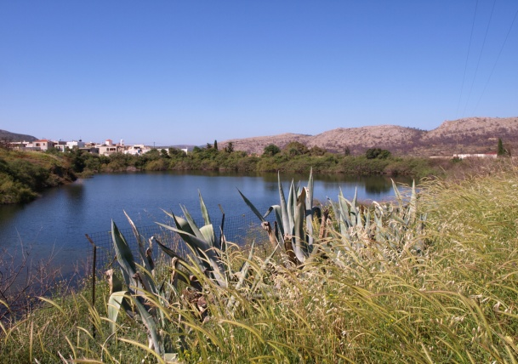 | 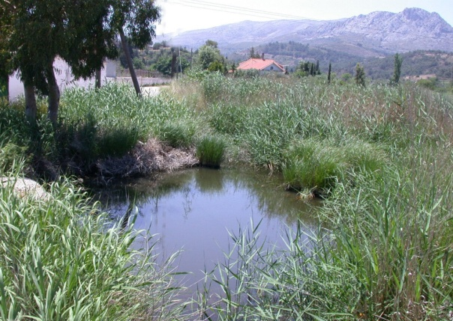
FIG A. Armolia Reservoir | FIG B. Marmaro Marsh
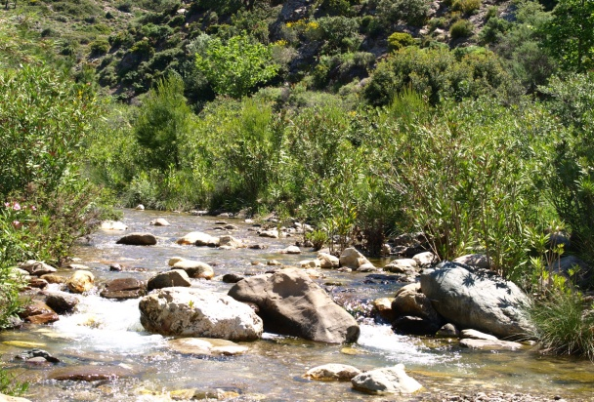
FIG C. Magaliotis River upper reach | FIG D. Magaliotis River lower reach
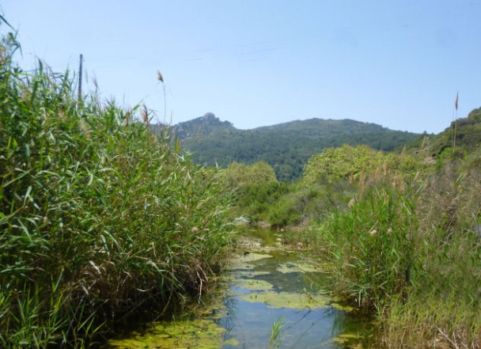 | 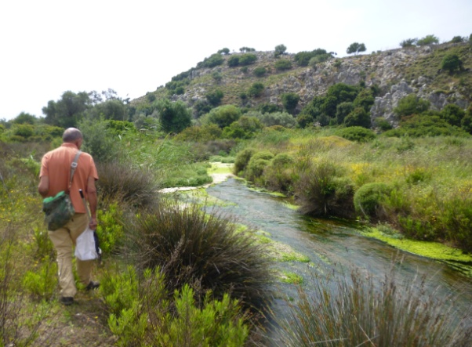
FIG E. Kampia River | FIG F. Lagkada Marsh
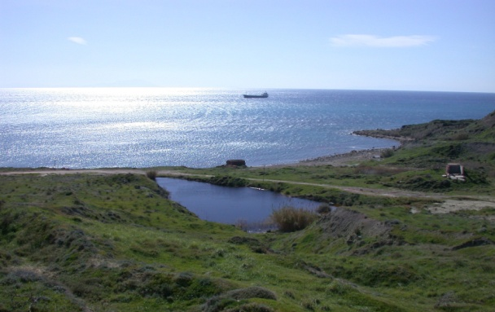 | 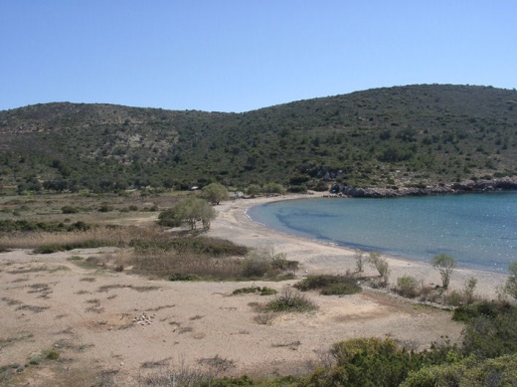
FIG G. Keramia Pool | FIG H. Kato Fana

Selection of Dragonfly Photographs taken in 2014. PLATE 2
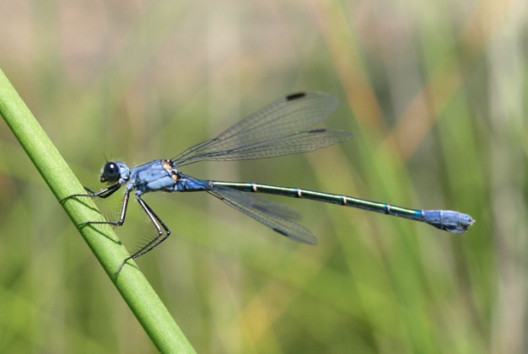 | 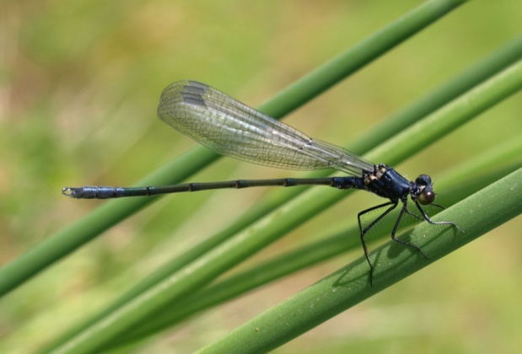
Lestes macrostigma adult female | Lestes macrostigma teneral male
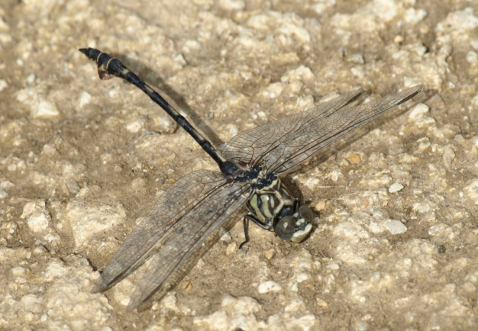 | 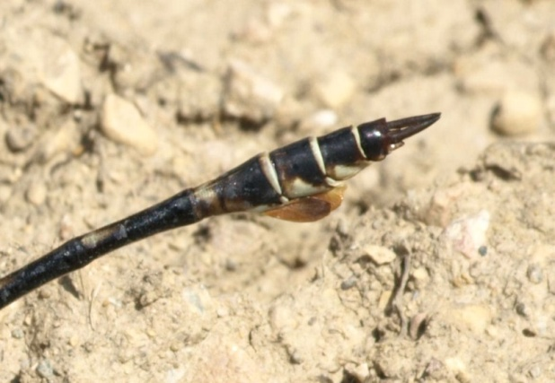
Lindenia tetraphylla adult male | Lindenia tetraphylla adult male rear abd
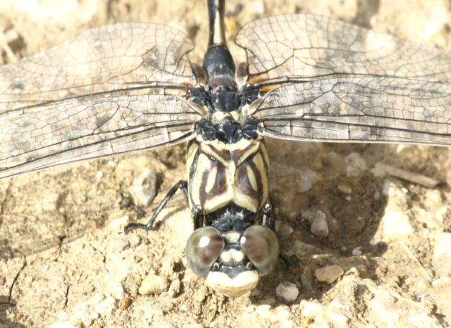 | 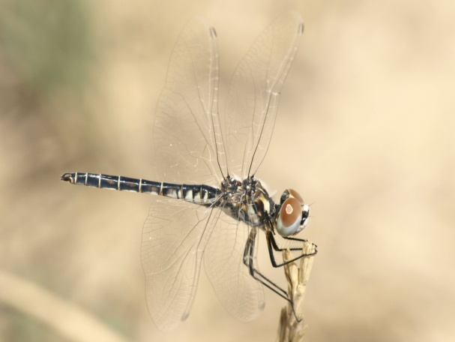
Lindenia tetraphylla male head & thorax | Selysiothemis nigra immature male
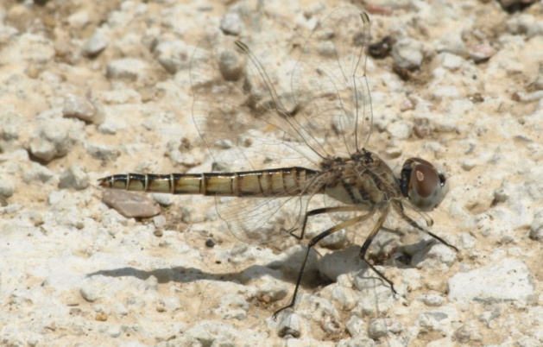 | 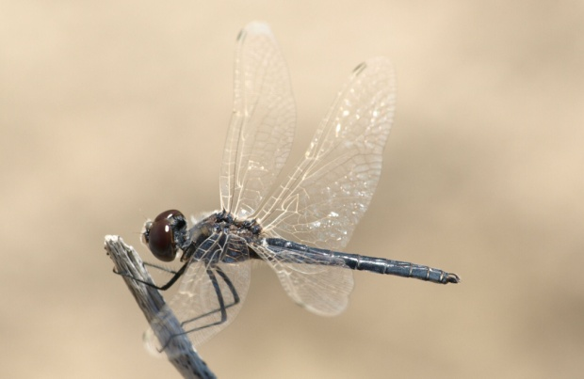
Selysiothemis nigra immature female | Selysiothemis nigra adult male
Acknowledgement
I would like to thank Richard Gabb, for his help in my survey of the Chios Odonata in 2013 and 2014. Richard became a member and treasurer of the British Dragonfly Society soon after its inception. He was then the County Recorder for Cheshire, U.K. and initiated a breeding survey of the county, culminating in the publication of ‘The Dragonflies and Damselflies of Cheshire’. Richard has lately been recording and photographing Odonata in Andalucia and also in Morocco where Orthetrum Sabina was found for the first time.
References
Ref 1. Mike Taylor, The Naturalist on Chios, Pelineo Editions, Chios, Greece, 2003.
Note, now out of print but downloadable from my website:- www.miketaylornaturalist.co.uk

11 November 2014

